FAO/GLOBAL ENVIRONMENT FACILITY
PROJECT DOCUMENT
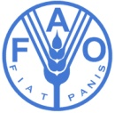

PROJECT TITLE: Contributing to Land Degradation Neutrality (LDN) Target Setting by Demonstrating the LDN Approach in the Upper Sakarya Basin for Scaling up at National Level
PROJECT CODE:
FINANCING PARTNER: GEF
FAO Project ID: 640662  FAO/GLOBAL ENVIRONMENT FACILITY  PROJECT DOCUMENT |  | GEF/LDCF/SCCF Project ID: 9586
EXECUTING PARTNERS: Ministry of Agriculture and Forestry (MAF)
Expected EOD (Starting Date): 010119
Expected NTE (End Date): 311221
CONTRIBUTION TO FAO’s STRATEGIC FRAMEWORK: | a. Strategic Objective/Organizational Result:  SO2: Increase and improve provision of goods and services from agriculture, forestry and fisheries in a sustainable manner  SO5: Increase the resilience of livelihoods to threats and crises  b. Regional Result/Priority Areas:  RI3: Sustainable use of natural resources, adaptation to climate change and disaster risk management  c. Country Programming Framework Outcome:  1 Food security and accessibility for agricultural products ensured  2 Quality and safety of food at all stages of the food chain improved  3 Sustainable use of natural resources and forests ensured and improved  - Climate change mitigation and adaptation in agriculture and forestry sectors,  and resilience of livelihoods to natural disasters and crisis situations  enhanced  - Capacity of the organizations related to agricultural and forestry sectors are  strengthened to enable them deliver better services
GEF/LDCF/SCCF Focal Area: Land Degradation
GEF/LDCF/SCCF strategic objectives: LD-3 Program 4: Scaling up sustainable land management through the landscape approach
Environmental and social risk classification (insert √): Low risk Moderate risk High risk
Financing Plan: GEF/LDCF/SCCF allocation:  GEF financing:  Co-financing:  MAF  FAO  Sub-total cofinancing:  Total Budget: |  |  | USD 2 388 584  13 200 000  400 000  13 600 000  15 988 584
Executive Summary
Within the context of Land Degradation Neutrality (LDN), Turkey aims to maintain and increase the amount of healthy and productive land resources in line with the national development priorities. Turkey has actively been combating land degradation for many years. In this context Turkey has already established the Basin Monitoring and Evaluation System (BMES) which will act as a key infrastructure for LDN and it will inform the decision-making system for LDN target setting as well as monitoring the status of land degradation/desertification and the success of basin wide sustainable land and forest management (SLM/SFM) activities. Turkey is thus well prepared to develop and implement the LDN approach in a coherent and consist way across sectors and land uses and to effectively demonstrate it and mainstream LDN into the planning processes.
The Project sets out to develop a model for LDN target setting, planning and implementation in the Sakarya basin for upscaling at national level in line with Sustainable Development Goals (SDGs) Target 15.3. It will take a phased approach and first strengthen the enabling environment for LDN and multi-sectoral land-use planning processes in Turkey, followed by development of a Decision Support System (DSS) for LDN that will first be applied in the Sakarya basin in northwestern Turkey. The final phase involves achieving land degradation neutrality on the ground in the Sakarya basin with associated global benefits generated related to improved land cover, enhanced soil carbon and enhanced land productivity. The LDN-DSS will be integrated into existing land-use planning and will be upscaled to set targets at the national level.
The project will knowledge and communication products in the area of SLM and SFM practices that can be applied to achieve LDN at sub-national and national levels in Turkey as well as other countries. A national LDN guideline that describes how LDN should be measured at different scales and how gains and losses could be balanced from the micro-basin, basin, landscape and up to the national scale will also be prepared. Thus, the project will enhance communication and visibility of LDN at the national level through support to dissemination of best practices and lessons learnt and the field level through support to demonstrations of SLM and SFM to achieve LDN and counterbalancing of gains and losses.
The proposed project is consistent with the various strategies, programs and action plans promulgated by the Government of Turkey (GoT) pursuant to its commitments under the relevant multilateral environmental agreements, as well as with the relevant national development plans adopted by the GoT. The Project includes a broad and diverse number of stakeholders with representatives of line ministries, the private sector and civil society, and when relevant, regional and international institutions. The Project is also fully in line with FAO’s Strategic Objectives.
This Project will contribute to socio-economic sustainability at the pilot site where LDN will be implemented. Demonstrations of SLM and SFM will contribute to income-generation for local communities. Special attention will be paid to identifying and supporting the special needs of rural women to ensure that their important role in natural resource management and agriculture is recognized and that they reap the benefits of investments in LDN. The project will strengthen existing institutional capacities within Turkey in LDN. Strengthened institutional, legal and policy enabling conditions for LDN will also enhance environmental sustainability and contribute to strengthen the capacity of Turkey to plan and manage these resources successfully under an LDN approach.
This project on operationalizing the LDN concept is the first of its kind in Turkey and is also linked to the global pilot project on LDN coordinated by the UNCCD. As such, it will generate new and innovative approaches to multi-sectoral land use planning based on testing and implementation in the Sakarya Basin. The experiences are expected to be replicable across Turkey through activities of the Ministry of Agriculture and Forestry (MAF) and opportunities for scaling up best practices will also be explored in the context of Turkey’s sharing of experiences with other countries and the UNCCD, especially in Central Asia.
The outputs of this project can act to fill the gaps on mainstreaming LDN into national policies and establishing necessary capacity for LDN monitoring through several indicators by developing methods and tools for LDN implementation, monitoring and evaluation.

Table of Contents
Acronyms 5
SECTION 1 – PROJECT RATIONALE 8
1.1 PROJECT CONTEXT 8
1.2 THE CURRENT SITUATION 14
1.3 THE GEF ALTERNATIVE 20
1.4 LESSONS LEARNED 47
1.5 STRATEGIC ALIGNMENT 48
SECTION 2 – FEASIBILITY 50
2.1 ENVIRONMENTAL IMPACT EVALUATION 50
2.2 RISK MANAGEMENT 50
SECTION 3 – IMPLEMENTATION AND MANAGEMENT ARRANGEMENTS 51
3.1 INSTITUTIONAL ARRANGEMENTS 51
3.2 IMPLEMENTATION ARRANGEMENTS 54
3.3 PLANNING AND FINANCIAL MANAGEMENT 59
3.4 PROCUREMENT 62
3.5 MONITORING AND REPORTING 62
3.6 EVALUATION PROVISIONS 66
3.7 COMUNICATION AND VISIBILITY 67
SECTION 4 – SUSTAINABILITY OF RESULTS 68
4.1 SOCIAL SUSTAINABILITY 68
4.2 ENVIRONMENTAL SUSTAINABILITY 68
4.3 FINANCIAL AND ECONOMIC SUSTAINABILITY 68
4.4 SUSTAINABILITY OF CAPACITY DEVELOPMENT 68
4.5 APPROPRIATENESS OF TECHNOLOGIES INTRODUCED and COST/EFFICIENCY 68
4.6 REPLICATION, SCALE-UP and INNOVATIVENESS 68
APPENDICES 70
APPENDIX 1: RESULTS FRAMEWORK 71
APPENDIX 2: WORK PLAN Fel! Bokmärket är inte definierat.
APPENDIX 3: PROJECT BUDGET 94
APPENDIX 4: RISK MATRIX 98
APPENDIX 5: ENVIRONMENTAL AND SOCIAL ASSESSMENT…………………………………………………………………… 105
APPENDIX 6. TERMS OF REFERENCE……………………………………………………………………………………………………… 107
APPENDIX 7. MAPS OF THE PROJECT INTERVENTION AREAS…………………………………………………………………. 107

Acronyms
AWP/B Annual Work Plan and Budget
BH Budget holder
BÜGEM General Directorate of Crop Production
CA Conservation Agriculture
CATAK Financing Environment Friendly Agriculture in Turkey
CBD Convention on Biological Diversity
CCM Climate Change Mitigation
CEO Chief Executive Officer
CPF Country Priority Framework (FAO)
CSA Climate-Smart Agriculture
CSO Civil Society Organisations
CSR Corporate Social Responsibility
CED Environmental Impact Assessment, General Directorate of Authorization and Auditing
CEKÜL Foundation for the Protection and Promotion of Environmental and Cultural Values
CEM General Directorate of Combating Desertification and Erosion
CMO Chamber of Environmental Engineers
CYGM General Directorate of Environmental Management
DHKD Natural Life Protection Association
DKM Nature Conservation Center
DKMP General Directorate of Nature Conservation and National Parks
DS-SLM Decision Support for mainstreaming and scaling up SLM
DSI General Directorate of State Hydraulic Works
FAO Food and Agricultural Organization of the United Nations
FE Final Evaluation
FLO Funding Liaison Officer
FFS Farmer Field School
FPMIS Field Programme Management Information System
GCU FAO GEF Coordination Unit in Investment Centre Division
GDP Gross Domestic Product
GEBs Global Environmental Benefits
GEF Global Environment Facility
GSP Global Soil Partnership
GHG Greenhouse Gases
GIS Geographical Information System
HQ Headquarter
ICT Information and Communication Technology
INRM Integrated Natural Resources Management
IT Information Technology
IW Inception Workshop
LDN Land Degradation Neutrality
LOA Letter of Agreement
LTO FAO Lead Technical Officer
LTU FAO Lead Technical Unit
M Million
MAF Ministry of Agriculture and Forestry
MGM General Directorate of Meteorology
M&E Monitoring and Evaluation
MEU Ministry of Environment and Urbanization
MIT Ministry of Industry and Technology
MPGM General Directorate of Spatial Planning
MTR Mid-Term Review
NAP National Action Program (of the UNCCD)
NBSAP National Biodiversity Strategy and Action Plan
NCCAS National Climate Change Adaptation Strategy
NDS National Development Strategy
NGO Non-Governmental Organization
OGM General Directorate of Forestry
OMO Chamber of Forest Engineers
ORKOOP Forestry Cooperatives Central Union of Turkey
PC Project Coordinator
PCU Project Coordination Unit
PES Payment for Ecosystem Services
PIR Project Implementation Review
PPR Project Progress Repots
PSC Project Steering Committee
PTF Project Task Force (FAO)
PY Project Year
RAPTA Resilience, Adaptation and Transformation Assessment
REU Regional Office for Europe and Central Asia
RF Project’s results framework
R&D Research and Development
SDG Sustainable Development Goal
SLM Sustainable Land Management
SO Strategic Objective
STAP Scientific and Technical Advisory Panel (of the GEF)
STAR System for Transparent Allocation of Resources
SYGM General Directorate of Water Management
TAGEM General Directorate of Agricultural Researches and Policies
TEMA The Turkish Foundation for Combating Soil Erosion, for Reforestation and the Protection of Natural Habitats
TCI The FAO Investment Centre Division
TCM Turkey Desertification Model
TCV Environment Foundation of Turkey
TOR Terms of Reference
TRGM General Directorate of Agricultural Reform
TT Tracking Tool (GEF)
TUBITAK The Scientific and Technological Research Council of Turkey
UNCCD United Nations Convention to Combat Desertification
UNDP United Nations Development Programme
UNFCCC United Nations Framework Convention on Climate Change
USD United States Dollar
ZMO Chamber of Agricultural Engineers

SECTION 1 – PROJECT RATIONALE

1.1 PROJECT CONTEXT
1.1.1 The national context
Turkey’s geographical location, climate, topography and soil conditions together with the country’s rapid socio-economic development, increases its sensitivity to desertification and drought. The total arable land area of Turkey is about 28 million ha out of a total area of more than 78 million ha. The main source of income of the country is agriculture and agriculture-based industry. However, the prime soils with high productivity and high organic carbon content cover only 17.5 % of the total land surface and the productivity of the rest of the soils is limited by topographical, chemical (e.g. high calcium carbonate content, alkalinity and low organic matter), and physical (e.g. water logging, texture) attributes. Plains from sea level to 250 m altitude cover only one tenth of the country, whereas places higher than 800 m cover two thirds, and half of the country is higher than 1000 m. Most mountain ranges extend from west to east and great ranges appear in the form of arches like the Taurus Mountains in the south, with development of topographically almost identical highlands and basins between the ranges. Because of these conditions, erosion is one of the most severe environmental problems affecting 81 % of the total land surface in varying degrees of severity (about 73 % of the cultivated land and 68 % of the prime agricultural land). Stream bank erosion affects 57.1 million ha while wind erosion degrades another 466,000 ha. As a result, about 168 million tons of soil is transported to the sea every year.
While the government of Turkey has been very active in addressing land degradation, there are many remaining challenges particularly in the context of the new Land Degradation Neutrality (LDN) target. The aspirational goal of a land degradation neutral world, to be realized by reducing the rate of land degradation and increasing the rate of restoration of degraded land, was agreed at the Rio+20 Conference in 2012. Subsequently, target 15.3 of the Sustainable Development Goals (SDGs) sets out a new global ambition: to achieve a Land Degradation Neutral World by the year 2030. Land degradation neutrality aims to maintain and increase the amount of healthy and productive land resources, in line with national development priorities. Land degradation neutrality is a flexible target that can be implemented at local, regional or national scales. It has been suggested that an LDN scheme should be introduced in phases. Phase 1 would focus on restoring degraded lands, improving national land use planning systems, and establishing international and national monitoring capacities. Phase 2 would reduce desertification rates with the help of fully integrated land use planning and monitoring systems. Phase 3 would set a target year for realizing an LDN goal, based on experiences in Phases 1 and 2. All three phases would be informed by existing scientific knowledge and generating new knowledge by launching a scientific LDN process that will evolve in parallel with the political process. This received major impetus following the 12th Conference of Parties (COP) to UNCCD in Turkey during October 2015 and the launch of the ‘Ankara Initiative” by the GoT. The COP decided to make LDN a guiding principle for implementing the convention. However, the knowledge base for the LDN concept is still evolving and frameworks which could serve as a common point of reference for LDN target setting, particularly with regard to the balance between “gains” (improvements) and “losses” (degradation) and scale of neutrality have not yet been tested in the field.
Institutional frameworks
The general framework of land policy in Turkey is articulated in the 44th Article of the Constitution “The Government is obliged to take necessary measures to protect and improve soil productivity, to prevent soil erosion, and to provide land for farmers who are landless or without enough land”. This Article envisages the regulation of land ownership and land degradation, erosion prevention and sustainability of land productivity. The protection of national land resources is guaranteed by the Government in Article 45 of the Constitution: "The Government shall make it easier to provide the means and supplies of farming and livestock farming enterprises and other inputs for the farmers raising crop and livestock production in order to prevent the use and degradation of agricultural land and meadows, and to increase crop and livestock production in accordance with the principles of agricultural production planning ".

The protection and use of agricultural land has been included in all Development Plans from the First Five-Year Development Plan (1963-1967) to the Tenth Development Plan (2014-2018). The 10th Development Plan foresees the use of common soil data and integrated project work in the prevention of land degradation. It is stated that the "National Soil Database" would be created by using remote sensing and geographical information systems in order to ensure access to up-to-date and accurate soil/land information, and land use planning will be made so that effective use of land will be ensured especially in agriculture.

In addition to the Development Plans the protection and effective use of fertile agricultural soils and conservation issues of forest and pastureland in Turkey have taken place as policy measures in the Annual Programs. To prevent misuse of natural resources, Soil, Pasture and Forest Laws must be implemented unfailingly and seriously. The action plans prepared by the General Directorate of Combating Desertification and Erosion for the 2013-2017 (“Action Plan for Combating Erosion"; "Upper Basin Flood Control Action Plan", "Dam Basin Green Belt Afforestation Action Plan "and" Mining Fields Rehabilitation Action Plan ") will ensure the protection of water basins by taking biological, cultural and physical precautions (afforestation, prevention of erosion and sediment transport, improvement of degraded forest areas, pasture rehabilitation, rehabilitation activities, research and development activities, training, promotion and capacity building activities and etc.).

The institutional framework in Turkey for sustainable land management and LDN is comprised of a number of national institutions and related units that are summarized in Table 1 below:

Table 1. Institutional framework

Institutions/ Organizations | Related Units
Ministry of Agriculture and Forestry (MAF) | General Directorate of Combating Desertification and Erosion (CEM)
Ministry of Agriculture and Forestry (MAF) | General Directorate of Forestry (OGM)
Ministry of Agriculture and Forestry (MAF) | General Directorate of State Hydraulic Works (DSI)
Ministry of Agriculture and Forestry (MAF) | General Directorate of Water Management (SYGM)
Ministry of Agriculture and Forestry (MAF) | General Directorate of Nature Conservation and National Parks (DKMP)
Ministry of Agriculture and Forestry (MAF) | General Directorate of Meteorology (MGM)
Ministry of Agriculture and Forestry (MAF) | General Directorate of Crop Production (BÜGEM)
Ministry of Agriculture and Forestry (MAF) | General Directorate of Agricultural Reform (TRGM)
Ministry of Agriculture and Forestry (MAF) | General Directorate of Agricultural Researches and Policies (TAGEM)
Ministry of Environment and Urban Planning (MPA) | General Directorate of Spatial Planning (MPGM)
Ministry of Environment and Urban Planning (MPA) | General Directorate of Environmental Management (CYGM)
Ministry of Environment and Urban Planning (MPA) | Environmental Impact Assessment, General Directorate of Authorization and Auditing (CED)
Ministry of Interior | General Directorate of Local Authorities
Ministry of Industry and Technology (MIT) | General Directorate of Regional Development and Structural Adjustment
Ministry of Industry and Technology (MIT) | General Directorate of Economic Sectors and Coordination
Ministry of Industry and Technology (MIT) | General Directorate of Social Sectors and Coordination
Ministry of Science, Industry and Technology | General Directorate of Mining Affairs
Ministry of Science, Industry and Technology | General Directorate of Renewable Energy
Universities
TUBITAK
UNCCD
FAO
UNEP
NGOs | Chamber of Forest Engineers (OMO)  Chamber of Agricultural Engineers (ZMO)  Chamber of Environmental Engineers (CMO)  Turkey Union of Chambers of Agriculture  Forestry Cooperatives Central Union of Turkey (ORKOOP)  TEMA Foundation  Natural Life Protection Association (DHKD)  Foundation for the Protection and Promotion of Environmental and Cultural Values ​​(CEKÜL Foundation)  WWF Foundation  Environment Foundation of Turkey (TCV)  Nature Association, DKM - Nature Conservation Center

Under the coordination of the Ministry of Agriculture and Forestry, a strong cooperation with other ministries, universities and non-governmental organizations, especially with the Ministry of Development and the Ministry of Environment and Urban Development needs to be developed. This cooperation will make a significant contribution to the prevention and balancing of land degradation to achieve land degradation neutrality.

Legal and policy framework
The legislative framework of the Republic of Turkey contains a set of laws aimed at land use regulation. (Table 2). Strategic Plans are also being prepared in the framework of the basic policies, priorities, targets or precautions in the national or regional strategy documents and/or action plans relating to the international conventions, the National Programs of the Sectors, the Development Plan, the Medium-Term Program, the Medium-Term Fiscal Plan and other top policy documents.

Table 2. Legal and policy framework.
Name | Law/regulation number | Areas /law regulation applies to
National Law
Constitution of the Republic of Turkey | Law No: 2709 /Date of Acceptance: November 7, 1982  Articles; 44, 45, 56, 57, 90, 166, 169, 170, 171  Within the context of natural resource management and prevention of land degradation, these law regulations are applied to;  - protection of land,  - elimination of poverty in rural areas,  - land acquisition by landless farmers,  - protection of forests and pastures,  - raising the living standards of forest villagers,
Land Conservation and Land Use Law | Law No: 5403 /Date of Acceptance: July 19, 2005 – law regulation is applied to;  - conserving land and soil resources  - use of agricultural lands
Forest Law | Law No: 6831 /Date of Acceptance: September 8, 1956 – law regulation is applied to;  - Forest areas  - In site Forest pastures  - Forest villagers
Agricultural Reform Law on Land Regulation in Irrigation Areas | Law No: 3083 /Date of Acceptance: December 1, 1984 – law regulation is applied to;  - Irrigated agricultural lands
The Environment Law | Law No: 2872 /Date of Acceptance: August 1, 1983 – law regulation is applied to;  - biological, physical, social, economic and cultural environments
Pasture Law | Law No: 4342 /Date of Acceptance: February 28, 1998 – law regulation is applied to;  - pastures and meadows  - grasslands
Agriculture Law | Law No: 5488 /Date of Acceptance: April 25, 2006 – law regulation is applied to;  - Agricultural sector  - Rural area
Organic Farming Law | Law No: 5262 /Date of Acceptance: December 3, 2004 – law regulation is applied to;  - Organic farming activities
Law on Waters | Law No: 831 /Date of Acceptance: May 10, 1926 – law regulation is applied to;  - Drinking water
Law on Underground Waters | Law No: 167 /Date of Acceptance: December 23, 1960 – law regulation is applied to;  - Underground waters
Irrigation Unions Law | Law No: 6172 /Date of Acceptance: March 22, 2011 – law regulation is applied to;  - Irrigation Unions
Biosafety Law | Law No: 5977 /Date of Acceptance: March 26, 2010 – law regulation is applied to;  - Organisms and products modified genetically
National Parks Act | Law No: 2873 /Date of Acceptance: August 11, 1983 – law regulation is applied to;  - National park  - Nature park  - Natural monument  - Natural protection areas
National Forestation and Erosion Control Mobilization Law | Law No: 4122 /Date of Acceptance: July 26, 1995 – law regulation is applied to;  - Forestation and erosion control works
Land Hunting Law | Law No: 4915 /Date of Acceptance: July 11, 2003 – law regulation is applied to;  - Hunting and wildlife management
Law on the Use of Renewable Energy Sources for the Purpose of Generating Electricity Energy | Law No: 5346 /Date of Acceptance: May 10, 2005 – law regulation is applied to;  - Renewable Energy Sources
Cadastre Law | Law No: 3402 /Date of Acceptance: July 9, 1987 – law regulation is applied to;  - Real estate
Law on the Protection of the Integrity of the Development Plans | Law No: 3067 /Date of Acceptance: November 6, 1984 – law regulation is applied to;  - Planning of national development at the macro level
Law on the Establishment, Coordination and Duties of Development Agencies | Law No: 5449 /Date of Acceptance: February 8, 2006 – law regulation is applied to;  - Providing development on regional basis
Metropolitan Municipality Law | Law No: 5216 /Date of Acceptance: July 23, 2004 – law regulation is applied to;  - Metropolitan municipality and municipalities within the borders of the metropolis
Turkish Civil Law | Law No: 4721 /Date of Acceptance: December 8, 2001 – law regulation is applied to;  - Relations between individuals
International Conventions adopted in parliament pursuant to Article 90 of the Constitution; | - United Nations Framework Convention on Climate Change (UNFCCC) - Law No: 4990 / Date of Acceptance: October 21, 2003  - United Nations Convention to Combat Desertification (UNCCD) - Law No: 4340 / Date of Acceptance: February 14, 1998  - United Nations Biodiversity Convention (UNBDC) - Law No: 4177 / Date of Acceptance: September 3, 1996  - European Landscape Convention - Law No: 4881/Date of Acceptance: June 17, 2003  - Ramsar Convention) - Law No: 3958 / Date of Acceptance: May 17, 1994
Government Regulations
10. Development Plan  (2014-2018) | - protection of the environment and sustainable use of resources
Government Program  (2016-2019) | - In the 65th Government Program, the issues that govern the management and sustainable use of country's natural resources are included in the program under Chapter 4 "Strong Economy" and Chapter 5, "Livable Cities and Environment"

In Turkey, the Strategic Plans related to LDN and the Action Plans related to these strategic plans are prepared and implemented within the scope of international agreements and Law No. 5018. The prepared strategy documents are:
- Turkey's Climate Change Strategy and Action Plan (2010-2023)
- National Strategy and Action Plan to Combat Desertification (2015-2023)
- National Biological Diversity Strategy and Action Plan (2007)
- National Watershed Management Strategy (2014-2023)
- National Drought Management Strategy Document and Action Plan (2017-2023)
- Strategy and Action Plan for Combating Drought (2017-2023)
- EU Integrated Environmental Adaptation Strategy (2007-2023)
- Water Quality Management Strategy Document and Action Plan (2015-2023)
- National Rural Development Strategy (2014-2020)

Building on this baseline, the project will address the lack of conservation and development policies for LDN as well as the frequent changes in legal arrangements and institutional structures. It will also strengthen the ability of institutions to establish investment programs within the framework of LDN principles, and ensure effective synergies between the three Rio Conventions for their effectively in Turkey.

1.1.2 Area of intervention
This study will be carried out in the Upper Sakarya Basin, a sub-basin of the Sakarya Basin, which includes the provinces of Afyon, Ankara, Bilecik, Bolu, Cankırı, Eskişehir, Konya, Kütahya and Uşak (Figure 1). The Sakarya basin is located between 4198159-45334009 m North and 178492-535438 m East (UTM - WGS-84) coordinates and is about 63,300 km². Although Sakarya Basin is heavily industrialized and the pace of industrialization is increasing, it is still one of the well-established agricultural basins of Turkey. The lower parts of the basin and plains at higher altitudes are mainly used for agricultural purposes. Almost half of the terrestrial lands in Sakarya Basin are agricultural lands. The main agricultural products are wheat, barley, rye, corn, sesame, sunflower and sugar beets as well as vegetables. Animal husbandry is predominant in some parts of the Basin with mostly cattle breeding around Ankara and sheep and goat breeding in Ankara and Eskişehir regions. The Upper Sakarya Basin covers an area of 4 899 302 ha with 3 169 588 of cropland, 980 179 ha of forest and 164 060 ha of pastures/grasslands, with the rest belonging to other land use groups such as water bodies and urban areas. According to the analyses made by the Basin Monitoring and Evaluation System (BMES), 2 227 401 ha of land is under high and very high desertification risk.
The altitude of the northern parts of the Sakarya Basin near the Black Sea is about 200 m from sea level, but it rises up to 1000 m in the south. In addition, the altitude reaches about 2 400 m with the mountains on the northeastern and south-western borders of the basin. In the Upper Sakarya basin the altitude ranges from 1 000 m to 2 400 m. Slope gradient in the northeastern parts of the basin changes between 30 and 50%, whereas in the Upper Sakarya Lower Basin, it ranges mostly between 0 and 20% excluding the mountainous area in the southwest. The northern part of the basin is mostly covered by forest, and dry and irrigated agriculture, while the southern and central parts of the basin, in which the Upper Sakarya sub basins is located, is mostly used for dry agriculture and pasture. Similarly, the Brown Forest Soils and Non-Calcareous Brown Forest Soils are widely distributed in northern part of the basin, whereas Brown Soils and Reddish Brown Soils are distributed in the area including the Upper Sakarya lower basin. In terms of soil organic carbon (SOC), it mostly ranges between 20 to 40 tons/ha and reaches up to 70 tons/ha only in a small part, the western region of the Upper Sakarya basin.

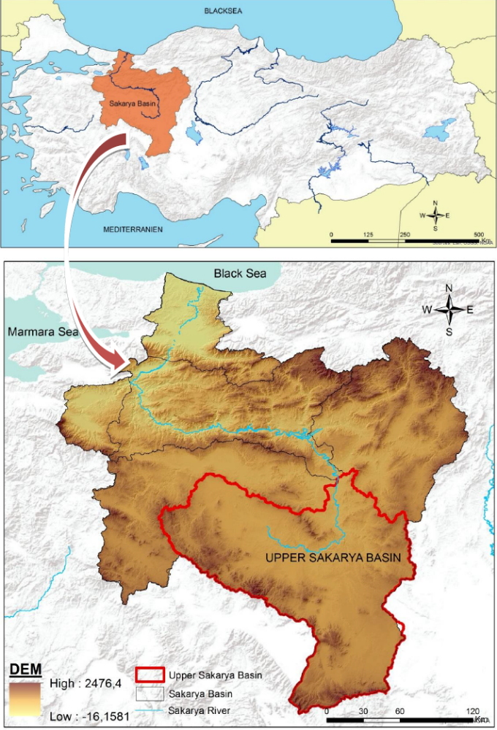
Figure 1: Upper Sakarya Basin as part of the Sakarya Basin (delineated in red)

1.2 THE CURRENT SITUATION
1.2.1 Threats to Global Environmental Benefits
Due to the steep topography and inappropriate land management, the Upper Sakarya Basin faces serious degradation. Due to the existing poverty level, local people heavily utilize the forest, pastures and agricultural resources. This has resulted in reduced land productivity and reduction of soil organic carbon. Some of the forests in the basin are degraded or lost due to land clearing for the opening of new farmlands, overgrazing and high demand for fuelwood. Although livestock is one of the main sources of income, the pressure on pastures is also increasing as grazing is conducted in an unplanned way. This degradation of natural resources is compounded by climatic conditions such as irregular and heavy precipitation which results in floods and economic losses in the region.

    - Baseline initiatives
The government of Turkey has been very active in addressing land degradation, but more remains to be done particularly with respect to integrating all sector-specific plans within a holistic decision-making mechanism that integrates the concepts of land degradation neutrality. The development plans are the key planning instruments in Turkey. Under the business-as-usual scenario, the government of Turkey will continue to develop a process whereby development plans are prepared mainly in isolation responding mainly to the needs of the Ministry of Development which is in charge of executing them. In the same way, capacity building and knowledge sharing continues to be done by the line ministries and only partly include LDN concepts. The following is the list of projects/program that constitute the baseline and will be counted as co-financing to the proposed project:
Basin Monitoring and Evaluation System (BMES); The General Directorate of Combating Desertification and Erosion (CEM) has initiated a large-scale project in collaboration with TUBITAK (The Scientific and Technological Research Council of Turkey) in order to create the ultimate system to monitor seven different indicators for basins in Turkey. One of these indicators is desertification that is also including erosion and soil conservation themes. The project has involved many scientist and institutes to determine the criteria for desertification. Up on consultations, TUBITAK has developed the database and the desertification module based on defined criteria. The database and module have been designed to meet the reporting needs of many relevant organizations in Turkey regarding combating desertification. At the end of the project, a desertification risk map has been produced. The module developed has been tested and calibrated. Currently, CEM is planning to undertake new projects to define modules for other indicators such as water module. The BMES has established Turkey’s base for monitoring the status of desertification and success of basin wide SLM activities. The BMAS will act as a key infrastructure for LDN and it will inform the decision-making system for LDN target setting as well as monitoring the success.
Identification of Potential Forestry Activities System – A baseline to LDN decision making in Forests. In the recent past, Turkey has undertaken a project to determine the priorities of forestry actions in terms of restoration and land improvement. The project aimed at to define areas suitable for afforestation, forest rehabilitation, erosion control and rangeland rehabilitation. The model uses GIS infrastructure and data is gathered from expert and stakeholder consultations as well as literature data such as forest management plans. The model developed was piloted in an area of 461,128 ha within Ankara, Cankiri and Bolu provinces in Sakarya Basin. This approach can serve as a baseline model for LDN decision-making when it comes to defining priorities in selecting areas of land improvement/ restoration interest.
Soil Information System; The GoT and the FAO have been cooperating under the FAO-Turkey Partnership Programme (FTPP) to establish a consolidated soil information system that can be accessed online through a web-based GIS by farmers, researchers, and decision-makers. It is expected that stakeholders will have access to reliable data in order to make better investment decisions leading to the preservation and sustainable management of soils. To date, all soil samples from the Ministry’s archive have been analyzed for data related to fertility, texture, organic carbon and bulk density.
Integrated Natural Resource Management Projects in Turkey; In Turkey, currently there are two large scale integrated basin rehabilitation projects under implementation. First, the Coruh River Watershed Rehabilitation Project (2012-2018) is led by General Directorate of Forestry (GDF) supported by the finance of Japan International Cooperation Agency (JICA). The project covers an area of 2 million hectares in northeast Turkey. The project aims to provide integrated watershed rehabilitation including vegetation, soil and water resources; better living conditions for the rural population; soil conservation; rehabilitation of degraded forests; and prevention of natural disasters (avalanche, flood and overflow control). The total budget of the action is around USD 52 million.
Second, the Murat River Watershed Rehabilitation Project (2013-2018) is also led by GDF. It is located in eastern Turkey in the provinces of Elazığ, Muş and Bingöl with 25 micro-basin pilot sites. The project is funded by IFAD and GDF. The main goal of the project is to prevent land degradation and contribute to poverty reduction. The project has a strong community focus in the forest villages. The total budget of the project is around USD 38.6 million.
In addition, the Ministry of Agriculture and Forestry (MAF) is undertaking “integrated micro basin rehabilitation projects” from its own budget. Currently there are 7 projects under implementation with a total budget of USD 35 million. Among these, 4 projects are implemented in Konya province, 2 in Afyonkarahisar and one in Şanlıurfa. The projects that are under implementation will be finalized before the end of 2021. Additional projects are expected to be budgeted for and implemented during the coming years.
Financing environment friendly agriculture in Turkey (CATAK); A finance model for CSA. The Ministry of Agriculture and Forestry (MAF) has been running the Conservation Program on the Agricultural Lands for Environment (CATAK) since 2005 aiming to conserve and achieve sustainability in the use of soil and water, avoidance of erosion, reducing the negative effects of agricultural practices and support conservation of lands. The CATAK provides direct subsidy to farmers who are willing to improve their agricultural activities according to a set of criteria. The program has provided more than USD 20 million to more than 40,000 farmers covering an area of 140,000 ha (2014 figures).
Current drought Early Warning Systems; Although there are several research attempts to define and implement drought early warning systems for agriculture in Turkey, currently they are all in development phase and there is not an agreed and established system. The Ministry of Agriculture and Forestry is working on some early warning methods based on monitoring of soil moisture and plant phenology. However, defining a proven and accepted method is expected to take more time.
Turkey’s Desertification Model and Risk Map (TCM) – This project is carried out by the General Directorate of Combating Desertification and Erosion in cooperation with the TUBITAK-BILGEM. The model, an original geographic-based mathematical model specific to Turkey, is a tool used for estimating land degradation and desertification risks, preparing watershed based risk maps and monitoring hot spot areas for land degradation and desertification. The updated (2018) land degradation/desertification map of Turkey has already been prepared and the validation and calibration studies are still ongoing. The produced map has a potential to be used as a tool for LDN assessment. All types of land degradation including desertification will be monitored within specific time periods (5/10 years intervals depending on risk factor).
Collect Earth (Assessment of Land Productivity); Land productivity of 100,000 sites in arid and semi-arid areas around the World was evaluated under the Global Forestry Survey conducted by FAO. This study aims to determine the status of arid areas by evaluating specifically forest areas and the other areas including agricultural areas, bushes, and pasture lands. In the study, 15.000 points in the Middle East Region including Turkey were also evaluated. As a result of this study it was reported that in arid and semi-arid regions of Turkey, 1.425.000 hectares of land has greening tendency but 823.000 hectares of land has declining productivity. But it is absolutely know from the visual analysis that forest rejuvenation studies being carried out in Turkey were evaluated as declining in land productivity. In this Project context, symmetrically selected 61 865 reference points with 4 km distances in all around Turkey has been evaluated, and analysis is still ongoing. In order to make evaluations within the scope of the project, new open source software was developed.
Soil Organic Carbon (SOC) Monitoring Model of Turkey and the Map of SOC; Soil Organic Carbon Monitoring Model and Mapping Project of Turkey will serve for determining and monitoring soil organic carbon content which is one of the indicators of Land Degradation Neutrality. Cooperation among the related Government institutions, universities and the TUBITAK was provided for this extensive and intensive study covering the whole of Turkey. In this context, several projects have been carried out to expose current soil organic carbon content of Turkey, to improve monitoring system for determining the amount of soil organic carbon and to develop a model for estimating SOC. With this Project; (I) Carbon units will be defined for areas where the amount of organic carbon in the soil may be similar, (II) A country specific model for estimating soil organic carbon will be developed, (III) Soil organic carbon will be monitored at certain periods at the national scale, (IV) The produced and registered data to be prepared at the realization of the country targets for Land Degradation Neutrality will open to the relevant beneficiaries via the web, and (V) Decision-support will be provided for the decision makers of the responsible and stakeholder organizations.
Dynamic Erosion Model and Monitoring System (DEMIS); The map of soil losses reaching rivers in Turkey was obtained by using the RUSLE-the Revised Universal Soil Loss Equation. A Dynamic Erosion Model and Monitoring System (DEMIS) has been developed to provide a dynamic structure for this model and to achieve monitoring and reporting for years. With this system, changes in land cover and changes occur due to soil-water conservation activities will be determined, and the effect of these applications on changes in the amount of erosion will be determined temporally, spatially and locally. Turkey's "potential", "real" and "reaching the river" average annual soil loss soil erosion digital maps were prepared using the Erosion Model and Dynamic Monitoring System. The Rainfall Erosivity Factor (R) and Crop Cover Management Factor (C) have been updated with the DEMIS software. Soil Erodibility Factor (K) and Sediment Delivery Rate (SDR) will also be monitored.
Wind Erosion Monitoring System; Highly comprehensive, dynamic and updatable data sets are needed in order to estimate wind erosion at the national scale. The development of effective protection methods and the sustainable resource use will only be possible in this case. Areas with high risk potential for wind erosion in our country will be revealed by the wind erosion risk map. For this purpose, the areas affected by wind erosion and having a potential for wind erosion on a national scale are set out according to the 'wind erosion climate factor'. In this context, wind erosion in pasture and agricultural areas under threat of wind erosion and in areas where wind erosion prevention works are done is determined and risk assessment is made by the pilot projects. Measurements are carried out with sediment trap sets installed in the project areas. With the system, the risk of wind erosion in different land uses is directly measured.
National Land Cover/Land Use Classification and Monitoring System (UASIS); CORINE (Coordination of Information on the Environment) Project is one of land management projects under the GMES (Global Monitoring for the Environment and Security) program of the European Union. The most common initiative of the project is the creation of "Land Cover/Land Use" maps of the European Union member states according to the criteria of the European Environment Agency (EEA). Within the scope of the Project prepared by the Ministry of Agriculture and Forestry and submitted to the EEA, Turkey's CORINE 1990, 2000, 2006, 2012, 1990 to 2000 change, 2000 to 2006 change, and 2006 to 2012 change databases created and delivered by the EEA so far. The Ministry of Agriculture and Forestry presented the scope of the EEA prepared vested in the project so far, Turkey's CORINE 1990, 2000, 2006, 2012, 1990 to 2000 changes, changes in 2000-2006, 2006-2012 and open to change databases created It has been delivered. These generated maps were formed on the basis of 5 bases, 44 sub-land cover/land use class, based on the classes determined by the European Environment Agency. Also, according to the EEA standards, the classification is made every 6 years, with 1/100.000 scale and the smallest mapping unit being 25 hectares. But, it is necessary to monitor the changes in the land cover within the scope of struggle with natural disasters such as desertification, erosion, flood, landslide as continuously and sustainably rather than at certain periods. In this context, the CORINE model may not be adequate to work with underclass determined in accordance with the needs of Turkey. For this reason, the National Land Cover/Land Use Classification and Monitoring System (UASIS) project has started. This model is of great importance in terms of semi automatically collecting instant data, transferring it to the system, verifying it, and making immediate intervention to system faults etc.
Moreover, Turkey has two drought management approaches in place: Strategy and Action Plan for Combating Agricultural Drought (2013-2017) and Drought Management Plans that are prepared for river basins of the country. The first strategy and action plan sets in place a province-based approach to respond to agricultural drought. It has two different approaches for irrigated and rainfed croplands. Through analyzing monthly precipitation levels and soil moisture, the level of agricultural drought is determined in all of the provinces. The different levels are defined as “Normal; Prepare for drought; Drought Alarm; and Restrictions”. The steps to be taken in each category are defined in the strategy document. The decisions are taken by the province councils led by the deputy governor.
The basin wide Drought Management Plans are developed by the Ministry of Agriculture and Forestry. It focuses on all sectors and defines what to be done by different stakeholders in case of drought emergencies with a focus of water allocation. The plans aim to decrease the effect of drought and better inform the decision makers. Currently two drought management plans are prepared and put into operation for Akarcay and Konya Basins. The rest of the plans are expected to be finished before the end of 2020.
Farmer Field Schools/Rural Advisory Services in Turkey; the Ministry of Agriculture and Forestry (MAF) is leading two different GEF supported projects: “Sustainable Land Management and Climate Friendly Agriculture” and “Conservation and Sustainable Management of Turkey’s Steppe Ecosystems”. Both projects have the common approach to capacity development for local farmers, shepherds and villagers that are called Farmer Field Schools (FFS). The first project is under implementation and the first FFS is expected to be operational at the end of 2016 in Karapinar, Konya. The others will follow in a few more cities in the Project pilot sites. Although not part of the co-financing scheme, these two GEF-funded projects are part of the joint work between the Turkish Government and FAO. The LDN Project will benefit from the know-how, established processes and lessons learnt from the current FFSs. FFSs were designed by FAO to empower farmers and ranchers to become better informed on SLM to improve production, maintain ecosystem integrity, and reduce the long-term economic risks associated with degradation. FFSs are expected to establish a continuous learning approach between government staff and farmers so that all sides are better-informed regarding SLM approaches.
Another important baseline project in FAO’s Sub-Regional Office that the project will build on is entitled “Towards achieving Land Degradation Neutrality: turning the concept into practice”. UNCCD led this pilot project with the contribution of Government of Republic of Korea and 12 countries participated. The aim of the project was to have a representative sample of affected country Parties translate the land degradation neutrality goal into national voluntary targets, making use of the implementation framework and the monitoring and assessment mechanisms established within the UNCCD process. Turkey was a voluntary country party of this initiative—this is, it did not receive funding. Project activities included an analysis of soil organic carbon and land productivity index in a small pilot site in the Gediz Basin. Turkey did not set national targets, as higher resolution data are needed for this purpose. In addition, the Ministry of Agriculture and Forestry (MAF) is carrying out the National Land Consolidation Program that through re-orientating property lines to create more square parcels will increase land productivity. The program was initiated in 2008 and will be finalized in 2018. The target is to consolidate 8.5 million hectares nationally with a total investment of US$ 660 million.
The baseline scenario thus includes a number of important elements for establishing an LDN scheme in Turkey, as well as valuable experiences from an earlier LDN pilot project. However, to take the LDN approach to a new level in Turkey, incremental GEF funding is required to ensure that the LDN approach is developed and implemented in a coherent and consist way across sectors and land uses that enables scaling up at national as well as international level.
1.2.3 Remaining barriers
The Turkish government has already developed a series of plans and action plans to guide its investments in natural resource management, but these are generally sector-specific and lack a coherent approach that could form the basis for LDN target setting. Similarly, while the government of Turkey has carried out significant efforts to train its staff and local stakeholders to implement their sector-specific plans, additional work is needed in order to effectively demonstrate the LDN approach and mainstream LDN into the planning process. Likewise, while the GoT has carried out significant efforts to raise awareness and disseminate best practices and technologies to address land degradation, monitoring systems need to be strengthened to integrate LDN indicators and metrics to enable LDN target setting at landscape and national scales. In summary, the following barriers remain:
Barrier 1: Inadequate enabling environment: One of the key barriers to addressing land degradation effectively is the inadequate enabling environment, both from a policy/planning perspective and a capacity perspective. Each of these issues is described below.
- Policy/planning processes
Spatial Planning in Turkey is undertaken through Environmental Plans coordinated by the Ministry of Environment and Urban Planning. The key regional planning tools are (i) the Integrated River Basin Management (IRBM) Plans, (ii) forest management plans, (iii) agricultural development plans based on agricultural basins, and (iv) integrated Coastal Management (ICM) Plans. IRBM plans are basically “conservation plans” for river basins. Currently, the MAF has finalized the first steps towards developing IRBM plans—this is, plans for four basins are currently under preparation, and the government expects to have plans for all basins finalized before 2023. Regarding agricultural development plans, the Ministry of Agriculture and Forestry (MAF) organizes its plans through Agricultural Basins that are generally different from river basins.

Forest management plans are the key tools for forestry in Turkey. Forest management plans are prepared for each enterprise active in the Sakarya Basin every 10 years.In addition, the Ministry of Environment and Urbanization of Turkey is in the process of preparing Integrated Coastal Management Plans for all of the coastal provinces. The management and use of pasturelands is decided at the provincial level. Each province governorship founds a pastureland commission which meets regularly to decide on management issues, allocations and to solve any conflicts. The lack of participatory land-use planning especially for afforestation interventions increases the pressure on pastures and limits livestock husbandary to a significant extent. Finally, the GoT is currently defining and piloting a new and higher level of spatial planning called Strategic Spatial Planning. The fundamental idea with this new planning instrument is to have a more participatory and collaborative approach at the local level.

There are thus different levels of planning with some of them focusing on specific sectors or landscapes which are led by different institutions. This array of planning processes in Turkey needs to be better coordinated in order to support the LDN approach in which land degradation management is coupled with land use planning. The institutions at regional and national levels that are leading in designing and implementation of these plans should be better informed to ensure successful acceptance and integration of the LDN concept and approach for implementation at site level. As land degradation is a multi-sectoral issue, the priorities and needs arising from following a LDN approach have to be reflected in all of the above-mentioned planning and management processes and tools.

- Lack of adequate capacity to mainstream and implement LDN
Capacity is lacking both at the institutional (central and local government) and grassroots level (local communities, NGOs, Cooperatives, Farmer Unions) to mainstream and implement LDN. Although the recent developments in related sectors has increased the knowledge of combating land degradation in relevant institutions, the LD, LDN and SLM concepts are mostly interpreted as erosion control and/ or decreased productivity in production landscapes. Therefore, in order to achieve LDN mainstreaming at regional and national levels, the capacity and awareness of these institutions need to be enhanced. A capacity needs assessment and a corresponding training program will be designed during project preparation. The project will focus on building capacity of communities and government institutions within the Sakarya Basin, but keeping in mind the underlying goal of the project to upscale its experience both at the national and international levels.
Barrier 2. Limited data, knowledge and experience to support decision-making processes on LDN: During the UNCCD COP 12, the parties agreed that voluntary LDN targets will be selected by countries themselves and LDN will be mainstreamed into national plans for combating land degradation. Also, key indicators for monitoring LDN are (i) soil organic carbon levels, (ii) land cover, and (iii) land productivity. However, the necessary target setting, LDN mainstreaming and monitoring/reporting of results are not fully applied by the countries yet due to knowledge and capacity constraints. Therefore, this project aims to establish a decision making tool with modeling abilities on LDN with tested monitoring schemes for selected indicators.
The GoT has a long history of developing tools for monitoring land degradation and erosion. However, while the country possesses soil inventory reports that go back for decades, the soil data available is often incomplete, fragmented and inaccessible to stakeholders engaged in the agriculture sector.
Experiences from the UNCCD-supported LDN pilot project in the Gediz basin in southwestern Turkey showed the usefulness of land productivity maps as a base layer for analyzing land cover and organic carbon. The pilot project also came up with recommendations for categorizing land use using the LDN indicator framework. The approach is thus ready to be implemented but improvements and adaptations are needed based on further field testing.

1.3 THE GEF ALTERNATIVE
1.3.1 Project strategy
The Project sets out to develop a model for LDN target setting, planning and implementation in the Sakarya basin for upscaling at national level in line with SDG Target 15.3. It will take a phased approach and first strengthen the enabling environment for LDN and multi-sectoral land-use planning processes in Turkey, followed by development of a Decision Support System (DSS) for LDN that will first be applied in the Sakarya basin in northwestern Turkey. The final phase involves achieving land degradation neutrality on the ground in the Sakarya basin with associated global benefits generated related to improved land cover, enhanced soil carbon, and enhanced productivity thanks to improved land use. This will be followed by scaling up the LDN DSS to set targets at the national level. The Project theory of change is based on the scientific conceptual framework for LDN and its ToC that is summarized in Figure 2:

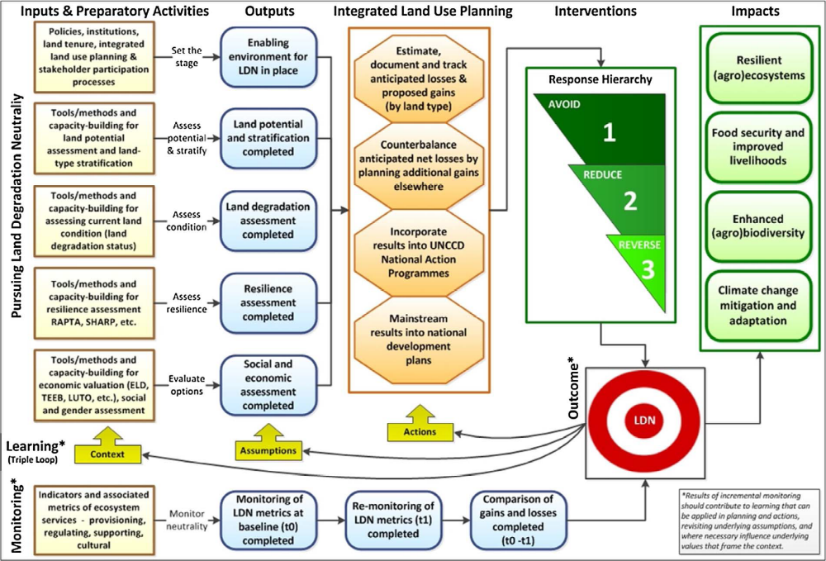
Figure 2. Theory of Change for Land Degradation Neutrality (LDN).
Pursuit of LDN requires effort to avoid further net loss of land-based natural capital relative to a reference state, or baseline. Planning for neutrality involves counterbalancing anticipated losses with measures to achieve equivalent gains, within individual land types, where land type is defined by land potential. LDN will be integrated into existing land-use planning in the selected project area. Capacity to monitor the UNCCD three global indicators for LDN – land cover, land productivity and carbon stocks – will be strengthened so that targets can be set in the demonstration area and nationally. The project-specific theory of change based on the LDN framework is summarized below:

Figure 3. Project Theory of Change
Impact
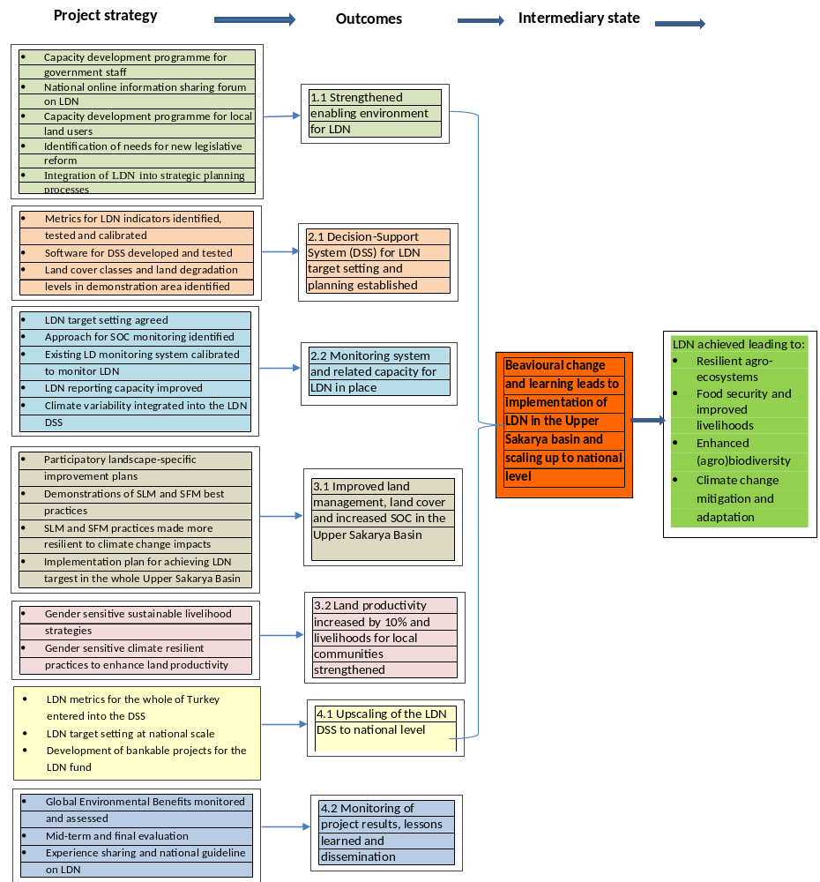

1.3.2 Project objectives, outcomes and outputs
The project objective is to develop a model for LDN target setting, planning, and decision-making at national level and for demonstration in the Upper Sakarya basin. It will be achieved through four components with related outcomes and ouputs:
Component 1: Strengthening the enabling environment for LDN
A capacity development program will be put in place on LDN target setting for local and central government staff. The project will seek to develop capacity both at the institutional (central and local government) and grassroots level. At the local level, the project will focus on communities and government institutions within the Sakarya basin, but keeping in mind the underlying goal of the project to upscale its experience at the national level. To strengthen stakeholder engagement at all levels, an online national Information Sharing Forum on LDN will be created, which will help in the identification of needs for new legislation and/or revision of existing legislation to support implementation of the LDN approach based on the project’s experiences. Integration of LDN into strategic planning process will strengthen the enabling environment for LDN implementation first in the Sakarya basin, through support to scaling-up of the multi-sectoral planning process, before it is extended to the national level, but also to the regional level in Turkey’s cooperation with Central Asia on sustainable land management.
Outcome 1.1: Enhanced enabling environment for LDN
Although the awareness of institutions, organizations, scientific communities, NGOs, private sector and public on combating desertification and erosion, conserving forests, environment and natural resources, and sustainable land management is quite strong, the culture of collaboration is very weak. In recent years, only a few participatory integrated basin rehabilitation projects have been undertaken with the participation of institutions, organizations, NGOs and local people. Unfortunately, project effectiveness and sustainability following the completion of project implementations have not been sufficiently monitored. Indeed, political, legal framework and strategic approaches, monitoring systems, technological infrastructure, and technical capacity and NGOs activities are at a relatively high level in Turkey. However, it is necessary to develop policies, strategies and activities to determine solution-oriented targets for LDN by bringing all these capacities together to promote a multi-sectoral, multi-stakeholder, multi-component and participatory approach. With this approach, the capacities of stakeholders therefore need to be strengthened through a number of outputs and associated activities.

Output 1.1.1: Capacity building program in place on LDN target setting and its implementation for local and central government staff
Raising awareness about LDN; a, related to global process, international agreements and obligations arising from these agreements, development plans, strategic plans, actions, etc. will include:
- Organizing informative meetings for the central administrative and strategic planners of LDN-related institutions, for the administrative and planners of local institutions, stakeholders, private sector and NGOs in the Upper Sakarya Basin,
- Ensuring that institutions include the concept of LDN in the institutional training programmes,
- Creating public awareness through visual media,
- Organizing awareness-raising activities together with NGOs in the Upper Sakarya Basin, especially in micro-basins,
- In the 3rd year of the project, it is planned to organize “the First National LND Symposium” with a special session on the Upper Sakarya Basin LDN implementations in order to increase national awareness on LDN,
- In the 4th year of the project, it is also planned to hold “the 1st International LDN Symposium” to promote international awareness.

Output 1.1.2: Creation of a national online Information Sharing Forum on LDN for stakeholder engagement
An interactive National Online Information Sharing Forum on LDN managed by a team of moderators will be created to allow discussions on LDN-related opening headings among the stakeholders. The Forum platform will include LDN related topics, questions and answers, as well as project documents and progeny announcements. All stakeholders will have more information about the progress of the project and its outputs. In addition, stakeholders will contribute to the project with their participation and by transferring experiences they had during ongoing or completed LDN projects. The Forum will also have sections that can be accessed without being a member of the system. Membership will be stipulated only in sections where the added content must be followed.

Output 1.1.3: Capacity development program in place for farmers, herders and forest villages in the upper Sakarya Basin
Capacity development activities supported by the project will ensure the transition from traditional production methods of local people to modern and sustainable production methods and increase capacity to strengthen the economic and welfare level of local people.
In this context;
- The training of farmers will be supported by Farmer Field Schools (FFS). Farmers' education will be practical and combined with some theoretical information to increase the capacity of the local people more permanently and beneficially. The capacity target is to ensure that the producer is a specialist in his own fields, to improve production quality and to improve management skills. The training will be applied to the pre-determined producers in groups, taking into account groups of farmers who produce the same product.
- Group extension methods such as demonstrations, farmers' meetings, exhibitions and competitions, farmer courses, field days, etc. will be implemented,
- Mass media channels will be utilized in order to provide more effective farmer education and extension services,
- Training activities on different subjects including agricultural activities, livestock, beekeeping, greenhouse and irrigation management, collection and breeding of medical and aromatic plants, pasture management, certified shepherd education, crafts for women and young people, etc. will be given,
- Farmers will be informed about credits, promotions and government support.

Output 1.1.4: Identification of needs for new legislation and/or revisions of existing legislation based on project findings and targeted stakeholder consultations
As could be seen in the background section, Turkey has adopted a number of development and strategic plans to support sustainable land use, including plans addressing climate change, drought, desertification, land degradation, rural poverty, gender equality, etc. However, it is necessary to integrate the LDN concept and its priorities and adopt a more holistic approach that is multi-sectoral with multi-stakeholder participation. The project will support this starting with a more thorough gap analysis, building on the PPG work already done, followed by consultations with concerned sectors and stakeholders. New and/or revised legislation that operationalises the LDN approach will be drafted.

Output 1.1.5: Integration of the LDN approach and priorities into strategic planning processes at sub-national and national levels
To raise awareness of LDN and to provide a participatory understanding in determining the LDN country targets, the LDN Working Group, in which all related institutions are represented, has been established within the CEM. The project will support the working group activities as follows:
- Workshops of the LDN Working Group will be held at least once a year including project work in the Upper Sakarya Basin,
- At local level, the most intensive participation of institutions and local people will be ensured in planning and decision-making processes,
- It will be ensured that NGOs take an active role in the project, especially in public awareness activities. For this purpose, participation of NGOs will be ensured in the relevant meetings, workshops and planning stages,
- Private sector information visits will be organized by expert teams.

Component 2: Decision-Support System (DSS) for LDN
A Decision Support System (DSS) will be developed to prevent land degradation and ensure that the country achieves the LDN targets in the Project. In the system, the Watershed Monitoring and Evaluation System (WMES), the Dynamic Erosion Monitoring System (DEMIS), Land Information System, Identification of Potential Reforestation Area Model (POS), Turkey Desertification Model (TCM), Soil Organic Carbon Model (TOK), Collect Earth for Land Productivity (all currently present at the General Directorate of CEM), and the National Land Use Land Cover (UASIS) Model will be utilized.
Outcome 2.1: Decision-support system for LDN target-setting and planning established
The DSS and the existing monitoring systems that provide sub-system data for the development of this system need land validation and calibration studies. Part of the work to be done for this purpose will be carried out in the Upper Sakarya Basin. The monitoring capacity of the institutions will be strengthened by undertaking the training of technical personnel working in these activities at the same time.

Output 2.1.1: Metrics for LDN indicators (land cover, carbon stocks, and land productivity) identified, tested and calibrated
For land cover, the following hierarchical classification is recommended as the reference for Land Degradation Neutrality. Level 1 is based on the IPCC land categories (IPPC, 2006) . Level 2 is based on the land cover classification used by the Environmental and Economic Accounts System (SEEA) of FAO LCML (United Nations, 2014). Countries should use this hierarchical classification as the reference and consistent with the amount of information available describe each category of land cover (Retiere et al., 2015; UNCCD, 2016). To follow changes in the LULC occurring over time in the study area, Lansdat, Spot and Sentinel satellite images covering the 18-year period between 2000 and 2018 will be used with the controlled classification technique given in Table 3.

Table 3. Land use and land cover classes (Retiere et al., 2015; UNCCD, 2016).
Code | Level 1 | Level 2
1 | Forest land | Forest tree cover
2 | Pasture land | Pasture and natural meadows, shrubs, shrubberies, shrubs, sparse plant areas, natural vegetation communities and mosaics
3 | Cultivated land | Medium and large herbaceous crop fields in rainfed agriculture, medium and large herbaceous crop fields in irrigated agriculture, permanent crops, agricultural plantations, agricultural products communities and mosaics
4 | Water surfaces and wetlands | Open wetlands, terrestrial wetlands, coastal lagoons, water bodies, sea
5 | Artificial areas | City and urban areas, mining areas
6 | Other land types | Marginal areas, stony lands, permanent snow and glaciers

Landsat, Spot and Sentinel satellite images will be used to determine the 15 year NDVI between 2000 and 2015 for the Upper Sakarya basin, which will form the basis for the land productivity assessment. Land productivity data will be determined using land cover classes (Table 4) to calculate declines in productivity of forests, pastures and grasslands or agricultural land.

Table 4. Classes of Land Productivity Dynamics (Retiere et al., 2015).

Class | Definition
1 | Decline in land productivity
2 | Land productivity starting to show a tendency to decrease
3 | Productivity is static, but there is the possibility of pressure and damage
4 | Productivity is static, but there is no possibility of pressure and damage
5 | Increase in land productivity

A soil organic carbon map is being prepared by the Ministry of Agriculture and Forestry General Directorate of Combating Desertification and Soil Erosion in cooperation with the TUBITAK. In this context, approximately 20,000 soil samples at the country level were used and Turkey's soil organic carbon basic map was created (Figure 3). The first version of the soil organic carbon (TOC) distribution map of the Sakarya Basin is provided in Figure 4. In addition to the current SOC map of the Basin, the SOC monitoring system, which will be completed in June 2018, will also be utilized.

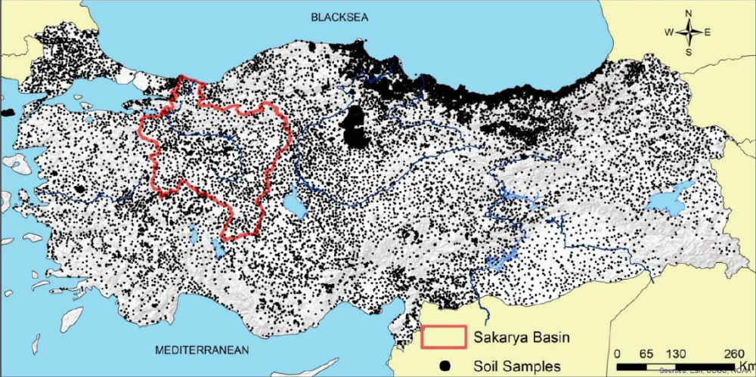
Figure 4. Distribution map of soil samples used to produce the Soil Organic Carbon Map of Turkey.

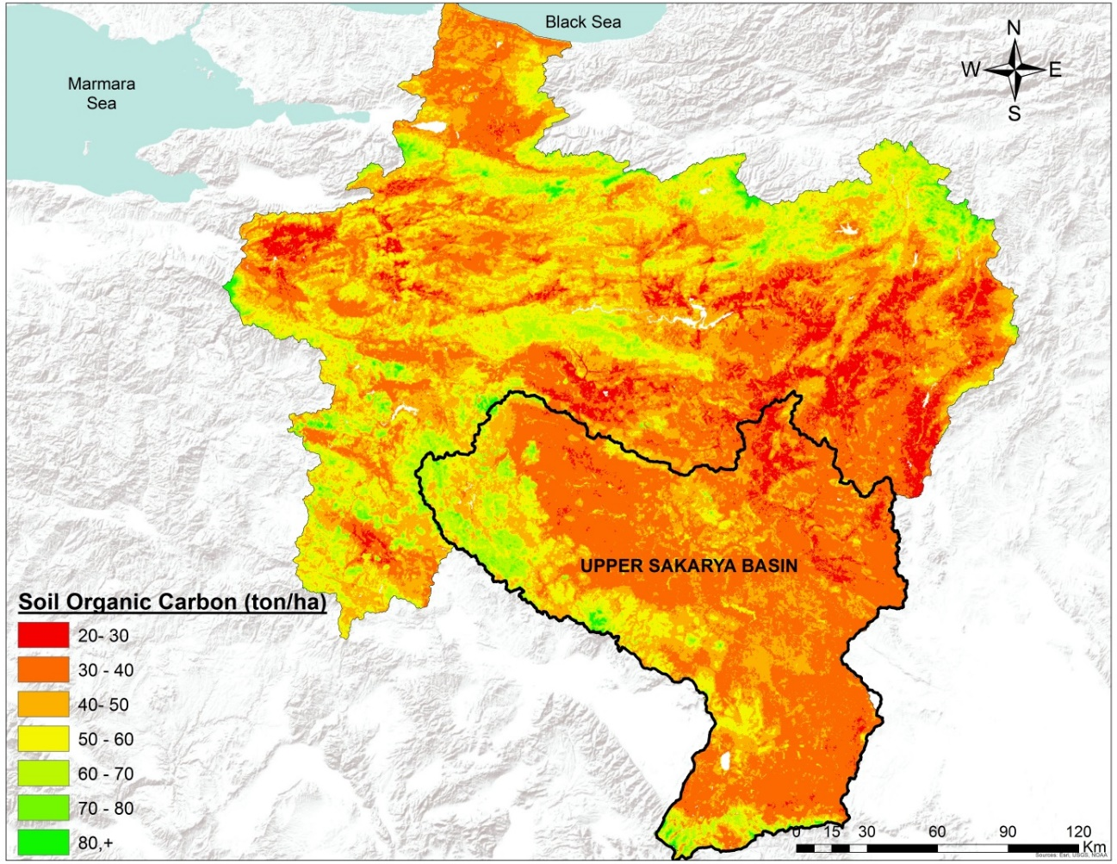
Figure 5. Soil organic carbon (SOC) distribution map of the Sakarya basin (KARBON Model of Turkey, version 1).

Output 2.1.2: DSS integrated and tested
The design of the DSS includes calibrating the three LDN indicators and their metrics (i.e. land cover, land productivity and SOC). These indicators will be provided by integrating existing DSS systems (Table 5).

Table 5. Software for the DSS.
Software for DDS | Period | Operation
National/Land Cover and Land Use Monitoring System (UASİS) | 2018-2022 | Not tested
National/Soil Organic Carbon Monitoring Model of Turkey | 2018-2022 | Tested
National/ Watershed Monitoring and Evaluation System (HIDS) | 2015-2018 | Tested
National/Assessment of Potential Forest Land Model (POS) | 2013-2014 | Tested
National/ Collect -Earth | 2015-2017 | Tested
National/Dynamic Erosion Model and Monitoring System (DEMİS) | 2016-2018 | Tested
National/Wind Monitoring System | 2015-2017 | Tested

This mechanism will also consider existing environmental, social data and global environmental benefits such as soil productivity when analyzing the balance between land cover, soil organic carbon and land use efficiency. In the context of the LDN concept, the mechanism to be developed will not be used as a tool only to assess land degradation in the field in some areas to balance these losses in other areas. Instead, the mechanism will be designed as a forward-looking process to integrate and coordinate activities for the prevention and reduction of land degradation, the remediation of partially degraded land, and the rehabilitation of desertified land.

Output 2.1.3: Land cover classes and land degradation levels in demonstration areas in the Upper Sakarya Basin identified
Land cover classes for the Upper Sakarya Basin are provided below (Table 6) and will be verified in the field. In addition, land degradation levels will be determined for the basin using the metrics and models discussed above.

Table 6. Land cover classes for the Upper Sakarya Basin.

Land Cover Classes | ha | %
Artificial Area | 29281.5 | 1.4
Agricultural areas | 1323930 | 62.2
Forest | 102246.3 | 4.8
Pasture | 650198.3 | 30.6
Water surfaces and wetlands | 13531.86 | 0.6
Other land types | 7947.72 | 0.4
Total | 2127136 | 100.0

Outcome 2.2: Monitoring system and related capacity for LDN in place
Many approaches or models from the plot to the local scale or from the regional to the national scale have been tried and for determining changes to land resources (positive or negative) against direct or indirect effects caused by human activity. One of the most recent approach is the "Land Productivity Dynamics" approach. At 2015 COP 12 in Turkey, this approach was proposed for setting targets for Balancing Land Degradation as an important step in the achievement of these goals. Integration with decision support systems is also possible. Thus, based on the functioning of the terrestrial ecosystem, in particular, biomass change, it is possible to present the land degradation situation correctly and quickly to the decision makers by using the metrics and monitoring systems provided by advanced technologies, such as geographical information systems and remote sensing techniques as well as ground truthing. Determining land productivity dynamics either qualitatively or quantitatively helps to define gains and losses in the biomass within the area following changes in vegetation cover during a certain period. These indicators are also used as sub-indicators in the calculation of the indicator "Degraded Land Area to Total Land Area" used for measuring progress in achieving the Sustainable Development Goal (SDG) 15.3 target on Land Degradation Neutrality.

Output 2.2.1: LDN target setting based on current and existing monitoring infrastructure and metrics agreed
In addition to the land productivity classes to be obtained with the analysis of land productivity dynamics and soil organic carbon distribution maps, the results of the existing model studies including Land Information System, Potential Forest Areas (POS), the Desertification Model of Turkey (TCM), Turkey’s Soil Organic Carbon Map (SOC), Assessment of Land Productivity using Collector Earth, and the Monitoring National Land Use/Land Cover (UASIS) Project, carried out by the General Directorate of Combating Desertification and Erosion, the Ministry of Agriculture and Forestry, will be utilized. The existing land degradation programmes and relevant ongoing national and sub-national monitoring systems are given in Table 7.

Table 7. Existing land degradation monitoring systems in Turkey at national and sub-national level.
Monitoring system/platform | Period of operation | Indicators being measured | Metrics used
Watershed Monitoring and Evaluation System (HIDS) | 2015-2018 | - Desertification and Land Degradation Risk | Categorical classification
Land Cover and Land Use Monitoring System (UASİS) | 2018-2022 | - Land use changes  - NDVI  - NPP  - LPD | ha and %  ha and %  kcal. m⁻² year ⁻¹  kcal. m⁻² year ⁻¹
Soil Organic Carbon Monitoring Model of Turkey (TOK) | 2018-2022 | - Organic Carbon Stocks | ton ha⁻¹
Assessment of Potential Forest Land Model (POS) | 2013-2014 | - Suitable sites for afforestation  - Suitable sites for forest rehabilitation  - Suitable sites for erosion control  - Suitable sites for rangeland rehabilitation | ha
Collect -Earth | 2015-2017 | - Land use land cover  - NDVI  - LPD | ha
Dynamic Erosion Model and Monitoring System (DEMİS) | 2016-2018 | - Soil loss | ton ha⁻¹ year⁻¹
Wind Monitoring System | 2015-2017 | - Sediment yield | ton ha⁻¹ year⁻¹

At the first step of the study, human pressures and changes of land use and land cover and different spatial and temporal processes in the Sakarya Basin will be revealed. Hot spots and cold spots for the gains and losses in land productivity dynamics caused by these changes will also be identified (Figure 6).

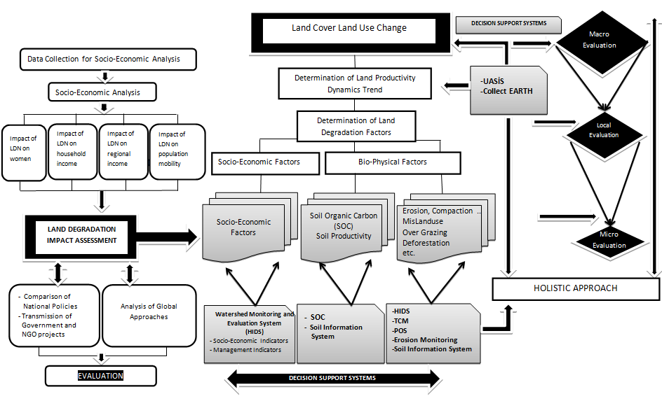
Figure 6. Flow diagram of the work stages.

As can be seen from the flow diagram in Fig. 6, the study has two main components; socio-economic and bio-physical analyzes. In the first stage, the LULC changes in large areas will be determined using satellite images over 10 or 15-year periods at macro scale. Since the effect of LULC on biomass will be determined, the NDVI and NPP changes will also be analyzed for monitoring the spatial trend of Land Productivity Dynamics (LPD) during the same period. The Collect Earth Model and the UASIS (National Land Cover /Land Use Classification and Monitoring System) Model will be used in determining LULC, NDI and NPP as well as upscaling of the results at national scale. Soil organic carbon will be determined using the TOK Model (Soil Organic Carbon Model of Turkey) for analyzing the spatial distributions of the LPD classes and the processes causing land degradation. In addition to the TOK Model, land degradation will also be supported by other DSS models such as TÇM, POS and Erosion Information Systems. At the same time, socio-economic analysis of land degradation will be carried out at micro-scale for integration with socio-economic and management criteria important for the HIDS Model.

The objective is to examine land cover and land use change, land productivity dynamics and erosion-organic carbon relations for 10-15-year periods to scale to the macro level (basin-based) problems. Thus, temporal and spatial changes between the years 2000 and 2018 will be introduced for the study area within the logic of the integrated basin study. In this project, the trend in land productivity dynamics due to biomass gains and losses in forest and pasture lands as well as the negative productivity trend in agricultural land because of misuse of agricultural lands will be determined. In addition, suggestions for reversing these adverse events will be presented.

Output 2.2.2: Effective and economic approach for soil organic carbon monitoring identified and disseminated
The Soil Organic Carbon Monitoring Model and Mapping Project of Turkey will serve for determining and monitoring soil organic carbon. A strong cooperation among the related Government institutions, universities and the TUBITAK has already been provided for this extensive and intensive study. So, the tested and validated Soil Organic Carbon Monitoring Model of Turkey (KARBON Model) will effectively and economically be used in the Upper Sakarya Basin for soil organic-C monitoring and scaling purposes. In this concept, after generating the Land Productivity Dynamics (LPD) Map, the SOC and the LPD (particularly for first three classes of LPD; Decline Productivity, Early-Sings of Decline and Stable but Stressed) will be combined to determine hot spot areas in terms of degradation. Therefore, it will take some measurements to save or to increase SOC by applying SOC managements systems under the best SLM and SFM practices.

Output 2.2.3: Turkey’s existing land degradation monitoring system calibrated to monitor LDN indicators and for testing in the Upper Sakarya Basin
Turkey’s existing Desertification-Land Degradation Monitoring System (TCM) will be calibrated in the field, applying a system analysis. The validation and calibration studies of the TCM Model have been ongoing in different basins in all over Turkey since 2015. The calibrated TCM Model, which addresses land degradation degree because of changes in land use/land cover, socio-economic structure and land management systems as well as changes in climate, soil and topographical features and water characteristics within the basin, will be tested in the Upper Sakarya Basin and be used to monitor LDN indicators. The National Land Cover/Land Use Classification and Monitoring System (UASIS) and the Turkey’s Soil Organic Carbon Monitoring Model will also be tested and calibrated in the Upper Sakarya Basin for monitoring LDN indicators. The results of TCM and the LPD will be compared on area base.

Output 2.2.4: LDN-related reporting capacity improved
The implementation of the Land Degradation Neutrality (LDN) process into the National Strategic Plans for Combating Desertification was targeted with the Ankara Initiative in 2015. In this context, the National Report on the Land Degradation Neutrality in Turkey (2016-2030) was prepared by the General Directorate of Combating Desertification and Erosion (CEM) in 2016. The national data on LDN indicators (soil organic carbon, net primary production and land use change) as well as the national targets and concrete measures to reduce/neutralize land degradation are well-described in this report. It is expected that all stakeholders (institutions/organizations and NGOs) report the actions and activities related to LDN every year. Moreover, a web-based Monitoring, Evaluation and Reporting (IDR) System (http://cmusep.cem.gov.tr) was developed for effectively collecting and reporting the regular activities of all the institutions and organizations involved in the National Strategy and the Action Plan for Combating Desertification (including LDN) by CEM. So, the IDR System will actively be used as a tool in LDN-related capacity building. Capacity building activities and training programs for decision-makers and technical staff and training and cooperation programs for NGOs and private sector on LDN approach and the actions on measuring and reporting LDN indicators will be established.

Output 2.2.5: Climate variability integrated into the LDN DSS and tested in the Upper Sakarya Basin
Impacts of climate change will alter land cover and soil organic carbon and hence affect LDN. The climatic indicator of the Desertification-Land Degradation Model of Turkey is capable to analyze climate variability effects on LDN. All sub-indicators of the climate indicator of the model; UNEP-UNCCD Aridity Index, Potential Evapotranspiration and Average Climatological Water Availability, Precipitation (Annual Average, Precipitation Type), Drought (Standardized Precipitation Index, Palmer Drought Severity Index), Rainfall Variability (Inter-Annual Rainfall Variability, Rainfall Seasonality Index, Precipitation Intensity) , Aridity and Precipitation Trends, Inter-Annual Air Temperature Variability, Mean Annual Air Temperature, Conrad’s Continentality Index, and Wind (Annual Mean Wind Speed, Annual Number of Windy Days) will be monitored, tested and analyzed in the Upper Sakarya Basin, and will be integrated with the LDN Model. On the other hand, the Soil Organic Carbon Monitoring Model also allows for simulations with changed air temperature. Thus, integration with the SOC model and the LDN model is possible. In addition, the UASIS model will be prepared in half artificial intelligence system using high resolution remote sensing images to determine land cover classes with high accuracy based on climate change scenarios or artificial effects which will influence directly LDN.

Component 3: Demonstration of the LDN approach in the Upper Sakarya Basin
The SLM and SFM practices will be carried out with intersectoral coordination and basin-based, integrated and participatory planning. In planning and implementation, new knowledge, findings and techniques for example innovations in agriculture, advanced livestock techniques and conservation tillage practices and others that will help raise the income and welfare of the people in the basin and sustain a healthy environment in the long run will be introduced and demonstrated. Basin-based mixed production systems will be used for preventing, balancing and improving land degradation. In the mixed production systems, agriculture, forestry and stockbreeding are carried out in the same area or side by side, to generate benefits from the land and increase the income level. More efficient/profitable methods will be used in the project and applications taking into consideration benefit cost analyses in a multi-objective, participatory and integrated approach.

Outcome 3.1: Improved land management, land cover, and increased soil organic carbon in the Upper Sakarya Basin.
Participatory land-use planning coupled with demonstrations of SLM and SFM will lay the foundation for future balancing of gains and losses and the increase in productivity and income.

Output 3.1.1: Participatory landscape-specific improvement plans based on priorities identified by the DSS covering 4,313,827 ha of land
For sustainable use of 4.313.827 ha of land, land use planning and land evaluation system will be developed (FAO, 1978 and 1993) by taking into consideration of bio-physical factors which will come from Turkey’s desertification model and the LDN’s indicators and socio-economic factors. Integrated watershed planning will continue with local demand-based, top-down and participatory approach. The LDN will be integrated into existing land-use planning in the project area. Sustainable land management and sustainable forest management practices for avoiding or reducing land degradation in normal land as well as rehabilitation/restoration works for reversing land degradation in degraded land will be set with the area-based approach. Thus, these activities will be expanded with the increase of income of the people living in the region due to increases in forests, pastureland and agricultural productivity.

Within the context of the application of the LDN approach in the Upper Sakarya Basin; firstly existent conditions, hot-spot areas for LDN, and high risk areas in future will be determined. Participatory land use plans and special development plans will be prepared based on the priorities determined by the Decision Support Systems. All these plans will be developed in a participatory manner in the selected microbasins. Including communities in planning of afforestation activities is importance since the lack of participatory land-use planning especially for afforestation interventions increases the pressure on pastures and limits livestock husbandary to a significant extent. The LDN approach will be integrated into the land use plans and special development plans to be adapted to the selected microbasins and also to the Upper Sakarya Basin by taking advantage of the national knowledge and acquisitions that we have on the Basin Rehabilitation Projects. The plan covers sub-plans for many sectors (forest land, pasture land, agricultural land, water and energy). These sub-plans, which have an impact on improving both natural resources and rural livelihoods, will be integrated to each other. Microbasin planning will be both application and monitoring participants. For this purpose, a participatory tool called Pro-Det-Sol (Problems-Detections-Solutions) will be utilized. During the planning process, focus group discussions and community consultations will be held when needed. The Microbasin Plans will be prepared by the Micro-Basin Planning Team (MHPEs), multidisciplinary service providers.

Output 3.1.2: Demonstrations of SLM and SFM best practices in forests, rangelands and croplands that provide carbon benefits on 14,000 ha of land
The project will include all of the best implementation methods and tools that Turkey has ever implemented. It will generate new and innovative approaches on forestland rehabilitation, best agricultural practices, fertilizer management, efficient and effective use of water, prevention of water and soil pollution, climate change adaptation and drought management to multi-sector land use planning based on testing and implementation in the Upper Sakarya Basin.

The following approaches and techniques will be implemented:
Sustainable land management:
Fertilization; as a result of soil laboratory analysis, the most economical fertilization programs can be given to farmers by agricultural expertise.
Mulching; leaving plant residues or organic materials on the soil surface and/or mixing with the soil will help to improve soil fertility and soil structural development, and most importantly to soil reduce moisture losses.
Contour farming; soil losses can be reduced by making tillage, sowing and planting processes perpendicular to the terrain slope.
Minimum soil tillage; limiting the number of cultivation and tillage equipments used without leading damages to soil and plant growth is an important management practice in the context of soil protection.
Zero tillage; zero tillage or no tillage is important tillage practice for energy saving soil surface protection.
Strip farming; strip farming systems are one of the most effective soil and water conservation methods in sloping land.
Terracing; terraces are the most effective structures used with the aim of cultivating agricultural crops by controlling the surface flow in sloping areas.
Crop Rotation; crop rotation improves soil quality and provides nutrient balance.

Sustainable pasture management:
Grazing pasture with a suitable number of cattle depending on grazing capacity; grazing capacity shows the maximum number of animals that can graze in the pasture without sacrificing soil and vegetation cover in a pasture season.
Rotational grazing; by rotational grazing, the continuity of the pasture plants that are exhausted, weakened or lost their growth power is ensured.
Adapting grazing period; in the spring, grazing should be started when important plants have reached the grazing stage and soil is dry.

Improving pasture productivity:
Weed control; weeds, poisonous plants and shrubs that appear can be removed mechanically and chemically, without causing erosion.
Insemination; artificial insemination is an effective technique in pasture rehabilitation if pasture cannot be rehabilitated only by arranging grazing.
Fertilization; fertilization of pastures and grassland is one of the best breeding methods.
Terracing; terraces may be needed to prevent erosion and flooding in degraded and severely eroded pastures where it is not possible to develop vegetation in a short time.
Pits; it is a process of opening pits in a certain shape and frequency on the soil surface in order to prevent surface flow and to keep more of rain water in the soil.
Gully prevention; gullies not exceeding 30 cm in depth can be avoided by terracing or constructing stone walls.
F

In addition, the following applications may help in grazing:
- Drinking water can be provided to the animals at a clean and convenient distance,
- Water wells can be opened for animal water needs in areas where surface waters are not available or where water is very scarce,
- Surface water (runoff) can be collected for animals by installing ponds or using other water harvesting techniques,
- Open or closed cages can be constructed for the protection of animals,
- Shadows can be constructed in warm regions to relax and warm up animals,
- Salt and feed in a regular manner can be provided for pasture animals,
- Sheep bathing can be done at appropriate places to clean the cows and to wash the wools before they are cut,
- Itching stakes can be set to relax animals from different insects,
- The electricity demands of farmers in yayla can be reduced by installing a spring solar energy panel in order to keep the farmers longer in pastures,
- Pasture roads can be constructed for transporting animals to and from the pasture.

Best SFM Applications in Forest Areas
Reforestation, rehabilitation and erosion control methods that can be applied to the balance of land degradation and for sustainable forest management in degraded forest areas, in open forests and off-forest areas;

Afforestation
Afforestation studies are planned for:
- Production,
- Soil Conservation and Hydrology,
- Aesthetic and recreational purposes,
- Rehabilitation and
- Soil stabilization

After planting, maintenance activities should be carried out for the success of afforestation. In this context, processes such as weeding, chopping, shoot control and terrace repair can be carried out according to the region's own climate characteristics, vegetation and soil characteristics.

Erosion Control
- Terraces can be built for controlling surface erosion in afforestation sites,
- Drainage ditches and channels can be opened to control mass movements and surface flows in wet rotten slopes,
- Line weed planting can be done in the improvement of well-grounded rotten slopes where the slope is very steep and surface transportation is not much,
- Bush fencing can be made to prevent soil movements,
- Geosynthetic fences may be placed in rows parallel to the leveling curves in sloping slopes,
- Cage wire terraces can be constructed perpendicular to the axis of the streams,

Rehabilitation of Degraded Forests
- Oak, juniper and cedar trees can be preserved within the basin
- In large spaces where there is sufficient amount of soil, cut terraces and moon terraces can be built using excavators and seedlings with suitable species and tubular seedlings can be planted (Income-generating species will be selected to provide economic contribution to the local people.).

Output 3.1.3: Measures and approaches for reducing the impacts of climate variability integrated into SLM and SFM practices

Climate change is expected to negatively affect agriculture, pasture and forest production and to cause more serious land degradation problems. In order to mitigate climate variability, climate-friendly agricultural/forestry practices will be introduced in the Upper Sakarya Basin. Technical assistance to farmers on reduced tillage practices, direct seedling (no-till agriculture), organic farming, legume crop production, water use efficiency techniques and practices (drip irrigation, water harvesting, mulching), fertilizer management, resilient crops, agroforestry etc. will be provided. These practices and applications will help to reduce energy consumption and greenhouse gas emissions and to increase C-stocks in soil. Mitigation of climate change effect will be monitored on farm level. Comparisons of yields, organic-C and soil health and quality indicators in areas under climate-friendly agricultural activities, SLM and SFM practices with these of the control areas will be done. A country specific self-evaluation methodology for evaluating impact of climate variability on farmers can be developed and used in the Upper Sakarya Basin and also for upscaling to all over the Country. In this context a monitoring and evaluation tool called SHARP (Self-evaluation and Holistic Assessment of climate Resilience of farmers and Pastoralists), developed and tested in a number of countries in sub-Saharan Africa may also be used after modification.

Output 3.1.4: Preparation of an implementation plan for achieving LDN targets in the whole Upper Sakarya Basin
After determining hot and cold spot areas for each different land use and land cover area in the Upper Sakarya Basin by using the LPD map associated with the SOC, an implementation plan for achieving LDN targets will be prepared considering the most appropriate SLM and SFM practices for these areas, then it will be up scaled up for similar areas in all Sakarya Basin. In other words, participatory land-use planning will be extended to the whole Sakarya basin building on ongoing watershed management planning.

Outcome 3.2: Land productivity increased by 10% and livelihoods for local communities strengthened
Raising the quality of life and welfare of the people living in the Upper Sakarya basin to reduce the pressure on natural resources is to achieve sustainable land management using the LDN approach. Land degradation neutrality and rehabilitation activities will integrate the activities of improving the living and income conditions of low-income people, who are putting pressure on natural resources. For this reason, the project supports income generating activities that are climate-smart, gender sensitive and sustainable.

Output 3.2.1: Introduction of gender sensitive sustainable livelihood strategies
A gender action plan identifying roles, responsibilities and priorities of women will be developed based on preliminary finding from the PPG phase and a more thorough analysis of the socio-economic situation at the project sites (Figure 7). For example, women aged 40-50 are strongly demanding that entrepreneurship training be provided, while younger women want to be trained on handicrafts. Another priority is to improve truffle mushroom production. Sustainable income sources will be suggested to improve the living conditions of local people. This project is aiming to increase the incomes of women by using environmentally friendly traditional and new natural resource usage practices. Solutions will be proposed to provide alternative sources of income such as beekeeping, medicinal and aromatic plant breeding, mushroom farming, vegetable food products, animal food products and wool production as well as good agricultural practices. In addition, income generating practices that could reduce pressure on land resources targeting women will also be supported, such as support to women entrepreneurs, support to development and marketing of handicrafts, such as carpets.

Socio-economic analysis of LDN helps efficient use of natural resources as a source of livelihood by analyzing the interactions between LDN and income-population movements. In this context more attention will be given for increasing occupational capacity of farmer women, establishing NGO-based production unions for ensuring the effective and active organization of women in rural areas, and organizing agricultural cooperatives.

To make comparisons with degraded areas, a statistically significant number of households (secondary target group) living in non-degraded areas will be interviewed. Participation in the study will be entirely voluntary and interviews will be made using questionnaires and recording equipment.

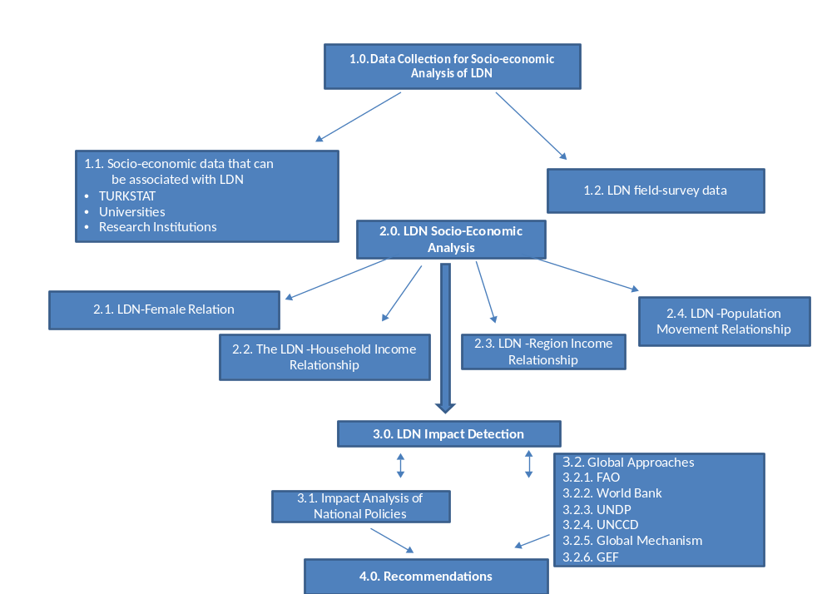

Figure 7. Methodological framework for socio-economic analysis of LDN.

Output 3.2.2: Introduction of gender-sensitive climate resilient practices to enhance land productivity
A number of SLM and SFM practices will be introduced in order to enhance land productivity. Based on the PPG field study, the following practices can both contribute to achieving LDN and to increase household incomes:

Constructing Agricultural Terraces
By terracing, average wheat grain yield can increase by 40-50% in farmer’s fields.

Support on certified fruit nursery , indoor garden facility and food processing for women
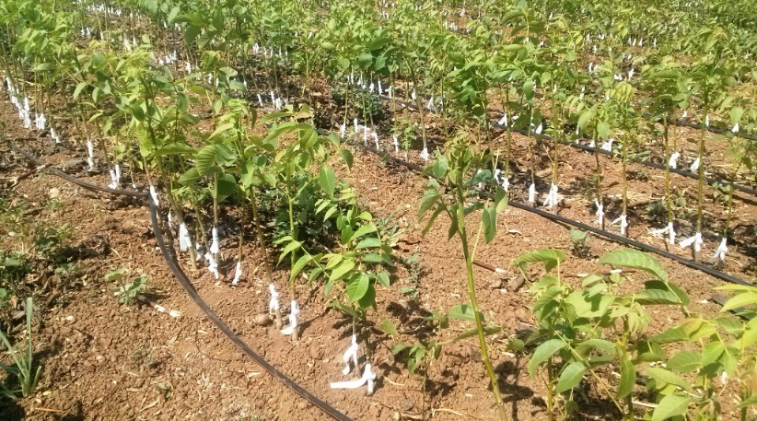
In order to spread and develop orchard activities, certified fruit nursery support will be provided to set up a fruit garden for the farmers in the Project area.
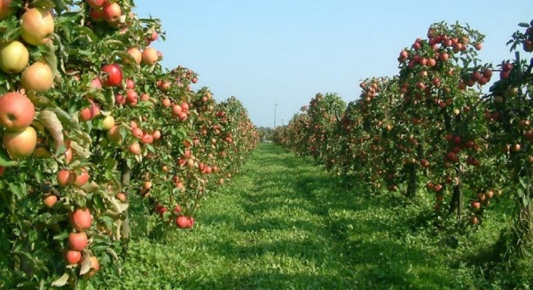

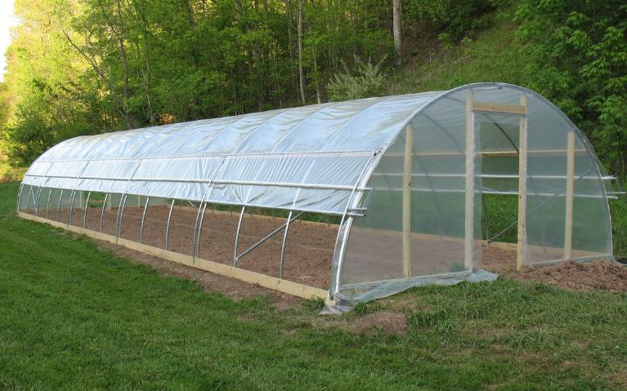
Constructing Greenhouses
Greenhouse support is provided for demonstration purposes in micro basins.

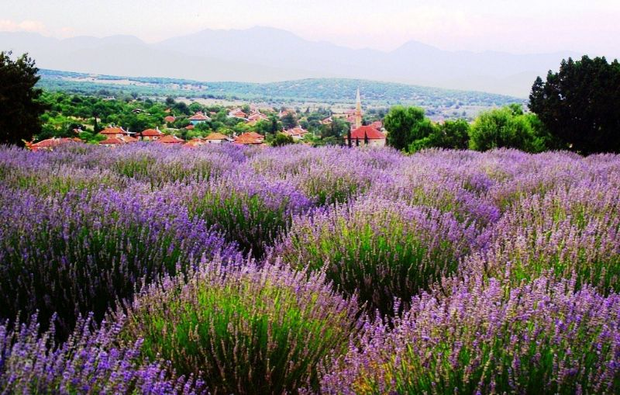
Medical and aromatic plant breeding
In the project, Medical and Aromatic Plants will be an alternative production model.

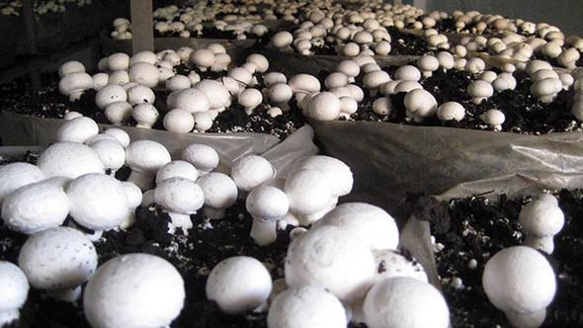

Mushroom farming
Sufficient technical information will be provided for the production of mushrooms and appropriate production environments will be established.

Soil analysis and fertilizer suggestions
In agricultural lands soil analysis will be performed and the most economical fertilization programs will be suggested to farmers by agricultural expertise.

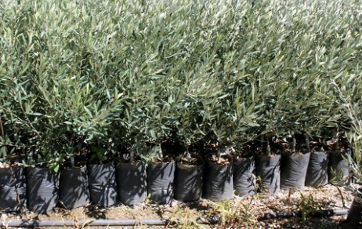
Support for nursery production
Small-scale nurseries for demonstration purposes will be established.

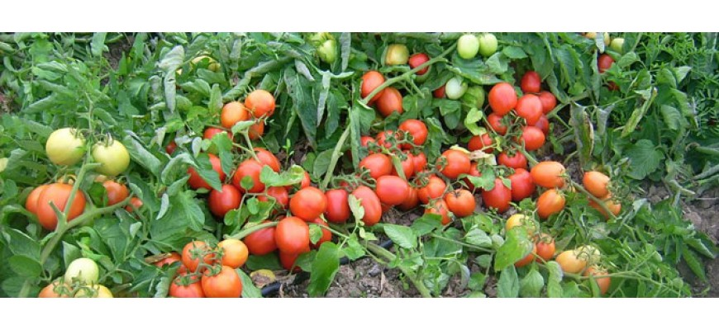
Development of vegetable production
Vegetable production suitable for the basin ecology can be developed to improve vegetable production and reduce costs in the Upper Sakarya Basin.

Development of feed crops production and forage seed support
Feed crops suitable for ecological conditions in the region will be promoted for cultivation. The project will support the production of forage seeds and feed plants.

Cattle and small animal support
The most important income sources for rural people are agriculture and animal husbandry. In order to increase the incomes of the villagers in the rural area, dairy cattle, milk sheep etc. livestock support will be given. In addition, support for livestock restoration and feed will also be provided.
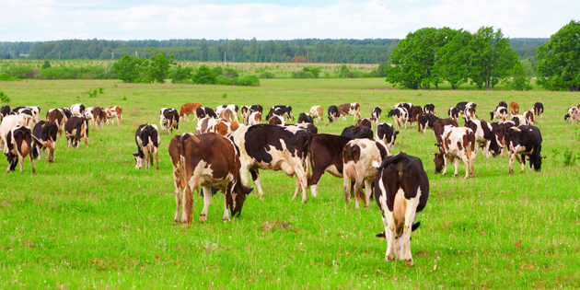
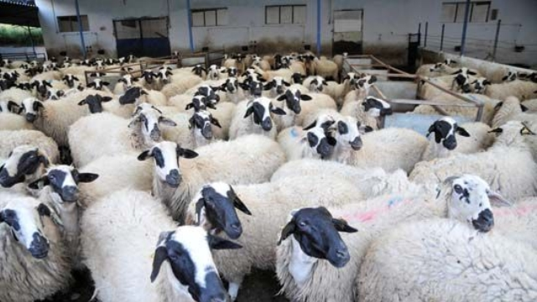

Beekeeping
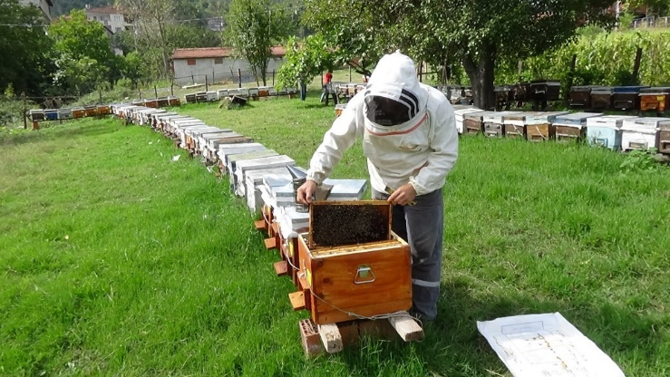
Beekeeping has become a significant progress sector in Turkey, often involving woemn as certified beekeepers. Within the scope of the project, the following will be provided:
- Beehive support with or without bees,
- Detection and installation of suitable bee locations,
- Electro shocked wire mesh support for controlling damages of wild animals,
- Establishing honey forest facility
- Beekeeping training.

Component 4: Upscaling of LDN experiences, monitoring and evaluation
The LDN monitoring system that is developed and calibrated based on the experiences from the Upper Sakarya basin will be upscaled to the nation as a whole. This is facilitated by the fact that it already builds on existing land degradation monitoring systems in Turkey, so if LDN can be determined at one site, it should be possible to do it at another using the same steps. In addition, this component will also establish a project monitoring system focused on monitoring of global environmental and socio-economic benefits generated by SLM and SFM. Lessons and experiences will be drawn from this monitoring to identify priorities for investments and bankable projects that will ensure that land degradation losses and balanced with gains from SLM and SFM interventions in similar land cover classes. This will also result in a national LDN guidelines with lessons learned.

Outcome 4.1: Upscaling of the LDN DSS to national level covering all of Turkey (78.4 million ha)
The LDN indicators (land cover-land use change, carbon stocks, and land productivity) obtained and tested at the selected micro-basins will be integrated into the existing land degradation programs and the relevant ongoing regional and national monitoring systems for upscaling. It is aimed to examine land cover-land use change, soil organic C and land productivity dynamic with 10-15 year periods (from 2000 to 2018) at the project area. The National Land Use/Land Cover (UASIS) Monitoring System will be used for upscaling of Land Use and Land Cover (LULC) changes, the Soil Organic Carbon Model (TOK) of Turkey for upsclaing organic C stocks and the Land Productivity Dynamics (LPD) approach for upsclaing land productivity.

Output 4.1.1: LDN metrics for the whole of Turkey entered into the LDN DSS and land cover classes and land degradation levels identified
Land cover classes for the whole of Turkey will be identified based on the 6 land cover classes recommended by the IPPC (2006) in Table 8 using the UASIS DSS. It will be produced from the NPP and NDVI using the same DDS. Then, it will generate classes of the LPD map. This can also be used to define soil organic C based bio-geographic regions and to estimate C stocks.

Table 8. Land categories for monitoring LDN.

Value | Categories | Short description
1 | Forest | Geographical areas dominated by natural tree plants with a cover of 15% or more  This class also includes;  - mosaic tree and shrub (>50%) / herbaceous cover  - seasonally or permanently flooded with fresh water
2 | Shrubs, grasslands, and sparsely vegetated area | Geographical areas dominated by;  - natural shrubs, or  - natural herbaceous plants, or  - sparse natural vegetation with a cover of 15% or less,  This class also include;  - mosaic natural vegetation (>50%) / crops  - mosaic herbaceous cover (>50%) / tree and shrub
3 | Cropland | Geographical areas dominated by;  - herbaceous crops; or  - woody crops; or  - mixed herbaceous and woody crops;  This class also include;  - mosaic crops (50%) / natural vegetation
4 | Wetlands and water bodies | Geographical areas dominated by;  - shrub or herbaceous vegetation, aquatic or regularly flooded, or  - mangroves or  - water bodies
5 | Artificial areas | Geographical areas dominated by artificial surfaces, including urban and associated areas (e.g. urban parks), transport infrastructures, industrial areas, burnt areas, waste deposits, extraction sites
6 | Bare land and other area | Geographical areas dominated by;  - bare areas or  - snow and glaciers

Output 4.1.2: LDN target setting and national scale in place
In the project it will be determined whether the LDN indicators (land cover-land use change, carbon stocks, and land productivity) used and tested in the micro-watershed scale can be effectively used for assessing and monitoring LDN. Alternative indicator(s) will be examined in this context, in particular socio-economic indicators that can be adapted to national scale.

Output 4.1.3: Development of bankable projects for the LDN fund (at least 1)
The extension of the monitoring of LDN at the national scale and lessons learned on how to balance gains and losses at the field level in the Upper Sakarya basin, will be used to identify priorities for investments and bankable projects that will ensure the land degradation losses are balanced with gains from SLM and SFM interventions in similar land cover classes. At least one such bankable project concept will be developed for consideration by the LDN fund with involvement by the private sector, such as NG Kutahya Ceramic, KÜMAŞ Mining, and ETİ biscuits
Outcome 4.2: Monitoring of project results and lessons learned disseminated
This outcome will contribute to the FAO and GEF portfolio monitoring in order to identify lessons learned and enable continuous learning from assessment of LDN and SLM and SFM demonstration activities on the ground in the Upper Sakarya basin. This will inform adaptive management and improvement of the LDN monitoring tools and methodologies as well as GEF’s SLM portfolio monitoring, and design and application of the GEF Land Degradation tracking tool.

Output 4.2.1: Global environmental benefits monitored and assessed
A project M&E system will be established to measure project progress and impacts in terms of multiple global environmental benefits (GEBs), and social and economic benefits. Baseline and targets for project indicators will be refined and used for monitoring project progress and impacts and reporting through 5 annual project reports (PIRS) submitted to GEF Secretariat and 12 half yearly project progress reports submitted by the PCU to the LTU and FAO/GEF unit.

Output 4.2.2: Mid-term and final evaluation conducted
A mid-term evaluation will be carried out with field visits to selected sites and consultation with local stakeholders and national project partners. A final evaluation will also be conducted and will include review of project reports, web-based information, and field visits to selected project sites, with recommendations for ensuring sustainability of Project outcomes and the LDN system.

Output 4.2.3: Experience sharing on project-related “lessons learned” and a national LDN guideline published
The project will prepare a communication and outreach plan, followed by knowledge and communication products in the area of SLM and SFM practices that can be applied to achieve LDN at sub-national and national level in Turkey. A national LDN guideline will also be published that describes how LDN should be measured at different scales and how gains and losses could be balanced from the micro-basin, basin, landscape and up to the national scale.

1.3.3 Project Stakeholders
The project will work with a wide array of stakeholders, from the local, national level to international level. The main stakeholders and their roles are summarized below.
The Ministry of Agriculture and Forestry (MAF)

The MAF is authorized in the fields of forest land as well as agricultural land and pasture land in terms of LDN.

The General Directorate of Combating Desertification and Erosion (CEM): CEM is the competent authority in terms of the coordination of land degradation issues in Turkey and it is also the focal point of the UNCCD. The basic tasks of the General Directorate of Combating Desertification and include monitoring of erosion, desertification and land degradation in Turkey, and integrating sustainable land management (SAY) practices into the national planning and management processes directly related to LDN. The National Strategy Document and Action Plan for Combating Desertification (2013-2023) was prepared by the General Directorate of CEM. In addition, "United Nations Guidelines for the Formation of Landscapes Resistant to Global Changes in Dry Areas" was prepared in close cooperation with the CEM, UNCCD, FAO and UNDP.
The General Directorate of Forestry (OGM): It is responsible for the management and the operation of the country's forests. The OGM, which has a very strong organization locally, carries out a lot of works in the field for preventing desertification/land degradation.
The General Directorate of State Hydraulic Works (DSI): The DSI is responsible for the planning, management, development and operation of national water resources. The DSI is one of the key institutions in the field of desertification/land degradation from the perspective of soil erosion, flood control, management of surface and ground waters.
The General Directorate of Water Management (SYMM): The SYMM is responsible for making policies and studies regarding the protection, improvement and utilization of water resources.
The General Directorate of Nature Conservation and National Parks (DKMP): The General Directorate of DKMP is an important institution for LDN with the task of managing and improving the protected areas in terms of rational and sustainability principles in order to ensure the preservation and continuity of biological diversity, and all natural-related resources.
The General Directorate of Meteorology (MGM): This organization provides meteorological support for many institutions and organizations, including agriculture and forestry.
The General Directorate of Crop Production (BÜGEM): Within the scope of combating desertification/land degradation, the BUGEM is responsible for developing and disseminating organic agriculture and good agricultural practices for agricultural basins, and for implementing activities related to water, soil, environment and climate change etc.
General Directorate of Agricultural Reform (TRGM): It plays an important role in desertification/land degradation with activities such as preparation of land use plans, protection of agricultural land, changes in land use and preparation of soil maps.
General Directorate of Agricultural Researches and Policies (TAGEM): This organization conducts studies on desertification, erosion, combating drought, salinity, protection and development of soil and water resources.

Ministry of Environment and Urbanism (CŞB):
The General Directorate of Spatial Planning (MPGM): It is very important that the MPGM is actively involved in combating to desertification/land degradation. This organization directs the upper-scale spatial planning system, provides planned development, and provides technical guidance to local administrations.
The General Directorate of Environmental Management (CYGM): It is the institution that prepares and coordinates the national environmental strategy and action plans.
General Directorate of Environmental Impact Assessment, Authorization and Auditing (CED): It conducts environmental impact assessment and strategic environmental assessment.

Local-level stakeholder will be engaged in the Upper Sakarya Basin, especially in Component 3 on Demonstration of the LDN approach. They will include:

Table 9. Project stakeholders in the Upper Sakarya basin.
 | Regional-Government Institutions
 | Regional Directorates of the Ministry of Agriculture and Forestry (MAF) | The Regional Directorates will be a member of the project implementation unit and will support the sharing of information and monitoring the success of the target.
 | The Regional Directorate of State Hydraulic Works (DSI) | DSI will be a member of the project implementation unit and will support the sharing of information and monitoring the success of the target.
 | The Regional Directorate of Forestry (OGM) | The OGM will obtain all necessary data during the planning and implementation of the project. As a member of the project implementation unit, the OGM will provide coordination and implementation of the project at the provincial level (including all project sites) and will support sharing of information and monitoring of target success.
 | Regional Directorate of Meteorology (MBM) | The MBM will provide all the climatic data required during the planning and implementation of the project. The MBM will be a member of the project implementation unit and will support the sharing of information and monitoring of the target success.
 | Provincial Government Agencies - Stakeholders
 | Provincial Directorates of the Ministry of Agriculture and Forestry (PDAs) | The PDAs as a member of the project implementation unit will support monitoring the impact and progress of the project in rural areas.
 | Provincial Directorates (Towns) of the Ministry of Agriculture and Forestry | These Government Agencies will be responsible for transferring information on conservation and sustainability of natural resources and cooperating with farmers, farmers' associations, universities and non-governmental organizations (NGOs).
 | Academic and Scientific Organizations
 | TÜBITAK |  |  | Cooperation in research management, financing and applications with the TUBITAK will be possible.
 | Universities |  |  | Coordination with relevant universities will be undertaken during the implementation of the project.
 | Water Institute of Turkey |  |  | Synergies will be established with this institution
 | Forest Soil and Ecology Research Institute |  |  | Synergies will be established with this institution
 | Forest Trees and Seed Breeding Research Institute |  |  | Synergies will be established with this institution
 | Soil, Fertilizer and Water Resources Central Research Institute |  |  | Synergies will be established with this institution
 | Non-Governmental Organizations (NGOs)
 | Farmers and animal producers |  |  | Hundreds of farmers and animal producers in the region will be included into the project. These farmers are in the most important category of stakeholders.
 | Irrigation Union Cooperatives |  |  | A strong relation will be established with the Irrigation Union Cooperatives in the region
 | Sofca Fishery Cooperative |  |  | A strong relation will be established with the Sofca Fishery Cooperative in the region
 | Agriculture Associations |  |  | A strong relation will be established with the Agriculture Associations in the region
Private Sector
NG Kütahya Ceramic |  |  | A strong relation will be established with the private sectors in the region
KÜMAŞ Mining |  |  | A strong relation will be established with the private sectors in the region
ETI Biscuits |  |  | A strong relation will be established with the private sectors in the region

Gender considerations
For the last 30 years in Turkey, although industrial development is advancing, agriculture, forestry, pasture and soil are still the basis of the socio-economic structure. In Anatolia in central Turkey, land is indispensable for women as it provides food security and it contributes to the family economy by selling agricultural products. However, when the statistical data are analyzed over time, it is revealed that women are to a large extent unpaid agricultural workers. In 2017, 79.9% of women were in the position of unpaid family workers. Among the OECD countries, Turkey is the country with the most unpaid female labor days - women spend 6.2 hours of unpaid labor, while 1.9 hours for men.
Poverty in Turkey is mainly an issue for those employed in the agricultural sector and live in rural areas. In Turkey, 52.9% of the poor lives in rural areas, while 47.1% live in urban areas. In addition, many women living in rural areas are faced with inequality in work opportunities and access to resources compared to those living in the city. This causes women in rural areas to become increasingly poverty stricken. The need for more women-focused training activities for women is clear. From 2007 to 2016, the share of women's employment declined by 2%, in agriculture, forestry and animal husbandry sector. Women are often employees rather than property owners in these areas. For example, in 2016 out of 2.26 million registered farmers in Turkey only 330,000 were women, which shows the inequality in women’s assets.
The decrease in the participation of women in rural and urban labor force not only affects economic income but also their social security. For example, FAO (2016) reported that in 2014 81.8% of women in rural areas did not have any social insurance coverage and 17.5% had no health assurance. The data reveal the necessity of plans and programs for women to join the labor force in the country. Turkey has prepared the Gender Equality National Action Plans (2008-2013; 2014-2018 action plan) and the Women's Employment Action Plan (2016-2018) for increasing the women employees to 41% and to resolve other employment problems.
The National Desertification Action Plan (2015-2023) which is Turkey's land degradation and desertification roadmap defined targets for combating of desertification/degradation, identifies land degradation related socioeconomic changes and effect on gender and society. In addition, the aim of implementing various awareness-raising activities, including women for the sustainable use of natural resources, shows that the action plan is in line with the LDN. In the 10-Year Development Plan (2014-2018) 40 of Turkey, the emphasis was given on the creation of income sources based on the empowerment of rural women and the encouragement of entrepreneurship to reduce the pressure on natural resources. These approaches will enable households to achieve food security by ensuring equitable sharing of natural resource use, proper use of resources and sustainable development, together with targets to improve women's economic position.
Building on the above-mentioned national commitments and targets, the project will engage women to participate in all project activities, including in data collection and analysis, policy development and education, awareness raising activities, as well as income generating activities targeting women. During implementation of the project, efforts will also be made to better inform women and to support interventions that will contribute to inclusion of women in governance of land and forest resources, allow access to, and support their involvement in, and management of all SLM and SFM actions. The activities of the project should result in an increase in household incomes, both through cost reductions and productivity increases, and should increase employment opportunities in rural areas for women. The promotion of FFS activities through group structures will enhance social development in participating rural communities. The project will seek to raise awareness of gender issues in participating ministries by including women in all activities following FAO gender guidelines, including demonstrations, trainings and other capacity building activities.
The project is thus fully in line with the goal of FAO’s Policy on Gender Equality to achieve equality between women and men in sustainable agricultural production and rural development for the elimination of hunger and poverty. Women should be enabled to participate equally with men as decision-makers in rural institutions and in shaping laws, policies and programmes; both sexes should have equal access to and control over decent employment and income, land and other productive resources, women and men should have equal access to goods and services for agricultural development and to markets, and women’s work burden should be reduced through improved technologies, services and infrastructure. Indicators to measure theses gendered benefits are included in the project design and the results framework and can be summarized as follows:
- Key gender benefits:
- Income: Income of women based on natural resources is very low. Therefore, it is planned to increase women’s income with the traditional forgotten professions and new professions to be introduced to women. In this context, traditional occupations such as beekeeping, home gardening, poultry farming, handicrafts, and new approaches such as mushroom production, undercover vegetable farming will be introduced.
- Commodity: As women's wealth decreases, their income depends on men. So, the one of the main targets of this project is organize training programs for increasing income of women. As the economic power increases, the ownership of the property will increase.
- Participation and Decision-Making: Administrative changes that encourage or even compulsory participation of women to local meetings be held in the region can be made.

- Gender specific activities and indicators:
- Increasing income: Women will be encouraged to work in environmentally friendly activities that reduce the pressure on natural resources and for increasing household income, such as medical aromatic plant breeding which does not need intensive labor and poultry farming. An overall increase in productivity of 10% will contribute to an equivalent increase in income.
- Making a profession: It is planned to support female producers' associations which can make new professions (mushroom production, nursery, etc.) and resurrection of old traditional professions (poultry, handcrafts etc.) for limiting degradation of natural resources and for selling the products they produce. 300 women will be targeted for this support.
- Training: Training will be provided to reduce the degradation of natural resources and to raise awareness. A special focus will be on training women entrepeneurs (300 women trained).
The preparation of a gender action plan was initiated in the PPG phase and will be completed during the first six months of project implementation.
LDN Gender Action Plan
To provide participation of women in the project within the scope of LDN and for the success of land degradation prevention, mitigation and evaluation studies, the following will be completed
- Identifying women who are affected by land degradation in the project area (from survey and existing data).
- Determining the extent to which land degradation has led to for example, a decrease in income
- Measuring the effects of problems by identifying women's current working conditions, income sources, nutritional status, socio-cultural structures (questionnaire and existing data)
- Ensuring awareness of LDN, to determine the number of women (willingness) to participate in the actions to be made for LDN (questionnaires and interviews)
  - Giving education in-place: Describing LDN with socio-economic analysis, to provide efficient use of natural resources as a source of livelihood, increasing the occupational capacity of farmer women, NGO-based production unions to ensure the effective and active organization of women in rural areas, and trainings on organizing in the form of cooperatives.
  - Women champions to be sharing the experience of the projects, including best practices, with the wider public.
- Identifying ways to receive possible support for local government agencies (education, agriculture, forestry, etc.) by introducing women's issues in LDN.
- Creating income sources from LDN with the government, local governments and non-governmental organizations (agriculture and trade chambers; agricultural and trade chambers), and proposing alternatives, providing information on government grants, incentives and loans provided by the private sector etc. (natural resource use, good agricultural practices, handicrafts using local resources, medicinal and aromatic plants from forests, mushrooms, resins, etc., vegetable food products, animal food products, wool etc.) on the basis of applications with which they are most likely among survey.
1.3.4 Expected global environmental and adaptation benefits
As a result of implementation of the project, the following global environmental and socio-economic benefits will be generated:
- Increased spatial coverage of SLM and SFM practices in the wider landscape on 14 000 ha, including 5 000 ha on forest land, 5 000 ha on arable land and 4 000 ha on pasture;
- Increased area under landscape specific improvement plans: 4 313 827 ha;
- Improvement in the provision of ecosystem goods and services, including increase in productivity of 10-25% and reduction in soil erosion of 2-6 t/ha/y;
- LDN scheme at national level (covering 78.4 million ha of land).
The assessment of the global benefits of the project is based on the following data:
Name of demonst  ration site | Land Use/Land Class | Agroeco-logical zone | Demons-tration area (ha) | Tested SLM/SFM technology | Increase in produc-tivity (%) | Total C seq. by end of project (tCO2/ year) | Reduction in soil erosion (t/ha/y)
Kutahya | Cropland | Semi-arid | 500 | Soil surface management & Conservational soil tillage practices | 20 | 500 | 5
Eskisehir | Cropland | Semi-arid | 500 | Soil surface management & Conservational soil tillage practices | 20 | 500 | 5
Ankara | Cropland | Semi-arid | 1000 | Soil surface management & Conservational soil tillage practices | 20 | 1000 | 5
Kutahya | Cropland | Semi-arid | 500 | Fertility mng. & Crop rotation & Organic farming prac. | 30 | 500 | 3
Eskisehir | Cropland | Semi-arid | 500 | Fertility mng. & Crop rotation & Organic farming prac. | 30 | 500 | 3
Ankara | Cropland | Semi-arid | 500 | Fertility mng. & Crop rotation & Organic farming prac. | 30 | 500 | 3
Kutahya | Cropland | Semi-arid | 500 | Vegetable production& fruit nursery &greenhouses&medical and aromatic plants&forage crops | 25 | 500 | 2
Eskisehir | Cropland | Semi-arid | 500 | Vegetable production& fruit nursery &greenhouses&medical and aromatic plants&forage crops | 25 | 500 | 2
Ankara | Cropland | Semi-arid | 500 | Vegetable production& fruit nursery &greenhouses&medical and aromatic plants&forage crops | 25 | 500 | 2
Eskisehir | Pasture | Semi-arid | 1000 | Rotational grazing | 20 | 1500* | 5
Eskisehir | Pasture | Semi-arid | 1500 | Pasture rehabilitation | 30 | 3000 | 5
Eskisehir | Pasture | Semi-arid | 500 | Pasture facilities | 15 | 500 | 4
Kutahya | Pasture | Semi-arid | 500 | Pasture facilities | 15 | 500 | 4
Ankara | Pasture | Semi-arid | 500 | Pasture facilities | 15 | 500 | 4
Kütahya | Forest | Semi-arid | 1500 | Forest rehabilitation | 20 | 2250 | 2
Eskisehir | Forest | Semi-arid | 1000 | Forest rehabilitation | 20 | 1500 | 2
Ankara | Forest | Semi-arid | 500 | Forest rehabilitation | 20 | 750 | 2
Kütahya | Forest | Semi-arid | 500 | Afforestration | 30 | 1000 | 3
Eskisehir | Forest | Semi-arid | 300 | Afforestration | 30 | 600 | 3
Ankara | Forest | Semi-arid | 200 | Afforestration | 30 | 400 | 3
Kütahya | Forest | Semi-arid | 500 | Erosion control | 10 | 500 | 5
Eskisehir | Forest | Semi-arid | 300 | Erosion control | 10 | 300 | 5
Ankara | Forest | Semi-arid | 200 | Erosion control | 10 | 200 | 5
TOTAL |  |  | 14.000 ha |  |  | 74.000 tCO2/ 4 years
*: 1.5 metric ton CO₂ per hectare per year

1.4 LESSONS LEARNED
Key inputs derived from FAO’s experience from similar projects incorporated into project design include the following:
- The project should include a broad and diverse number of stakeholders with representatives of line ministries, the private sector and civil society, and when relevant, regional and international institutions;
- Flexibility should be integrated into project design to allow for changing conditions that may occur between the design phase and actual implementation;
- Projects supporting SLM and integrated natural resources management should adopt a holistic landscape and ecosystem-based approach and address the main barriers and associated economic and regulatory issues at the design stage;
- A phased approach to the testing and upscaling of new technologies is required (e.g. for SLM and SFM) to inform the formulation of relevant policies and legislation;
- Overly ambitious project design should be avoided and assumptions critically verified;
- The use of business models for sustained action beyond the project cycle;
- Given the significant differences between men and women involved in agricultural production and farming in terms of access to resources, knowledge and decision-making, a gender-sensitive approach that aims to mitigate historical inequalities is required in project design, implementation and M&E; and
- Participatory design of an agreement on specific M&E plan elements and indicators is advisable.

1.5 STRATEGIC ALIGNMENT

1.5.1 Consistency with national development goals and policies
With respect to GoT national development plans, the project will directly contribute to the Tenth Development Plan of Turkey (2014-2018) currently under implementation. The plan clearly prioritizes the Management of the Soil and Water Resources through “management systems” aiming at the sustainable use of water and soil. Action plans are the second level policy and implementation documents for national and regional context. The project’s promotion of integrated management of the country’s lands and other natural resources, including forests, rangelands and agricultural production landscapes, will significantly support this priority of the Development Plan. Moreover, the project will clearly support implementation of the GoT’s National Rural Development Plan (2009-2013), which targets the conservation of agricultural areas, pastures and forests, including soil and water resources in areas that will be integrated into forest regimes. The Rural Development Plan underscores the relationship between rural poverty and natural resource degradation, recognizing a significant increase in recent years in erosion and degradation of land and water resources in the country, in many cases due to improper farming techniques and increasing climate variability (droughts, floods and landslides). To mitigate these processes, the Plan gives priority to strategies, measures and activities that address desertification and promote proper management of land and water land resources. The agricultural and natural resources management practices included in the proposed project will directly contribute to the objectives and implementation of this Rural Development Plan.
1.5.2 Consistency with national communications and reports to the United Nations Convention to Combat Desertification, Convention on Biological Diversity, Stockholm Convention on POPs, United Nations Framework Convention on Climate Change (as applicable).
The proposed project is consistent with the various strategies, programs and action plans promulgated by the Government of Turkey (GoT) pursuant to its commitments under the relevant international environmental conventions, as well as with the relevant national development plans adopted by the GoT. With respect to the environmental conventions, i.e. the UN Convention to Combat Desertification (UNCCD), and the UN Framework Convention on Climate Change (UNFCCC), the proposed project is fully consistent with and will contribute significantly to implementation of the following strategies, programs and action plans:
The National Action Program on Combating Desertification (2006) calls for identifying the causes of desertification and specifying appropriate responses for addressing the problems caused. The proposed project will contribute specific responses to address a number of the causes of desertification identified in the National Action Program, including (i) mismanagement of agricultural lands and inappropriate agricultural practices; (ii) unplanned, uncontrolled over-grazing of rangelands and pastures; (iii) the lack of due regard for botanical, cultural and physical soil conservation measures; and (iv) soil degradation from wind and water erosion. Upon ratification of 10- Year Strategy of UNCCD, MAF has revised its approach through a strategy and NAP. The strategy and plan is targeting 2015-2023 period in a harmony with UNCCD 10-Year Strategy. It is a framework plan organizing and coordinating all relevant organizations’ approaches and plans regarding the desertification with a key emphasis on biodiversity and climate change mainstreaming
Pursuant to the UNFCCC, the GoT formulated its National Climate Change Strategy (2010), which specifically addresses land use, agriculture and forestry strategies in its chapter on greenhouse gas (GHG) emission control. The proposed project will support many of the short, medium and long-term strategies identified for mitigating GHG emissions (e.g. improved agricultural techniques, adoption of proven technologies for carbon sequestration and/or absorption in soil (and monitoring) and methane gas capture, afforestation and rehabilitation of degraded lands with drought tolerant species and plant varieties). Furthermore, the project addresses priorities identified in the GoT’s new Climate Change Action Plan 2011-2023 (2011), such as increasing the sink capacity of and decreasing GHG emissions from the agricultural sector, as well as increasing carbon sequestered in forests and reducing deforestation and forest damage. Determination of carbon capture potential is one of the major activities in the Action Plan and the project will support achievement of this priority. Furthermore, the project will directly address one of the cross-cutting issues requiring capacity development, namely sustainable land management, identified in Turkey’s National Capacity Self Assessment under Rio Conventions (2011).
1.5.3 Consistency with GEF focal area
In working towards its overall objectives, the project will contribute to achieving the GEF goals and targets for the Land Degradation focal area under the LD-3: Reduce pressures on natural resources by managing competing land uses in broader landscapes and its Program 4: Scaling up sustainable land management through the landscape approach. GEF support will be used to operationalise the LDN approach and to scale up policies, practices and incentives for balancing gains and losses related to SLM/SFM and land degradation in Turkey that generate environmental benefits. It will encourage a multi-sectoral planning process and participatory multi-stakeholder land use planning for scaling up innovative practices and approaches contributing to LDN and maintenance of long-term agroecosystem services.
1.5.4 Consistency with FAO’s Strategic Framework and Objectives
The Project is fully in line with FAO’s Strategic Objectives (SOs) that provide the overall direction, goals and targets for the organization until 2018, specifically: SO2: Increase and improve provision of goods and services from agriculture, forestry and fisheries in a sustainable manner; and SO5: Increase the resilience of livelihoods to threats and crises. The project is also consistent with FAO’s regional initiative 3 (RI3) on Sustainable use of natural resources, adaptation to climate change and disaster risk management, as well as FAO’s Country Programming Framework for Turkey 2016-2020. and will contribute to the following objectives/priorities of the organization:
FAO Strategic Objective/Organizational Result:
SO2: Increase and improve provision of goods and services from agriculture, forestry and fisheries in a sustainable manner
SO5: Increase the resilience of livelihoods to threats and crises
b. Regional Result/Priority Areas:
RI3: Sustainable use of natural resources, adaptation to climate change and disaster risk managemen
c. Country Programming Framework Outcome:
- Food and nutrition security and food safety – the project will contribute to the sustainable usage of agricultural and ecological resources
- Sustainable forest and natural resources management including fisheries – the project will contribute to sustainable use of natural resources and forests and to adapt and mitigate climate change impacts in the agricultural and forestry sectors
- Institutional capacity enhancement and of public and private sectors – the project will contribute to the strengthening of farmers’ organisations, development of training programmes for public institutions, and development of data and analytical systems for monitoring and more effective decision making.

SECTION 2 – FEASIBILITY

2.1 ENVIRONMENTAL IMPACT EVALUATION
The project is rated as a low risk project. An environmental and social assessment is presented in Appendix 5.

2.2 RISK MANAGEMENT
2.2.1 Risks and mitigation measures
A full risk analysis following FAO guidance with identification of mitigation actions is found in Appendix 4. A simplified risk analysis is found in Table 10 below.
Table 10. Risk analysis
Risk Type | Probability | Mitigation Measures
Lack of close and collaborative cooperation between many institutional stakeholders | High | Close and collaborative cooperation between many institutional stakeholders will be essential for the project to achieve its stated goal and objectives. This will be achieved through involvement of all stakeholders from the early beginning of the project, preparation of project document and through establishment of working group for the project implementation as well as the project steering committee. Promotional materials and communication strategy will be developed and, regular meetings and presentation of project results in different phases of the project implementation will be organised.
Unclear responsibilities of institutions at national and local level | Medium | Clearly defined and legally prescribed responsibilities of different institutions as well as involvement of all of responsible institutions are the main project goals. Moreover, the project will support improvement of institutional framework and through that ensure sustainability of the project results after its finalization.
Low technical capacity at national and local level | Medium | Capacity and technical expertise of stakeholders are weak. To mitigate this risk, the project will support a capacity building through development of program for trainings during the project, taking into account specific needs of stakeholders. It will also support a national Information Sharing Forum.
Natural disasters | Medium | Natural disasters, such as drought and floods, may impede the adoption of new technologies. The project is designed as a multi-year intervention, where demonstrations can be run over several seasons. The project will also be linked to the drought early warning services of the MAF.
Climate change | Low | The MAF, with support of FAO technical expertise, are in a good position to adopt new research results on how to enhance resilience of SLM and SFM practices to climate change and, when necessary, adapt local livelihood strategies, which is supported under output 2.2.1 of the project.

2.2.2 Analysis of fiduciary risks and mitigation measures (only for OPIM projects)
The fiduciary risks have been evaluated separately through a micro-assessment of the OP, a government entity. The following section provides a summary of the central results of the micro-assessment. The detailed assessment of fiduciary risks, which are overall rated as low and manageable, can be found in the Risk Mitigation and Assurance Plan, annex of OPA.
The National Executing Agency for this project is the Ministry of Agriculture and Forestry (MAF). Specifically, the General Directorate of Combating Desertification and Erosion Control of the Ministry of Agriculture and Forestry (CEM) will act as national coordinator institution of the project. MAF will set up a central Project Implementation Unit (PIU) and three Provincial Implementation Units, consisting of MAF staff and project funded staff. The central PIU’s work will be supported by provincial level PIUs officers in each of the project provinces. The PIU will be responsible for the day-to-day management of project implementation.
According to the results of the micro-assessment key findings on OP’s project execution capacity are;
- Programme management
Since the OP is a public entity, it operates within a heavily regulated framework and has adopted written policies and procedures on key processes and functions, which have been properly communicated to appropriate staff members. The OP uses sufficiently detailed written policies from the Ministry of Development for programme management; however, there is no guidance for project development or work plan templates for programme management.
The micro-assessment rates the risk in programme management as moderate.
Risk mitigation measures for the programme management;
FAO will organize a training for OP`s staff, responsible from the project financial reporting and other relevant staff, on the project financial management rules and reporting procedures.
FAO will provide continuous support to OP`s staff, responsible from the project financial reporting, to ensure they are aware of for any new procedures.
- Organisational structure and staffing
All CEM staff are public officers and subject to the state personnel law, consequently, sufficient controls and checks are made during the recruitment process of staff.
The micro-assessment rates the risk in organisational structure and staffing as low.
- Accounting policies and procedures
Since OP is as a public sector entity and operates in a heavily regulated framework, it has adopted written policies and procedures on key processes and functions, which have been properly communicated to appropriate staff members.
Accounting policies for all public sector entities are set out by the Ministry of Finance.
The OP uses a computerized accounting system which allows for the proper recording of financial transactions from United Nations agencies.
The micro-assessment rates the risk in accounting policies and procedures as low.
- Financial reporting and monitoring
OP regularly prepares financial reports for review by the Ministry of Development and Turkish Court of Accounts that conducts annual financial audits of government entities in Turkey, including OP. The accounting department and strategy department controls are also involved in this process.
No significant recommendations have been made by auditors in the prior five audit reports. Nor have there been any major issues relating to ineligible expenditure by the OP.
The computerized financial management system used by the OP is capable of producing the necessary financial reports.
The micro-assessment rates the risk in Financial reporting and monitoring as low.
Risk mitigation measures for OPIM modality;
FAO will organize a training for OP`s staff, responsible from the project financial reporting and other relevant staff, on the project financial management rules and reporting procedures.
FAO will provide continuous support to OP`s staff, responsible from the project financial reporting, to ensure they are aware of for any new procedures.
The monitoring and evaluation activities will be key instrument to increase project efficiency especially in OPIM.
The monitoring and evaluation of progress in achieving the results and objectives of the project will be based on targets and indicators in the Project Results Framework (Appendix 1 and descriptions in sub-section 1.3.2). Project monitoring and the evaluation activities are budgeted (Table 8). Monitoring and evaluation activities will follow FAO and GEF policies and guidelines for monitoring and evaluation. Two Monitoring & Evaluation Experts will support to project;

- Monitoring & Evaluation Expert, part time for project duration, will be responsible for monitoring and evaluation. He/she will based at FAO office and reports to FAO Monitoring Officer.

- Monitoring & Evaluation Expert, full time project duration, full time for project duration will be responsible for monitoring and evaluation. He/she will based at the Project Implementation Unit office and reports to FAO Monitoring Officer.

Annual audits, one for each year in total four, were planned in the Risk Mitigation and Assurance Plan (annex of OPA).

SECTION 3 – IMPLEMENTATION AND MANAGEMENT ARRANGEMENTS

3.1 INSTITUTIONAL ARRANGEMENTS

The Project will be implemented and managed by the MAF in corporation with 3 other ministries; the Ministry of Environment and Urbanization (MEU), the Ministry of Interior (MI) and the Ministry of Development (MD). Coordination with regional and relevant universities, private sector and NGOs (Chambers of Agriculture, Irrigation Associations, Farmer Organizations, National Foundations, Provincial Representatives of Associations, Village Development Cooperatives) will be undertaken during the implementation of the project. The lead Government Agencies and the local units are given in Table 11.

Table 11. The lead government agencies and local units of the project.
Institution | Directorate/Institute/Unit | Local Unit
Ministry of Agriculture and Forestry (MAF) | Ministry of Agriculture and Forestry (MAF) /Regional Directorates | 5th Regional Directorate-Afyonkarahisar
Ministry of Agriculture and Forestry (MAF) |  | 9. Regional Directorate-Ankara
Ministry of Agriculture and Forestry (MAF) | General Directorate of Forestry/Regional Directorates | Ankara Regional Directorate of Forestry
Ministry of Agriculture and Forestry (MAF) | General Directorate of Forestry/Regional Directorates | Eskişehir Regional Directorate of Forestry
Ministry of Agriculture and Forestry (MAF) | General Directorate of Forestry/Regional Directorates | Kütahya Regional Directorate of Forestry
Ministry of Agriculture and Forestry (MAF) | General Directorate of State Hydraulic Works/ Regional Directorates | 3. Regional Directorate-Eskisehir
Ministry of Agriculture and Forestry (MAF) |  | 5. Regional Directorate-Ankara
Ministry of Agriculture and Forestry (MAF) | General Directorate of Meteorology | 3. Regional Directorate-Eskisehir
Ministry of Agriculture and Forestry (MAF) | General Directorate of Meteorology | 9. Regional Directorate-Ankara
Ministry of Agriculture and Forestry (MAF) | Forestry Research Institutes | Directorate of Central Anatolia Forestry Research Institute-Ankara
Ministry of Agriculture and Forestry (MAF) | Forestry Research Institutes | Directorate of Forest Trees and Seeds Breeding Research Institute-Ankara
Ministry of Agriculture and Forestry (MAF) | Forestry Research Institutes | Directorate of Forest Soil and Ecology Research Institute-Eskisehir
Ministry of Agriculture and Forestry (MAF) | Provincial Directorates | Provincial Directorates of Ankara, Eskişehir and Kütahya
Ministry of Agriculture and Forestry (MAF) | Agricultural Research Institutes | Directorate of Agricultural Economics and Policy Development Institute-Ankara
Ministry of Agriculture and Forestry (MAF) | Agricultural Research Institutes | Directorate of Field Crops Central Research Institute-Ankara
Ministry of Agriculture and Forestry (MAF) | Agricultural Research Institutes | ​Directorate of Soil, Fertilizer and Water Resources Central Research Institute-Ankara
Ministry of Agriculture and Forestry (MAF) | Agricultural Research Institutes | Directorate of Transition Belt Agricultural Research Institute-Eskisehir
Ministry of Agriculture and Forestry (MAF) | Agricultural Research Institutes | ​Directorate of Soil, Water and Desertification Research Institute-Konya
The Ministry of Environment and Urbanization  (MEU) | Provincial Directorates | Provincial Directorates of Ankara, Eskişehir and Kütahya
The Ministry of Interior  (MI) | Governorships | Governorships and District Governorships in Ankara, Eskişehir and Kütahya
The Ministry of Interior  (MI) | Municipalities | Ankara and Eskisehir Metropolitan Municipality and district municipalities, Kütahya Municipality and District Municipalities
The Ministry of Industry and Technology (MIT) | Development Agencies | Ankara Development Agency
The Ministry of Industry and Technology (MIT) | Development Agencies | BEBKA - Bursa Eskişehir Bilecik Development Agency-Bursa
The Ministry of Industry and Technology (MIT) | Development Agencies | Zafer Development Agency-Afyonkarahisar

3.1.1 Coordination with other relevant GEF-financed and other initiatives
The proposed project will be directly coordinated with and greatly benefit from the ongoing FAO/GEF full-size project on “Sustainable Land Management and Climate Friendly Agriculture in Konya (Turkey)” which aims at rehabilitation of degraded drylands, including forests, and mainstreaming of biodiversity conservation into production landscapes. Specifically, (i) preparation of integrated SLM and biodiversity conservation land-use plans in pilot areas; (ii) certification of forest and rangeland landscapes by internationally recognized environmental standards that incorporate biodiversity considerations; (iii) establishment of a biodiversity monitoring system; (vi) quantification of ecosystem services values in pilot areas; and (v) relevant enabling environment activities, will be the main outcomes to benefit from and to coordinate with under the proposed project.

The project will also benefit from the recently finalized FAO/GEF project on “Alignment of Turkey's National Action Plan with UNCCD 10-Year Strategy and Reporting Process”. Special attention will be given to mainstreaming biodiversity conservation into land-use strategic planning processes and the monitoring system to be established for UNCCD reporting.

As Turkey has become one of the main contributors to the second phase of the Central Asian Countries Initiative on Land Management (CACILM), renamed “Integrated natural resources management in drought-prone and salt-affected agricultural production systems in Central Asia and Turkey”, this FAO/GEF project will offer many opportunities for coordination, upscaling and creating mutual benefits. CACILM2 will, among others, focus on (a) Integrating resilience across natural resources management (NRM) sectors and production landscapes; (b) Upscaling of a proactive drought risk management (DRM) approach and innovative integrated natural resources management (INRM) technologies in production landscapes; (c) Enhancing knowledge of the costs of land degradation and benefits of INRM and drought preparedness to national economies to inform policy and investment decisions; and (d) Enhancing multi-country collaboration and information sharing to promote investment for INRM scaling up.

The global FAO/WOCAT/GEF project on “Decision Support for Mainstreaming and Scaling up of Sustainable Land Management” can provide harmonized tools for land degradation assessment, land-use systems diagnostics and best SLM practices assessments to support programmatic processes for SLM upscaling. In this framework, Turkey will receive technical assistance on land use mapping in support of SLM planning and decision making and, improve capacities for mainstreaming of SLM best practices to combat land degradation and increase resilience to CC impacts.

The global Economics of Land Degradation (ELD) initiative, launched by UNCCD together with the Government of Germany for economic valuation of DLDD with the view to adapt and mainstream ELD best practices into national strategies for SLM. LADA and its different databases were identified as key sources of information and close cooperation on generating evidence-based knowledge on the full economic valuation of land degradation and benefits of INRM (including SLM technologies) will be established.

The proposed project will also benefit from the methods for integration of biodiversity conservation into forest landscape management developed under the ongoing UNDP/GEF project on “Integrated Approach to Management of Forests in Turkey”, with demonstration sites in high conservation value forests in the Mediterranean region. This project promotes an integrated approach at landscape level to the management of high conservation value forests in the Mediterranean region to secure, among others, biodiversity mainstreaming.

Coordination and benefits can be achieved with the Turkish project on “Rehabilitation of Degraded Agricultural Lands (RDAL-STATIP)” which includes re-identification of land-use classification in 16 provinces to update the nationwide Province Directorates. These practices will help to determine land-use changes. The experience with capacity development during the Coruh River Watershed Rehabilitation Project (2012-2018) will inform similar activities under the proposed project. This may include activities such as workshops, practical training courses in connection with sub-projects and implementation, and technical study tours or training visits for the project implementation staff abroad. These diversified activities cover both local communities and technical staff.

The National Basin Management Strategy of Turkey (NBMS) will be one of major projects with which the present proposal will coordinate. The results and the recommendations of NBMS will lead the project to identify participatory measures that would maximize social economic benefits and build capacities among key stakeholders, including local governments, communities and the private sector. This will be part of the process to strengthen the resilience of rural economies and ensure sustainability of the natural resource base.

Finally, lessons learnt can be taken from the “Murat Watershed Rehabilitation Project” which aims at increasing household income by preventing natural resource degradation. Critical features of this project are to link natural resource rehabilitation and sustainable management with diversifying and improving natural resource-based household income generating activities.

3.2 IMPLEMENTATION ARRANGEMENTS
3.2.2 Roles and responsibilities
The Ministry of Agriculture and Forestry (MAF) will act as the project executing entity. The MAF will have the overall executing and technical responsibility for the project, with FAO providing technical and operational oversight as GEF Agency.
The MAF will coordinate all efforts to implement the project’s components, aligning with other initiatives and assuring that all deadlines are achieved and that the project’s results are discussed throughout all national and local institutions involved.
FAO has been selected as the GEF Implementing Agency for the proposed project, and as such, will provide project cycle management services as established in the GEF Policy. FAO will be responsible for providing oversight, technical backstopping and supervision of project implementation to ensure that the project is being carried out in accordance with agreed standards and requirements. Technical backstopping will be provided by FAO in coordination with government representatives participating in the Project Steering Committee. As the GEF Agency, FAO will:
- Administrate funds from GEF in accordance with the rules and procedures of FAO;
- Oversee project implementation in accordance with the project document, work plans, budgets, agreements with co-financiers and the rules and procedures of FAO;
- Provide technical guidance to ensure that appropriate technical quality is applied to all activities concerned;
- Conduct at least one supervision mission per year; and
- Report to the GEF Secretariat and Evaluation Office, through the annual Project Implementation Review, on project progress and provide financial reports to the GEF Trustee.
FAO roles in internal organization are described in Appendix 7.
Other main institutions involved in the project are as follows:
DG Combating Desertification and Erosion will act as the National Project Coordination Institute within the Ministry of Agriculture and Forestry. DG Forestry will be leading the field activities through its Regional Directorates. Regional Directorates will be part of the project implementation unit and will implement the field activities and report on the achievements.
Regional Directorate of State Hydraulic Works (DSI), General Directorate of Water Management, General Directorate of Nature Conservation and National Parks, General Directorate of Meteorology, General Directorate of Crop Production, General Directorate of Agricultural Researches and Policies of the MAF, as well as General Directorate of Spatial Planning General Directorate of Environmental Management General Directorate of Environmental Impact Assessment, Authorization and Auditing of the Ministry of Environment and Urbanism will also support the project implementation.
As requested by the government, the MAF will be the project “Operational Partner” (OP) in line with FAO rules and regulations on indirect implementation of projects. The OP will be responsible for the day-to-day management of project components entrusted to it in full compliance with all terms and conditions of the Operational Partners Agreement that will be signed between the OP and FAO and this Project Document. The OP will be accountable to the Government and FAO for the quality and timely achievement of project results, the appropriate use of project resources entrusted to it by FAO, both when directly implementing project activities and when delegating others to do so.
FAO and the project partners will collaborate with the implementing agencies of other programs and projects to identify opportunities and facilitate synergies with other relevant GEF projects, as well as projects supported by other donors. This collaboration will include: (i) informal communications between GEF agencies and other partners in implementing programs and projects; and (ii) exchange of information and outreach materials between projects. The project will develop mechanisms for collaboration with the GEF and non-GEF initiatives discussed above.
A Project Steering Committee (PSC) will be established and co-chaired by General Directorate of Combating Desertification and Erosion of the MAF and FAO. It will be comprised of one permanent and one alternate representatives from:
- General Directorate of Combating Desertification and Erosion,
- General Directorate of Forestry,
- General Directorate of Agricultural Researches and Policies,
- General Directorate of Agricultural Reform,
- FAO Representation in Turkey.
The General Directorate of Combating Desertification and Erosion will be the Secretary to the PSC as National Coordinator Institute. The PSC will meet at least two times per year to ensure:
- Oversight and assurance of technical quality of outputs;
- Close linkages between the project and other ongoing projects and programmes relevant to the project;
- Timely availability and effectiveness of co-financing support;
- Sustainability of key project outcomes, including up-scaling and replication;
- Effective coordination of government partner work under this project; and
- Approval of the six-monthly Project Progress and Financial Reports, the Annual Work Plan and Budget.
FAO backstopping
Budget Holder
Lead Technical Officer
Funding Liaison Officer
PIU
National project director

National Project Coordinator
Regional Coordinators
Financial Monitoring specialist
Budget and operations officer
Translator/secretary
Procurement/Finance Expert

Project Steering Committee
MAF
FAO
Technical support
Technical experts from different institutions of the MAF and MoEU

Figure 8. Project roles and responsibilities.
The members of the PSC will each assure the role of a Focal Point for the project in their respective agencies. Hence the project will have a Focal Point in each concerned institution. As Focal Points in their agency, the concerned PSC members will (i) technically oversee activities in their sector, (ii) ensure a fluid two-way exchange of information and knowledge between their agency and the project, (iii) facilitate coordination and links between the project activities and the work plan of their agency, and (iv) facilitate the provision of co-financing to the project.
A Project Implementation Unit (PIU) will be created and funded by the GEF. The main function of the PCU, following the guidelines of the Project Steering Committee, is to ensure the coordination and execution of the project through the effective implementation of the annual work plans and budgets (AWP/Bs). The PIU will consist of a National Project Coordinator (NPC) who will work full-time for the project lifetime. In addition, the PIU will include (administrative and financial manager, administrative assistant, procurement assistant, technical experts). The PIU will be based in the MAF. The MAF will provide office space and office equipment as co-financing.
MAF will designate a senior staff member with relevant experience as National Project Director who will act as the responsible focal point at the political and policy level within MAF and will ensure that all necessary support and inputs from Government personnel are provided for proper implementation of the project activities.
A National Project Coordinator (PC) will be a senior officer seconded to the Project by the national lead agency to be in charge of daily project management and technical supervision including: (i) managing Project Coordination Unit (PCU); (ii) coordinating annual and quarterly workplans and ToRs preparations (iii) ensuring all PCU staff and all consultants fully understand their role and their tasks, and support them in their work; (iv) coordinating day-to-day implementation of the project in line with the workplans; (v) coordinating regular planning and communication events, starting with inception mission and inception workshop; (vi) overseeing preparation and implementation of M&E framework; (vii) overseeing preparation and implementation of project communication and knowledge management frameworks; (viii) overseeing preparation of progress reports and all monitoring reports (ix) leading interactions with stakeholders (x) Liaising with government agencies and regularly advocate on behalf of the Project; (xi) coordinating project interventions with other ongoing activities, especially those of co-financers and other GEF projects; (xii) facilitating and strengthening collaboration between national project’s stakeholders and regional/international partners to ensure smooth implementation and delivery of project’s activities; (xiii) supporting the establishment of the project as an umbrella for LDN in Turkey and encourage regional/international partners to support this initiative; (xiv) promoting the project and its outputs and findings on a national, and where appropriate, regional stage. The NPC will be accountable for monitoring, providing technical support and assessing the outputs of the project national consultants, who will be hired with GEF funds, as well as the products generated in the implementation of the project, including products and activities carried out by project consultants.
A Project Manager (PM) will be recruited with project funds to be in charge of daily project management and technical support to PC in leading, managing, administering and overseeing the implementation of the project and ensure that organization procedures are adhered to (i) representing the project at different forums and collaborate with the relevant institutions as required; (ii) preparing detail project annual and quarterly work plans in line with the budget and in collaboration with implementation institutions and FAO, and make necessary arrangements of their successful implementation in a timely manner; (iii) submitting the six-monthly Project Progress Reports (PPRs) with the AWP/B to the PSC and FAO; (iv) submitting the OP six-monthly technical and financial reports to FAO and facilitate the information exchange between the OP and FAO, if needed; and (v) preparing the Project Implementation Review (PIR); (vi) supporting the organization of the mid-term and final evaluations in close coordination with the FAO Budget Holder and the FAO Independent Office of Evaluation (OED). Likewise, under FAO rules and procedures and in conformity with this project document, the Operational Partner Agreement (OPA) and the AWP/B, PM will support to NPC in identify expenses and disbursements that should be requested to FAO for the timely execution of the project; (vii) reviewing progress made towards the work plan proposed as well as the stated objectives; (viii) ensuring the preparation of quality reports in line with the rules and regulations; (ix) guiding and assisting in developing and strengthening the capacity of local institutions and organisations and communities, to be carried out in consultation with the project partners; (x) monitoring the project budget and preparing yearly expenditure plans and reports and informing the PC in a timely fashion; (xi) acting as PC as required.

A full-time Financial Monitoring Specialist (FMS) will be hired with project funds and placed at the FAO Representation. The FMS will be responsible for delivering training in the areas where the OP needs to improve (as identified by the Capacity Assessment); reviewing the quarterly Progress and Financial Reports that the OP will submit to FAO; checking that the Financial Reports are in line with the approved AWP/Bs and the Project Results Framework and the conditions of the signed OP for eligibility of expenditures; requesting further information to the OP, if needed; advising the Budget Holder (FAO Representative) on the report approval; reviewing the quarterly Request for Funds from the OP; ensuring that the request is in line with agreed WP/B, OPA conditions and eligibility requirements and that cost estimates are reasonable; requesting further information to the OP, if needed; advising the BH on the request for funds approval and disbursement of the quarterly transfer of funds to the OP.
A part-time Budget and Operations Officer (BOC) will be seated at the FAO Representation. The BOC will be responsible for the financial management, contract and day-to-day operations of the project activities implemented by FAO, as well responsible for progress monitoring, clearance of progress reports and organizing and following up on results. Given that this project is executed by the OP and most of the project funds will be transferred from FAO to the OP, the BOC’s functions will be limited to the following tasks: i) supporting FAO OED in organizing the independent project mid-term and final evaluations, including contacts with the OP, logistics, travel, and other administrative matters; ii) issuing the vacancy announcement, supporting the selection process, processing the contract, payment and payroll of consultants under direct FAO’s supervision; iii) processing purchase, contracts and other necessary inputs according to the approved AWP/B. The BOC will act on behalf of the FAO Budget Holder, and will work in close consultation with the NPC, the FAO Lead Technical Officer (LTO, see below) and the OP. The BOC will be responsible for the timely delivery of inputs needed to produce results.
A full time Translator/Secretary will be hired with project funds and placed at the PIU in MAF. Translator/secretary will closely work with the Project Coordination Unit, under direct supervision of PC. Translator/secretary will be responsible for direct translation services to the project team on a daily, project related documents such as progress reports, work plans, terms of references and other materials and correspondences related to project. Translator/secretary will provide direct interpretation services when needed in project meetings, workshops and other events related to project. Provide other support to PIU such as preparing/typing documents and meeting arrangements.
A full time Procurement/Finance Expert will be hired with project funds and placed at the PIU in MAF. Procurement/Finance Expert will closely work with the Project Coordination Unit, under direct supervision of NPC. Procurement/Finance Expert will be responsible for procurement and financial actions as well as their monitoring, documentation and reparation of financial reports.
The draft Terms of Reference (TOR) for the Project Coordinator (PC) and Project Team (PT) are listed in Appendix 6.

3.2.3 Decision-making mechanisms of the project
The decision-making mechanism of the project is summarized in Figure 9 below.
CEM
OGM
TAGEM
TRGM
PROJECT STEERING
CEM, OGM, TRGM, TAGEM, FAO
NATIONAL PROJECT COORDINATOR INSTITUTE (CEM) (PIU)
OPERATIONS/FINANCE/ADMIN/M&E
FAO
GEF
Reports to
Flow of GEF funds
PROVINCIAL PROJECT MANAGEMENT IMPLEMENTATION UNITS

GEF Global Environment Facility
FAO Food and Agricultural Organization of the United Nations
MAF Ministry of Agriculture and Forestry
CEM General Directorate of Combating Desertification and Erosion
OGM General Directorate of Forestry
DKMP General Directorate of Nature Conservation and National Parks
TAGEM General Directorate of Agricultural Researches and Policies
TRGM General Directorate of Agricultural Reform
Figure 9. Decision-making mechanisms of the project.

3.3 PLANNING AND FINANCIAL MANAGEMENT
The Project is funded by the Global Environment Fund (GEF) with co-financing from the MAF and FAO. FAO is the GEF Implementing Agency for the project, responsible for the monitoring, technical advice and management of resources. The Lead Government Agencies of the Project, the MAF, are responsible for the execution of the project activities, day-to-day monitoring and financial management.

3.3.1 Financial plan (by components, outcome and co-financiers)
Table 6. Financial plan (by components, outcome and co-financier).
COMPONENTS | GEF Funds | Co-financing | Total
1-Strengthening the enabling environment for (LDN) | 411,061 | 3,000,000 | 3,411,061
2-Decision-Support System (DSS) for LDN | 350,000 | 2,000,000 | 2,350,000
3-Demonstration of the LDN approach in the Upper Sakarya Basin | 1,184,800 | 6,000,000 | 7,184,800
4-Upscaling of LDN experiences, monitoring and evaluation | 325,123 | 1,600,000 | 1,925,123
5-Project Management | 117,600 | 1,000,000 | 1,117,600
TOTAL | 2,388,584 | 13,600,000 | 15,988,584

Table 7. Confirmed sources of co-financing
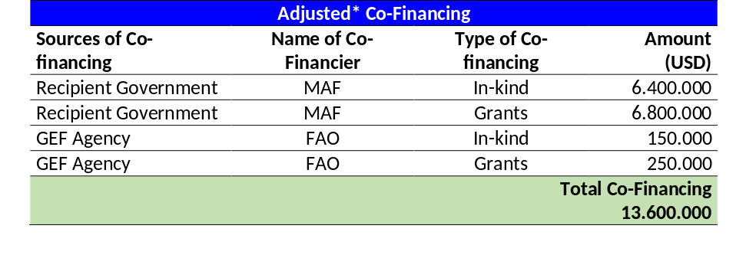
3.3.2 GEF Contribution
The GEF funds will finance inputs needed to generate the outputs and outcomes under the Project. These include: (i) local and international consultants for support to capacity building in LDN, as well as strengthening of local livelihoods and mainstreaming of gender in project activities, and project M&E; (ii) technical support to upscaling of demonstration activities (iii) support to information and knowledge management; (vi) LoA/contracts with technical institutions and service providers supporting the delivery of specific project activities on the ground; (v) international flights and local transport and minor office equipment; and (vi) training and awareness raising material. Total GEF funding to the Project amounts to US$2 388 584.
3.3.3 Government Contribution
The Government of Turkey, through the Ministry of Agriculture and Forestry, is providing cash co-financing to the project of USD6 800 000 from its basline programmes and projects. An additional USD6 400 000 is provided in-kind for office space to the PIU, and support from local authorities to field activities. The total co-financing from the Government of Turkey thus amounts to USD13 200 000.
3.3.4 FAO Contribution
FAO is providing cash co-financing from a Technical Cooperation grant of USD250 000 to support the operationalization of LDN in Turkey. In addition, an in-kind contribution of USD150 000 is provided from its global and regional monitoring programmes, such as the Global Soil Partnership and the work done by the Collect Earth team.
3.3.5 Financial management and reporting on GEF resources
As described above, the MAF will act as executing agency for the project. The MAF is accountable to FAO for achieving the agreed project results and for the effective use of resources made available by FAO. Financial management and reporting for the funds transferred to MAF will be done by MAF in accordance with terms, conditions, formats and requirements of FAO and the signed Operational Partners Agreement (OPA). The administration by the OP of the funds received from FAO shall be carried out under its own financial regulations, rules and procedures, which shall provide adequate controls to ensure that the funds received are properly administered and expended. The Operational Partner shall maintain the account in accordance with generally accepted accounting standards.
Financial management and reporting in relation to the GEF resources directly managed by FAO will be carried out in accordance with FAO’s rules and procedures, and in accordance with the agreement between FAO and the GEF Trustee. The FAO Representative in Turkey will be the Budget Holder (BH) and will be responsible for timely operational, administrative and financial management of GEF resources implemented by FAO directly (see Appendix 3). The budget holder will be also responsible for i) managing OPIM for results, including monitoring of risks and overall compliance with the OPA provisions; ii)review and clear financial and progress reports received from the OP and certify request for funds iii) review and clear budget revisions and annual work plan and budgets; iv) ensure implementation of the Risk Mitigation and Assurance Plan v) follow up and ensure that the OP implements all actions and recommendations agreed upon during Assurance Activities.
Financial records. FAO shall maintain a separate account in United States dollars for the Project’s GEF resources showing all income and expenditures. Expenditures incurred in a currency other than United States dollars shall be converted into United States dollars at the United Nations operational rate of exchange on the date of the transaction. FAO shall administer the Project in accordance with its regulations, rules and directives.
Financial reports. The BH shall prepare six-monthly project expenditure accounts and final accounts for the project, showing amount budgeted for the year, amount expended since the beginning of the year, and separately, the un-liquidated obligations as follows:
- Details of project expenditures on outcome-by-outcome basis, reported in line with Project Budget (Appendix 3 of this Project document), as at 30 June and 31 December each year.
- Final accounts on completion of the Project on a component-by-component and outcome-by-outcome basis, reported in line with the Project Budget (Appendix 3 of this Project Document).
- A final statement of account in line with FAO Oracle Project budget codes, reflecting actual final expenditures under the Project, when all obligations have been liquidated.
The OP will prepare the financial reports in accordance with terms, conditions, formats and requirements of FAO and the signed OPA. The BH will review and approve request for funds and financial reports of the OP. The subsequent installments can be released only based on the BH confirmation that all expenditures are eligible and all OPA requirements are fulfilled to the satisfaction of FAO. The BH will withhold any payment due to the OP in case of non-compliance with the reporting obligations detailed in the OPA.

Financial statements: Within 30 working days of the end of each semester, the FAO REU shall submit six-monthly statements of expenditure of GEF resources, to present to the Liaison Committees and the Project Steering Committee. The purpose of the financial statement is to list the expenditures incurred on the project on a six monthly basis compared to the budget, so as to monitor project progress and to reconcile outstanding advances during the six-month period. The financial statement shall contain information that will serve as the basis for a periodic revision of the budget.
The BH will submit the above financial reports for review and monitoring by the LTO and the FAO GEF Coordination Unit. Financial reports for submission to the donor (GEF) will be prepared in accordance with the provisions in the GEF Financial Procedures Agreement and submitted by the FAO Finance Division.
Responsibility for cost overruns: The BH shall utilize the GEF project funds in strict compliance with the Project Budget (Appendix 3) and the approved AWP/Bs. The BH can make variations provided that the total allocated for each budgeted project component is not exceeded and the reallocation of funds does not impact the achievement of any project output as per the project Results Framework (Appendix 1). At least once a year, the BH will submit a budget revision for approval of the LTO and the FAO/GEF Coordination Unit through FPMIS. Cost overruns shall be the sole responsibility of the BH.

As regards resources managed by MAF, the OP shall utilize the funds received from FAO in strict compliance with provisions of the signed OPA and its Annexes, including approved work plan and budget. The OP can make variations not exceeding 10 percent on any budget heading. Any variations above 10 percent on any budget heading that may be necessary will be subject to prior consultations with and approval by FAO.

Audit
The Project shall be subject to the internal and external auditing procedures provided for in FAO financial regulations, rules and directives and in keeping with the Financial Procedures Agreement between the GEF Trustee and FAO.
The audit regime at FAO consists of an external audit provided by the Auditor-General (or persons exercising an equivalent function) of a member nation appointed by the Governing Bodies of the Organization and reporting directly to them, and an internal audit function headed by the FAO Inspector-General who reports directly to the Director-General. This function operates as an integral part of the Organization under policies established by senior management, and furthermore has a reporting line to the governing bodies. Both functions are required under the Basic Texts of FAO which establish a framework for the terms of reference of each. Internal audits of imprest accounts, records, bank reconciliation and asset verification take place at FAO field and liaison offices on a cyclical basis.
Specific provision for auditing the OP managed funds are included in the project document. During implementation, assurance activities will be undertaken by FAO to determine whether the progress has been made and whether funds transferred to Operational Partners were used for their intended purpose, in accordance with the work plan and relevant rules and regulations. This may include, but is not limited to, monitoring missions, spot checks, quarterly progress and annual implementation reviews, and audits on the resources received from FAO.

3.4 PROCUREMENT
FAO’s procurement rules and procedures in accordance with the agreement between FAO and the GEF Trustee will be applied for the project activities under GEF-FAO budget (see Annex 3 for GEF-FAO and GEF-OPIM budget).
The procurement rules and procedures in OPA will be applied for the project activities under GEF-OPIM budget (see Annex 3 for GEF-FAO and GEF-OPIM budget).

3.5 MONITORING AND REPORTING
The monitoring and evaluation of progress in achieving the results and objectives of the project will be based on targets and indicators in the Project Results Framework (Appendix 1 and descriptions in sub-section 1.3.2). Project monitoring and the evaluation activities are budgeted at USD 131 500 (see Table 8). Monitoring and evaluation activities will follow FAO and GEF policies and guidelines for monitoring and evaluation. The monitoring and evaluation system will also facilitate learning and replication of the project’s results and lessons in relation to the integrated management of natural resources.

3.5.1 Oversight and monitoring responsibilities
The monitoring and evaluation roles and responsibilities specifically described in the Monitoring and Evaluation table (see Table 3.4 below) will be undertaken through: (i) day-to-day monitoring and project progress supervision missions (PIU); (ii) technical monitoring of indicators to measure a reduction in land degradation (PIU and LTU in coordination with partners); (iii) mid-term review and final evaluation (independent consultants and FAO Evaluation Office); and (v) monitoring and supervision missions (FAO).
At the beginning of the implementation of the GEF project, the PIU will establish a system to monitor the project’s progress. Participatory mechanisms and methodologies to support the monitoring and evaluation of performance indicators and outputs will be developed. During the project inception workshop (see section 3.5.3 below), the tasks of monitoring and evaluation will include: (i) presentation and explanation (if needed) of the project’s Results Framework with all project stakeholders; (ii) review of monitoring and evaluation indicators and their baselines; (iii) preparation of draft clauses that will be required for inclusion in consultant contracts, to ensure compliance with the monitoring and evaluation reporting functions (if applicable); and (iv) clarification of the division of monitoring and evaluation tasks among the different stakeholders in the project. The M&E Expert (see TORs in Appendix 6) will prepare a draft monitoring and evaluation matrix that will be discussed and agreed upon by all stakeholders during the inception workshop. The M&E matrix will be a management tool for the PC and the Project Partners to: i) six-monthly monitor the achievement of output indicators; ii) annually monitor the achievement of outcome indicators; iii) clearly define responsibilities and verification means; iv) select a method to process the indicators and data.
The M&E Plan will be prepared by the M&E Expert together with local communities in the three first months of the PY1 and validated with the PSC. The M&E Plan will be based on the M&E Table 8 and the M&E Matrix and will include: i) the updated results framework, with clear indicators per year; ii) updated baseline, if needed, and selected tools for data collection (including sample definition); iii) narrative of the monitoring strategy, including roles and responsibilities for data collection and processing, reporting flows, monitoring matrix, and brief analysis of who, when and how will each indicator be measured. Responsibility of project activities may or may not coincide with data collection responsibility; iv) updated implementation arrangements, if needed; v) inclusion of the tracking tool indicators, data collection and monitoring strategy to be included in the mid-term review and final evaluation; vi) calendar of evaluation workshops, including self-evaluation techniques.
The day-to-day monitoring of the project’s implementation will be the responsibility of the PC and will be driven by the preparation and implementation of an AWP/B followed up through six-monthly PPRs. The preparation of the AWP/B and six-monthly PPRs will represent the product of a unified planning process between main project stakeholders. As tools for results-based-management (RBM), the AWP/B will identify the actions proposed for the coming project year and provide the necessary details on output and outcome targets to be achieved, and the PPRs will report on the monitoring of the implementation of actions and the achievement of output and outcome targets. Specific inputs to the AWP/B and the PPRs will be prepared based on participatory planning and progress review with all stakeholders and coordinated and facilitated through project planning and progress review workshops. These contributions will be consolidated by the PC in the draft AWP/B and the PPRs.
An annual project progress review and planning meeting should be held with the participation of the project partners to finalize the AWP/B and the PPRs. Once finalized, the AWP/B and the PPRs will be submitted to the FAO LTO for technical clearance, and to the Project Steering Committee for revision and approval. The AWP/B will be developed in a manner consistent with the Project Results Framework to ensure adequate fulfillment and monitoring of project outputs and outcomes.
Following the approval of the Project, the PY1 AWP/B will be adjusted (either reduced or expanded in time) to synchronize it with the annual reporting calendar. In subsequent years, the AWP/Bs will follow an annual preparation and reporting cycle as specified in section 3.5.3 below.
3.5.2 Indicators and sources of information
Please refer to Appendix 1 (Results framework) for detailed outcome and output indicators as well as sources of information.
3.5.3 Reporting schedule
Specific reports that will be prepared under the monitoring and evaluation program are: (i) Project inception report; (ii) Annual Work Plan and Budget (AWP/B); (iii) Project Progress Reports (PPRs); (iv) Annual Project Implementation Review (PIR); (v) Technical reports; (vi) Co-financing reports; and (vii) Terminal Report. In addition, the GEF tracking tool for land degradation will be completed and will be used to compare progress with the baseline established during the preparation of the project.
Project Inception Report. After FAO internal approval of the project an inception workshop will be held. Immediately after the workshop, the PC will prepare a project inception report in consultation with the FAO Represenation in Turkey and other project partners. The report will include a narrative on the institutional roles and responsibilities and coordinating action of project partners, progress to date on project establishment and start-up activities and an update of any changed external conditions that may affect project implementation. It will also include a detailed first year AWP/B and the M&E Matrix (see above). The draft inception report will be circulated to FAO and the PSC for review and comments before its finalization, no later than three months after project start-up. The report will be cleared by the FAO BH, LTO and the FAO/GEF Coordination Unit. The BH will upload it in FPMIS.
Annual Work Plan and Budget(s) (AWP/Bs). The PC will present a draft AWP/B to the PSC no later than 10 December of each year. The AWP/B should include detailed activities to be implemented by project outcomes and outputs and divided into monthly timeframes and targets and milestone dates for output and outcome indicators to be achieved during the year. A detailed project budget for the activities to be implemented during the year should also be included together with all monitoring and supervision activities required during the year. The FAO Representation in Turkey will circulate the draft AWP/B to the FAO Project Task Force and will consolidate and submit FAO comments. The AWP/B will be reviewed by the PSC and the PIU will incorporate any comments. The final AWP/B will be sent to the PSC for approval and to FAO for final no-objection. The BH will upload the AWP/Bs in FPMIS.
Project Progress Reports (PPR). The PPRs are used to identify constraints, problems or bottlenecks that impede timely implementation and take appropriate remedial action. PPRs will be prepared based on the systematic monitoring of output and outcome indicators identified in the Project Results Framework (Appendix 1), AWP/B and M&E Plan. Each semester the PC will prepare a draft PPR, and will collect and consolidate any comments from the FAO PTF. The NPC will submit the final PPRs to the FAO Representation in Turkey every six months, prior to 10 June (covering the period between January and June) and before 10 December (covering the period between July and December). The July-December report should be accompanied by the updated AWP/B for the following Project Year (PY) for review and no-objection by the FAO PTF. The Budget Holder has the responsibility to coordinate the preparation and finalization of the PPR, in consultation with the PIU, LTO and the FLO. After LTO, BH and FLO clearance, the FLO will ensure that project progress reports are uploaded in FPMIS in a timely manner.
Annual Project Implementation Review (PIR). The PC, under the supervision of the LTO and BH and in coordination with the national project partners, will prepare a draft annual PIR report covering the period July (the previous year) through June (current year) no later than July 1st every year. The LTO will finalize the PIR and will submit it to the FAO-GEF Coordination Unit for review by July 10th. The FAO-GEF Coordination Unit, the LTO, and the BH will discuss the PIR and the ratings. The LTO is responsible for conducting the final review and providing the technical clearance to the PIR(s). The LTO will submit the final version of the PIR to the FAO-GEF Coordination Unit for final approval. The FAO-GEF Coordination Unit will then submit the PIR(s) to the GEF Secretariat and the GEF Independent Evaluation Office as part of the Annual Monitoring Review of the FAO-GEF portfolio. The PIR will be uploaded to FPMIS by the FAO-GEF Coordination Unit.
Technical reports. The technical reports will be prepared as part of the project outputs and will document and disseminate lessons learned. Drafts of all technical reports must be submitted by the Project Coordinator to the PSC and FAO SEC, which in turn will be shared with the LTO for review and approval and to the FAO-GEF Coordination Unit for information and comments before finalization and publication. Copies of the technical reports will be distributed to the Liaison Committee and the PSC and other project stakeholders, as appropriate. These reports will be uploaded in FAO FPMIS by the BH.
Co-financing reports. The PC will be responsible for collecting the required information and reporting on in-kind and cash co-financing provided by all the project cofinanciers and eventual other new partners not foreseen in the Project Document. Every year, the PC will submit the report to the FAO Representation in Turkey before July 10th covering the period July (the previous year) through June (current year). This information will be used in the PIRs.
GEF Land Degradation Tracking Tool. In compliance with GEF policies and procedures, the tracking tool for the ​​Land Degradation focal area should be sent to the GEF Secretariat in three stages: (i) with the project approval document by the GEF Executive Director; (ii) with the mid-term review of the project; and (iii) with the final evaluation of the project.
Final Report. Within two months prior to the project’s completion date, the Project Coordinator will submit to the PSC and FAO-Turkey a draft final report. The main purpose of the final report is to give guidance to authorities (ministerial or senior government level) on the policy decisions required for the follow-up of the Project, and to provide the donor with information on how the funds were utilized. Therefore, the terminal report is a concise account of the main products, results, conclusions and recommendations of the Project, without unnecessary background, narrative or technical details. The target readership consists of persons who are not necessarily technical specialists but who need to understand the policy implications of technical findings and needs for ensuring sustainability of project results. Work is assessed, lessons learned are summarized, and recommendations are expressed in terms of their application to the integrated landscape management in the three microregions in the context of the development priorities at national and departmental levels, as well as in practical execution terms. This report will specifically include the findings of the final evaluation as described in section 3.6 below. A project evaluation meeting will be held to discuss the draft final report with the PSC before completion by the Coordinator and approval by the BH, LTO, and FAO-GEF Coordination Unit.
3.5.4 Monitoring and Evaluation summary
Table 8 summarizes the main monitoring and evaluation reports, parties responsible for their publication and time frames.
Table 8. Summary of main monitoring and evaluation activities.
M&E Activity | Responsible parties | Time frame/  Periodicity | Budget
Inception workshop | PC; FAO-Turkey (with support from the LTO, and FAO-GEF Coordination Unit) | Within two months of project start up | USD 3,000
Project Inception report | PC, M&E Expert and FAO-Turkey with clearance by the LTO, BH and FAO-GEF Coordination Unit | Immediately after the workshop | -
Field-based impact monitoring | PC; project partners, local organizations | Continuous | USD 10,000
Supervision visits and rating of progress in PPRs and PIRs | PC; FAO (FAO-Turkey, LTO). FAO-GEF Coordination Unit may participate in the visits if needed. | Annual, or as needed | FAO visits will be borne by GEF agency fees  Project Coordination visits shall be borne by the project’s travel budget
Project Progress Reports (PPRs) | PC, with stakeholder contributions and other participating institutions | Six-monthly | USD 3,000
Project Implementation Review (PIR) | Drafted by the PC, with the supervision of the LTO and BH. Approved and submitted to GEF by the FAO-GEF Coordination Unit | Annual | FAO staff time financed though GEF agency fees.  PCU time covered by the project budget.
Co-financing reports | PC with input from other co-financiers | Annual | USD 500
Technical reports | PC, FAO (LTO, FAO-Turkey) | As needed | TBD
Mid-term review | FAO-Turkey, External consultant, in consultation with the project team, including the FAO-GEF Coordination Unit and others | Midway through the project implementation period | USD 50,000 by an external consultancy
Final evaluation | FAO Office of Evaluation Unit in consultation with the project team, including the FAO-GEF Coordination Unit and others | At the end of the project | USD 60,000 managed by OED with external evaluation team. FAO staff time and travel costs will be financed by GEF agency fees.
Terminal Report | PC; FAO (FAO-Turkey, LTO, FAO-GEF Coordination Unit, TCS Reporting Unit) | Two months prior to the end of the project. | USD 5 000
Total budget |  |  | USD 131 500

3.6 EVALUATION PROVISIONS
At the end of the first 18 months of the project, the BH will arrange a Mid-Term Review (MTR) in consultation with the PSC, the PIU, the LTO and the FAO-GEF Coordination Unit. The MTR will be conducted to review progress and effectiveness of implementation in terms of achieving project objective, outcomes and outputs. The MTR will allow mid-course corrective actions, if needed. The MTR will provide a systematic analysis of the information provided under the M&E Plan (see above) with emphasis on the progress in the achievement of expected outcome and output targets against budget expenditures. The MTR will refer to the Project Budget (see Appendix 3) and the approved AWP/Bs for PY1 and PY2. The MTR will contribute to highlight replicable good practices and main problems faced during project implementation and will suggest mitigation actions to be discussed by the PSC, the LTO and FAO-GEF Coordination Unit.
An independent Terminal Evaluation (FE) will be launched six monthsprior to the terminal report meeting. The Terminal Evaluation will aim to identify the project impacts, sustainability of project outcomes and the degree of achievement of long-term results. The TE will also have the purpose of indicating future actions needed to expand on the existing Project in subsequent phases, mainstream and up-scale its products and practices, and disseminate information to management authorities and institutions with responsibilities in food security, conservation and sustainable use of natural resources, small-scale farmer agricultural production and ecosystem conservation to assure continuity of the processes initiated by the Project. Both the MTR and TE will pay special attention to outcome indicators and will be aligned with the GEF Tracking tool (LD focal area).

3.7 COMMUNICATION AND VISIBILITY

The project will enhance communication and visibility of LDN at the national level through support to dissemination of best practices and lessons learnt under Component 4 and field level through support under Component 3 to demonstrations of SLM and SFM to achieve LDN and counterbalancing of gains and losses. At the local level, community exchange visits will be supported through e.g. Farmer Field Schools.
Proposed tools for enhancing visibility include:
- General aspects – the PIU will ensure that general aspects of project visibility are fulfilled, such as: (i) visual identity of project and partners; (ii) highlighting the project’ partners in media interviews, press releases, etc.); (iii) supporting documents such as photos of logos in the field, photos of activities, copies of press released will be included in the progress and final reports.
- Basic visibility at field level – At this level visibility strategy will consider: (i) signboards, display panels and banners; (ii) operational publications and materials such as training manuals and posters; (iii) supplies and equipment.
- Printed publications – Brochures, leaflets, flyers, newsletters and other publications to project activities and results.
- Website, webpage and social network pages – This will include: (i) partnerships and links; (ii) project information (objectives, activities, expected results, etc.).
- Audio-visuals – (i) Films for distribution by the media (mainly for television, campaigns and Internet); (ii) operational films (films to provide technical information and practices to local population, project partners and authorities).
- Public events – Many types of events are possible and attracting media interest will always be a key consideration in making the events cost-effective. Press release will be an integral part of the events.
FAO and GEF logos will be used, along with government logo, in all knowledge products and in any communication materials developed (such as posters, pamphlets etc.).
SECTION 4 – SUSTAINABILITY OF RESULTS

SOCIAL SUSTAINABILITY
This Project will contribute to socio-economic sustainability at in a pilot area where LDN will be implemented to balance gains and losses from land management. Demonstrations of SLM and SFM will contribute to income-generation for local communities. The project will pay special attention to identifying and supporting the special needs of rural women to ensure that their important role in SLM and agriculture is recognized and that they reap the benefits of investments in LDN. A long-term impact of the project also includes improved food security and nutrition in the pilot area, with a particular focus on provision of ecosystem services supporting agricultural production.

4.2 ENVIRONMENTAL SUSTAINABILITY
The project will pilot a scheme for LDN and support demonstration and scaling up of best practices on SLM and SFM in the production landscape essential for controlling land degradation and improving land productivity. Strengthened institutional, legal and policy enabling conditions for LDN will also enhance environmental sustainability and contribute to strengthen the capacity of Turkey to plan and manage these resources successfully under an LDN approach.

4.3 FINANCIAL AND ECONOMIC SUSTAINABILITY
The LDN approach will be effectively mainstreamed into key sectors, especially environment, forestry, agriculture and livestock. Moreover, monitoring of LDN will capitalize of Turkey’s many existing monitoring and modeling systems for land cover, productivity and soil organic carbon. This will contribute to the financial and economic sustainability of the LDN approach and monitoring and decision-support system (DSS). In addition, an investment programme for LDN will be developed and capacity to develop bankable projects will be build and at least one new LDN project developed.

4.4 SUSTAINABILITY OF CAPACITY DEVELOPMENT
The project will strengthen existing institutional capacities within Turkey in LDN. At the local level, the Project is designed to enhance the capacity of local authorities and communities and agro-enterprises to access new knowledge and implement best management practices in SLM and SFM to achieve LDN. These capacities will be sustained through the strengthened national coordination platform and continued outreach and dissemination of good practices and management advice.

4.5 APPROPRIATENESS OF TECHNOLOGIES INTRODUCED and COST/EFFECTIVENESS
Technologies
The selection of the SLM and SFM technologies and best practices for demonstration and counterbalancing of gains and losses is based on management practices already pilot tested and documented in DS-SLM in Turkey and the National Soil Information Data Base, for their environmental impact and economic feasibility. The practices include climate resilient practices related to soil management (e.g. terracing, fertilizer application, etc.), improved crop and rangeland practices (e.g. fruit nurseries, vegetable production, cattle and small animal support, etc.), alternative practices (e.g. medicinal and aromatic plants, mushroom farming, apiculture, etc.). The final fine-tuning of SLM and SFM interventions will be undertaken in close consultation with local communities and agro-enterprises participating in the project.

4.6 INNOVATIVENESS, REPLICATION and SCALE-UP

This initiative together with the baseline project on turning the LDN concept into practice is the first of its kind in Turkey and is also linked to the global pilot project on LDN coordinated by the UNCCD. As such, it will generate new and innovative approaches to multi-sector land use planning based on testing and implementation in the Sakarya Basin. The experiences are expected to be replicable across Turkey through activities of MAF and opportunities for scaling up best practices will also be explored in the context of Turkey’s sharing of experiences with other countries and the UNCCD, especially in Central Asia. During the COP 12, held in Ankara, Turkey declared that it will continue supporting countries that are lacking the financial and institutional means as well as capacities to address LDN, through the so called Ankara Initiative. The joint efforts of GoT, UNCCD and the Global Mechanism will make the know-how and financial tools available to countries in need of such support. Therefore, the outputs of this project can be disseminated through the Ankara Inititate as well as through other established channels. Although the parties of COP 12 have decided to adopt voluntary LDN targets, to mainstream LDN into national policies and to establish necessary capacity for LDN monitoring through several indicators, this knowledge is not yet fully available for countries. The project can act to fill this gap by developing methods and tools for LDN implementation, monitoring and evaluation.

APPENDICES

APPENDIX 1: RESULTS FRAMEWORK
APPENDIX 2: WORK PLAN
APPENDIX 3: PROJECT BUDGET
APPENDIX 4: RISK MATRIX
APPENDIX 5: ENVIRONMENTAL AND SOCIAL ASSESSMENT
APPENDIX 6: TERMS OF REFERENCE
APPENDIX 7: FAO’S ROLE IN INTERNAL ORGANIZATION (OPIM)

APPENDIX 1: RESULTS FRAMEWORK
Results chain | Indicators | Baseline | Mid-term target | Final target | Means of verification | Assumptions |  | Responsible for data collection
Objective: To develop a model for LDN target setting, planning and decision-making at national level and for demonstration in the Upper Sakarya basin
Component 1: Strengthening the enabling environment for Land Degradation Neutrality (LDN)
Outcome 1.1: Enhanced enabling Environment for LDN | Integration of LDN into strategic planning processes  Investment programme for LDN | LDN is not integrated into any process for e.g. watershed management, drought management | LDN integrated into at least one strategic planning process | LDN integrated into at least 3 strategic planning processes  Investment programme for LDN developed  At least 50 people participate in international exchange programmes on LDN (at least 20 women) | Revisions and amendements to strategic planning documents  Investment programme report |  | There is political will and interest in integrating LDN into strategic planning processes  PIRs, PPRs |  | MAF
Output 1.1.1: Capacity development program in place on LDN target setting and its implementation for local and central government staff | Number of institutional training courses that integrate LDN  Number of people trained at local and central level  National and international symposia  International LDN exchange | Knowledge of LDN and how to operationalize it at local and national level is limited despite the earlier LDN pilot project | At least one institutional training programme that integrates LDN  At least 30 people trained at central level and 15 at local  National LDN symposium  At least 5 people participate in national symposium related to LDN  At least 35 people participate in international LDN exchange programmes | At least two central-level training programmes and one local that integrates LDN  At least 150 people trained (at least 50 women)  International LDN Symposium  At least 5 people participate in national and 2 in a international symposiums related to LDN  At least 50 people participate in international LDN exchange programmes | LDN training manuals and modules  Reports from training courses; participants lists  Reports from symposia  Reports on attendence  Reports on technical trips  Reports on education  Reports on language courses |  | Key institutions and staff have the interest and capacity to access and internalise new knowledge on LDN |  | CEM
Output 1.1.2: Creation of a national online Information Sharing Forum on LDN for stakeholder engagement | National Online Information Sharing Forum on LDN | No LDN platform exists | 1 National Online Information Sharing Forum on LDN | 1 National Online Information Sharing Forum on LDN | Forum website statistics  Uploaded douments  Community of practice/Discussion groups |  | There is demand for an LDN discussion forum and interest in sharing information |  | CEM
Output 1.1.3: Capacity development program in place for farmers, herders and forest villages in the Upper Sakarya Basin | Number of Farmer Field Schools (FFS) established on modern and sustainable production methods  Number of local people trained, including how many women  Mass media campaigns on LDN | Knowledge of modern and sustainable production methods is limited at local village level  No mass media campaigns on LDN | At least 3 FFS established  At least 30 local people trained of which 50% are women  At least 1 mass media campaign | At least 3 FFS established  At least 60 local people trained of which 50% are women  At least 2 mass media campaign | FFS training manuals and modules  Reports from training courses; participants lists  Reports on campaign |  | Local people are interested in and motivated to participate in FFS |  | MAF
Output 1.1.4: Identification of needs for new legislation and/or revisions of existing legislation based on project findings and targeted stakeholder consultations | New and/or revised legislation that operationalise the LDN approach | LDN is not currently integrated into any legislation or regulations | Gap analysis of relevant legislation | New and/or revised legislation | Documented policy revisions  Draft bill with new LDN legislation |  | There is political will to update relevant policies and legislation to integrate LDN |  | MAF
Output 1.1.5: Integration of the LDN approach and priorities into strategic planning processes at sub-national and national levels | Integration of LDN into strategic planning processes  Strengthening of the LDN intersectoral working group | LDN is not integrated into any process for e.g. watershed management, drought management  The LDN working Group lacks capacity | LDN integrated into at least one strategic planning process  4 meetings of the LDN working group | LDN integrated into at least 3 strategic planning processes  8 meetings of the LDN Working Group | Documented revisions and amendements to strategic planning documents  Meeting minutes from LDN Working Group |  | There is political will and interest in integrating LDN into strategic planning processes  There is commitment across relevant sectors to collaborate on LDN |  | CEM
Component 2: Decision-Support System (DSS) for LDN
Outcome 2.1: Decision-support system for LDN target setting and planning established | DSS established with calibrated metrics for LDN indicators | There are many DSS for NRM in Turkey, but non that focuses on LDN | DSS for LDN in place with calibrated metrics for LDN indicators | DSS for LDN in place with calibrated metrics for LDN indicators | DSS portal  Database with LDN indicators  PIRs. PPRs | Data for assessing LDN is available in Turkey and has sufficient resolution for field application |  |  | CEM
Output 2.1.1: Metrics for LDN indicators (i.e. land cover, soil organic carbon and land productivity) identified, tested and calibrated | Calibrated metrics for LDN indicators available | Information on the three LDN indicators – land cover, SOC and productivity – is available but needs to be calibrated | Calibrated data on land cover, SOC and productivity available for the Upper Sakarya Basin | Calibrated data on land cover, SOC and productivity available for the whole of Turkey | Database with LDN indicators | Data for assessing LDN is available in Turkey and has sufficient resolution for field application |  |  | CEM
Output 2.1.2: DSS integrated and tested | Integration for LDN DSS | Software for other DSS exist that will be used to integrate the LDN DSS | LDN DSS available | LDN DSS integrated, tested and used | LDN DSS software available | Capacity exist to integrate the LDN DSS |  |  | CEM
Output 2.1.3: Land cover classes and land degradation levels in demonstration area in the Upper Sakarya basin identified | Land cover classes and land degradation levels in the Upper Sakarya Basin verified | Land cover classes and land degradation levels in the Upper Sakarya Basin have been determined, but need verification | Land cover classes and land degradation levels in the Upper Sakarya Basin verified | Land cover classes and land degradation levels in the Upper Sakarya Basin verified | Reports  Land cover and land degradation maps | The existing information on land cover is still relevant and can easily be verified |  |  | CEM
Outcome 2.2: Monitoring system and related capacity for LDN in place | LDN monitoring system in place with target setting agreed | Many monitoring approaches have been tested in Turkey that will provide the baseline | LDN monitoring system in place with target setting agreed | LDN monitoring system in place with target setting agreed | GIS-based monitoring system  Reports with LDN targets  PIRs, PPRs | Institutional and technical capacity in place |  |  | CEM
Output 2.2.1: LDN target setting based on current and existing monitoring infrastructure and metrics agreed | Target setting and hot spots and cold spots for gains and losses identified | Many monitoring approaches have been tested in Turkey, including the ‘land productivity dynamics approach’ that the target setting will build on | Target setting completed and hot spots and cold spots for gains and losses identified | Target setting completed and hot spots and cold spots for gains and losses identified | Maps  Reports | Institutional and technical capacity in place |  |  | CEM
Output 2.2.2: Effective and economic approach for soil organic carbon monitoring identified and disseminated | Agreed soil organic carbon monitoring approach | The Soil Organic Carbon Monitoring Model and Mapping Project of Turkey will serve as the baseline | Agreed soil organic carbon monitoring approach | Agreed soil organic carbon monitoring approach disseminated | Monitoring model  Reports  Maps | Strong cooperation between Government institutions, universities and TUBITAK. |  |  | CEM
Output 2.2.3: Turkey’s existing land degradation monitoring system calibrated to monitor LDN indicators and for testing in the Upper Sakarya Basin | TCM and LPD Models tested | The existing TCM model needs field calibration | TCM and LPD Models tested in the Upper Sakarya Basin | TCM and LPD Models compared on an area basis | Reports with model results | Strong cooperation between Government institutions and universities |  |  | CEM
Output 2.2.4: LDN-related reporting capacity improved | Web-based Monitoring, Evaluation and Reporting System (IDR) operationalized  Training of decision-makers and technical staff | The IDR has been developed, but further capacity in using it is needed | The IDR operationalized and 20 decision-makers and 30 technical staff trained of which 50% are women | A total of 30 decision-makers and 50 technical staff trained | Training manuals and reports  Participants lists | Decision-makers and technical staff motivted to take part in training |  |  | CEM
Output 2.2.5: Climate variability integrated into the LDN DSS and tested in the Upper Sakarya Basin | Sub-indicators of climate variability tested in the Upper Samaria Basin for the TCM and SOC Models | The TCM and SOC models have not been calibrated for climate variability | Sub-indicators of climate variability tested in the Upper Samaria Basin for the TCM and SOC models | Sub-indicators of climate variability tested in the Upper Samaria Basin for the TCM and SOC models | Reports of modelling results | Strong cooperation between Government institutions and universities |  |  | CEM
Component 3: Demonstration of the LDN approach in the Upper Sakarya Basin
Outcome 3.1: Improved land management, land cover, and increased soil organic carbon in the Upper Sakarya basin | Area with improved land management  Area with improved land cover  % increase in SOC | 0  41.7 ton C  ha⁻¹ 30 cm⁻¹ | 7,000  2,000,000  20% increase in SOC | 14,000  4,313,827  20% increase in SOC | Field surveys  Land-use plans  PIRs, PPRs  Measurement of C stocks at 30 cm soil depth | Local authorities and land users are willing to participate and priorities identified by the DSS are found to be relevant |  | MAF
Output 3.1.1: Participatory landscape-specific improvement plans based on priorities identified by the DSS covering 4,313,827 ha of land | Ha of land covered by landscape-specific improvement plans | 0 covered, but the LDN planning will be integrated into the exisiting integrated watershed planning processes | 2,000,000 | 4,313,827 | Participatory land-use plans  Special development plans  Micro-basin plans | Local authorities and land users are willing to participate and priorities identified by the DSS are found to be relevant |  | MAF
Output 3.1.2: Demonstrations of SLM and SFM best practices in forests, rangelands and croplands that provide carbon benefits on 14,000 ha of land | Area with demonstrations of SLM and SFM best practices  % increase in SOC in area covered by BPs | 0 covered, but the project will build on BPs tested elsewhere in Turkey | 7,000 | 14,000  20 % increase in SOC | Field surveys | Local land users willing to demonstrate new and innovative practices |  | MAF
Output 3.1.3: Measures and approaches for reducing the impacts of climate variability integrated into SLM and SFM practices | Number of climate-smart measures and approaches integrated into SLM/SFM | 0 | 5 | 10 | SHARP-like assessments | Local authorities and communities are aware of the impacts of climate change and ready to adapt their practices |  | MAF
Output 3.1.4: Preparation of an implementation plan for achieving LDN targets in the whole Upper Sakarya Basin | Implementation plan for achieving LDN targets in the Upper Sakarya Basin | No such plan exists | 1 implementation plan for achieving LDN targets in the whole Sakarya Basin | 1 implementation plan for achieving LDN targets in the whole Sakarya Basin | Published plan | Capacity exists in CEM to help prepare such a plan |  | CEM
Outcome 3.2: Land productivity increased by 10% and livelihoods for local communities strengthened | Increase in land productivity | Land productivity and incomes are low in the Upper Sakarya basin due to outdated SLM and SFM practices | 5% increase in land productivity | 10% increase in land productivity  300 households with improved living conditions  300 women trained in entrepneurship | Agricultural statistics  Field surveys  PIRs, PPRs | There is potential to increase land productivity through improved practices |  | MAF
Output 3.2.1: Introduction of gender sensitive sustainable livelihood strategies | Gender Action Plan for the Upper Sakarya Basin | No such plan exists | Gender Action Plan for the Upper Sakarya Basin | Gender Action Plan for the Upper Sakarya Basin | Report with Gender Action Plan | Women in the Upper Sakarya Basin are willing to participate and identify their priorities in a participatory manner |  | MAF
Output 3.2.2: Introduction of gender-sensitive climate resilient practices to enhance land productivity | Number of gender sensitive climate resilient practices targeting women  Area covered  Number of households with improved living conditions  Number of women trained | Existing practices are not climate resilient | 5 practices/200 women  1 500 ha  150 households | 10 practices/300 women  2 000 ha  300 households  300 women | Field surveys  Project reports | Local land-users willing to adopt new more climte-smart and gender sensitive practices |  | MAF
Component 4: Upscaling of LDN experiences, monitoring and evaluation
Outcome 4.1: Upscaling of the LDN DSS to national level covering all of Turkey (78.4 million ha) | Area covered by the LDN DSS | No national LDN DSS is in place | Land cover classes for the whole of Turkey identified based on the 6 IPCC classes | National LDN DSS covers the national territory of 78.4 million ha | LDN DSS portal accessible  Reports generated by LDN DSS | Institutional capacity and interest in estblishing and maintaining an LDN DSS |  | CEM
Output 4.1.1: LDN metrics for the whole of Turkey entered into the LDN DSS and land cover classes and land degradation levels identified | LDN metrics for the whole of Turkey available in DSS | No national LDN DSS or metrics is in place | Land cover classes for the whole of Turkey identified based on the 6 IPCC classes | LDN metrics for the whole of Turkey available in DSS | LDN DSS portal accessible  LDN DSS reports | Institutional capacity and interest in estblishing and maintaining an LDN DSS with updated metrics |  | CEM
Output 4.1.2: LDN target setting at national scale in place | LDN target setting in place | No LDN target setting at the national scale | Alternative indicators examined for use at the national scale (socio-economic) | National LDN target setting in place | LDN target setting reporting to UNCCD | The thee LDN indicators can be effectively used for assessing and monitoring of LDN in Turkey |  | CEM
Output 4.1.3: Development of bankable projects for the LDN fund (at least 1) | Number of bankable projects for the LDN fund | No projects for the LDN fund developed in Turkey | 0 | 1 bankable project | Project document | Capacity for development of LDN projects exists in concerned ministries and institutions as well as matching co-financing |  | MAF
Outcome 4.2: Monitoring of project results, lessons learned and dissemination | M&E system is in place  Lessons learned disseminated | No system in place | Implementation of project based on adaptive results based-management | Project delivers expected results and shares lessons learned | GEF LD Tracking Tools  PIRs, PPRs  Midterm Review and Final Evaluation | National lead agencies and other stakeholders support M&E processes, and are committed to continuous learning and exchange of knowledge on LDN |  | CEM/FAO
Output 4.2.1: Global Environmental Benefits monitored and assessed | Baseline and targets for GEB indicators refined | 0  0 | Project M&E system delivers expected reports and informs project management | Project M&E system delivers expected reports and informs project management | GEF LD Tracking Tool  PIRs PPRs,  Midterm Review and Final Evaluation | PMU functioning and adequate funding allocated to M&E |  | CEM/FAO
Output 4.2.2: Mid- term and final evaluation conducted | Mid-term and final evaluation reports | 0 | Mid-project review recommendations implemented | Final evaluation | Evaluation reports (FAO evaluation office) | Adequate funding allocated to evaluations |  | FAO/CEM
Output 4.3: Experience sharing on Project-related “lessons-learned” and a national LDN guideline published | Experience sharing notes  National LDN Guideline | 0 | 2 Experience sharing notes | 3 experience sharing notes  1 LDN guideline | Experience sharing notes  Guideline | National lead agencies and other stakeholders support M&E processes, and are committed to continuous learning and exchange of knowledge on LDN |  | MAF /FAO

APPENDIX 2: WORK PLAN

Output | Activities | Responsible  Entity | Year 1 |  |  |  |  | Year 2 |  |  |  |  |  |  |  | Year 3 |  |  |  | Year 4
Output | Activities | Responsible  Entity | Q1 | Q2 | Q3 |  | Q4 | Q1 |  | Q2 |  | Q3 |  | Q4 |  | Q1 | Q2 | Q3 | Q4 | Q1 | Q2 | Q3 | Q4
Component 1: Strengthening the enabling environment for Land Degradation Neutrality (LDN)
Output 1.1.1: Capacity development program in place on LDN target setting and its implementation for local and central government staff | Activity 1: Informative meetings for the central administrative and strategic planners of LDN-related institutions | CEM
 | Activity 2: Awareness-raising activities on LDN | CEM
 | Activity 3: Institutional-level training courses on LDN | FAO/CEM
 | Activity 4: National-level training courses on LDN | FAO/CEM
 | Activity 5: National LDN Symposium | FAO/MAF/CEM
 | Activity 6: International LDN Symposium | FAO/MAF/CEM
 | Activity 7: Domestic technical training trips for examining the best SLM and SFM applications related to LDN | FAO/CEM
 | Activity 8: International technical training trips for examining the best SLM and SFM applications related to LDN | FAO/CEM
 | Activity 9: Participation to international training, workshop and | CEM
 | Activity 10: International exchange
Output 1.1.2: Creation of a national online Information Sharing Forum on LDN for stakeholder engagement | Activity 1: Establishment of an Interactive National Online Information Sharing Forum on LDN | CEM
Output 1.1.3: Capacity development program in place for farmers, herders and forest villages in the Upper Sakarya Basin | Activity 1: Farmer trainings via Farmer’s Field Schools (at least 50% of participants are women) | MAF
 | Activity 2. Group organizations (field demonstrations/farmers meetings/exhibitions/competitions/ field days) | MAF
 | Activity 3: Certified herders training | MAF
 | Activity 4. Farmer exposure visits for demonstration of best practices on SLM and SFM
 | Activity 5: Mass media campaigns on LDN | MAF
Output 1.1.4: Identification of needs for new legislation and/or revisions of existing legislation based on project findings and targeted stakeholder consultations | Activity 1: Identification of needs for new legislation and/or revisions of existing legislation following National LDN Symposium | MAF
Output 1.1.5: Integration of the LDN approach and priorities into strategic planning processes at sub-national and national levels | Activity 1: Information dissemination meetings with the central administrative and strategic planners of LDN-related institutions and the administrative and planners of local institutions | CEM
 | Activity 2: Information dissemination meetings with stakeholders | CEM
 | Activity 3: Information dissemination meetings with NGOs (Upper Sakarya Basin) | CEM
Component 2: Decision-Support System (DSS) for LDN
Output 2.1.1: Metrics for LDN indicators (i.e. land cover, soil organic carbon and land productivity) identified, tested and calibrated | Activity 1: Identification metrics for Land Use Land Cover (UASIS Model) | CEM/TUBITAK
 | Activity 2: Identification metrics for Soil Organic Carbon (TOK Model) | CEM/TUBITAK
 | Activity 3: Identification metrics for Land Productivity | CEM/TUBITAK
Output 2.1.2: DSS integrated and tested | Activity 1: Calibration of UASIS Model for land cover | CEM/TUBITAK
Output 2.1.2: DSS integrated and tested | Activity 2: Calibration of TOK Model for soil organic carbon | CEM/TUBITAK
Output 2.1.2: DSS integrated and tested | Activity 3: Calibration of Land Productivity by Collect Earth and NPP | CEM
Output 2.1.2: DSS integrated and tested | Activity 4: Integration of of the LDN DSS | CEM
Output 2.1.3: Land cover classes and land degradation levels in demonstration area in the Upper Sakarya basin identified | Activity 1: Determination and validation of land cover classes in the Upper Sakarya Basin | CEM/TUBITAK
 | Activity 2: Determination and validation of land degradation levels in the Upper Sakarya Basin | CEM/TUBITAK
Output 2.2.1: LDN target setting based on current and existing monitoring infrastructure and metrics agreed | Activity 1: LDN target setting using the existing land degradation monitoring systems at national and sub-national level (TCM/TOK/POS/DEMIS) | CEM/TUBITAK
 | Activity 2: Identification of hot&cold spot areas in the Upper Sakarya basin | CEM/TUBITAK
Output 2.2.2: Effective and economic approach for soil organic carbon monitoring identified and disseminated | Activity 1: Integration Land Productivity Dynamic Map with the Soil Organic Carbon Model for effective monitoring SOC | CEM/TUBITAK
 | Activity 2: Use of effective SOC monitoring system under the SLM and SFM practices applied. | CEM
Output 2.2.3: Turkey’s existing land degradation monitoring system (TCM) calibrated to monitor LDN indicators and for testing in the Upper Sakarya Basin | Activity 1: Validation and calibration of the Desertification Model of Turkey (TCM) in the Upper Sakarya basin | CEM
 | Activity 2: Monitoring LDN indicators in the Upper Sakarya Basin using calibrated TCM (in addition to the calibrated UASIS, TOK and NPP mentioned in Output 2.1.2) | CEM
Output 2.2.4: LDN-related reporting capacity improved | Activity 1: Activating the Monitoring, Evaluation and Reporting System (IDR) | CEM
Output 2.2.4: LDN-related reporting capacity improved | Activity 2: Preparation of capacity building activities and training programs on the IDR System for decision-makers, technical staff, NGOs and private sector | CEM
Output 2.2.5: Climate variability integrated into the LDN DSS and tested in the Upper Sakarya Basin | Activity 1: Monitoring, testing and analyzing sub-indicators of climate factor of the TCM and Soil Organic Carbon (TOK) Models in the Upper Sakarya Basin | CEM
 | Activity 2: Integration of the TCM and the TOK models into the LDN_DSS | CEM
Component 3: Demonstration of the LDN approach in the Upper Sakarya Basin
Output 3.1.1: Participatory landscape-specific improvement plans based on priorities identified by the DSS covering 4,313,827 ha of land | Activity 1: Integration of LDN into existing land-use plans in the Upper Sakarya Basin | MAF
 | Activity 2: Development of participatory micro basin planning using Pro-Det-Sol (Problems-Detections-Solutions) approach | MAF
 | Activity 3: Focus group discussions and community consultations | CEM
Output 3.1.2: Demonstrations of SLM and SFM best practices in forests, rangelands and croplands that provide carbon benefits on 14,000 ha of land | Activity 1: Implementation of the best SLM applications (contour farming, terracing, fertility, crop rotation, organic farming …) on cultivated lands (5.000 ha) | MAF
 | Activity 2: Implementation of sustainable pasture management practices (grazing management, weed control, insemination, fertilization, terracing, gully prevention, water wells, water harvesting, open or closed cages, shadows, salt and feed, sheep bathing, itching stakes….) (4.000 ha) | MAF
 | Activity 3: Implementation of the best SFM on forest areas (afforestration, erosion control, rehabilitation) (5.000 ha) | MAF
Output 3.1.3: Measures and approaches for reducing the impacts of climate variability integrated into SLM and SFM practices | Activity 1: Technical assistance on climate-friendly agricultural/forestry practices | MAF
 | Activity 2: Integration of measures and approaches for climate resilience into SLM and SFM practices | MAF
 | Activity 3: Monitoring and evaluating climate resilience of SLM and SFM measures using SHARP like assessment | MAF
Output 3.1.4: Preparation of an implementation plan for achieving LDN targets in the whole Upper Sakarya Basin | Activity 1: Preparation of implementation plan for achieving LDN targets in the Upper Sakarya Basin | CEM
 | Activity 2: Up-scaling of the implementation plan to the whole Sakarya Basin | CEM
Output 3.2.1: Introduction of gender sensitive sustainable livelihood strategies | Activity 1: Interviews with target groups using questionnaires | MAF
 | Activity 2: Development of a gender action plan for identifying roles, responsibilities and priorities of women in the Upper Sakarya Basin | MAF
Output 3.2.2: Introduction of gender-sensitive climate resilient practices to enhance land productivity | Activity 1: Introducing soil and land management practices (terracing, soil analysis, fertility management …) | MAF
 | Activity 2: Introducing crop and pasture management practices (fruit nurseries, vegetable production, food processing feed crops and forage crop production, cattle and small animal support….) | MAF
 | Activity 3: Introducing alternative practices targeting 300 women (medicinal and aromatic plants, mushroom farming, fishing…..) | MAF
 | Activity 4: Training of 300 women in entrepeneurship, truffle production and handicrafts, etc. for marketing
Component 4: Upscaling of LDN experiences, monitoring and evaluation
Output 4.1.1: LDN metrics for the whole of Turkey entered into the LDN DSS and land cover classes and land degradation levels identified | Activity 1: Identification of land cover classes for Turkey based upon IPPC 2006
 | Activity 2: Upscaling Land Use and Land Cover (LULC) to whole of Turkey using the UASIS | CEM
Output 4.1.2: LDN target setting at national scale in place | Activity 1: Up scaling LDN indicators (land cover-land use change, carbon stocks, and land productivity) to national scale | CEM
Output 4.1.2: LDN target setting at national scale in place | Activity 2: Analyzing socio-economic indicators for a new input for LDN | CEM
Output 4.1.3: Development of bankable projects for the LDN fund (at least 1) | Activity 1: Development at least one bankable project for the LDN fund | MAF
Output 4.2.1: Global Environmental Benefits monitored and assessed | Activity 1: Establishment of monitoring and evaluating (M&E) system for GEB indicators | FAO/CEM
 | Activity 2: M&E of GEB indicators | FAO/CEM
Output 4.2.2: Mid-term and final evaluation conducted | Activity 1: Mid-term evaluation | CEM/FAO
Output 4.2.2: Mid-term and final evaluation conducted | Activity 2:Final evaluation | CEM/FAO
Output 4.2.3: Experience sharing on Project-related “lessons-learned” and a national LDN guideline published | Activity 1: Preparation of a National LDN guideline | MAF

APPENDIX 3: PROJECT BUDGET

Oracle code and description | Unit | No. of units | Unit cost | Result 1 | Result 2 | Result 3 | Result 4 | PM | Total  GEF Funds | Year 1 | Year 2 | Year 3 | Year 4 | TOTAL
Salaries Professional
Monitoring & Evaluation Expert | days | 240 | 80 | 19,200 | 0 | 0 | 0 | 0 | 19,200 | 4,800 | 4,800 | 4,800 | 4,800 | 19,200
Sub-total Salaries Professional |  |  |  | 19,200 | 0 | 0 | 0 | 0 | 19,200 | 4,800 | 4,800 | 4,800 | 4,800 | 19,200
5013 Consultants
Operational Project Staff |  |  |  |  |  |  |  |  |  |  |  |  |  | 0
Project Manager | months | 42 | 2,800 | 0 | 0 | 0 | 0 | 117,600 | 117,600 | 16,800 | 33,600 | 33,600 | 33,600 | 117,600
Technical Project Staff |  |  |  |  |  |  |  |  |  |  |  |  |  | 0
LDN Expert - Integrate LDN to LU plans | Lumpsum | 1 | 17,000 | 0 | 0 | 17,000 | 0 | 0 | 17,000 | 17,000 | 0 | 0 | 0 | 17,000
CD Expert - Participatory LU planning | Lumpsum | 1 | 40,000 | 0 | 0 | 40,000 | 0 | 0 | 40,000 | 40,000 | 0 | 0 | 0 | 40,000
SFM expert - agroforestry plans | Lumpsum | 1 | 10,000 | 0 | 0 | 10,000 | 0 | 0 | 10,000 | 10,000 | 0 | 0 | 0 | 10,000
Expert - Preparation of action plans for USB | Lumpsum | 1 | 70,000 | 0 | 0 | 70,000 | 0 | 0 | 70,000 | 0 | 0 | 0 | 70,000 | 70,000
Gender Expert | months | 1 | 20,000 | 0 | 0 | 20,000 | 0 | 0 | 20,000 | 20,000 | 0 | 0 | 0 | 20,000
M&E of GEB indicators |  | 1 | 50,000 | 0 | 0 | 0 | 50,000 | 0 | 50,000 | 50,000 | 0 | 0 | 0 | 50,000
FFS Expert | months | 8 | 1,500 | 12,000 | 0 | 0 | 0 | 0 | 12,000 | 3,000 | 3,000 | 3,000 | 3,000 | 12,000
Communications expert | days | 232 | 50 | 11,600 | 0 | 0 | 0 | 0 | 11,600 | 3,000 | 3,000 | 3,000 | 2,600 | 11,600
5570 Sub-total consultants |  |  |  | 23,600 | 0 | 157,000 | 50,000 | 117,600 | 348,200 | 159,800 | 39,600 | 39,600 | 109,200 | 348,200
5014 Contracts
Creation of a national online Information Sharing Forum on LDN for stakeholder engagement | Contract | 1 | 20,261 | 20,261 | 0 | 0 | 0 | 0 | 20,261 | 20,261 | 0 | 0 | 0 | 20,261
Validation of desertification model |  | 2 | 50,000 | 0 | 100,000 | 0 | 0 | 0 | 100,000 | 0 | 50,000 | 50,000 | 0 | 100,000
Monitoring of LDN parameters |  | 2 | 20,000 | 0 | 40,000 | 0 | 0 | 0 | 40,000 | 0 | 20,000 | 20,000 | 0 | 40,000
LDN reporting capacity - activate IDR system |  | 3 | 15,000 | 0 | 45,000 | 0 | 0 | 0 | 45,000 | 15,000 | 15,000 | 15,000 | 0 | 45,000
Integrate TCM/TOK models into DSS |  | 1 | 20,000 | 0 | 20,000 | 0 | 0 | 0 | 20,000 | 0 | 20,000 | 0 | 0 | 20,000
Integration Land Productivity Dynamic Map with the Soil Organic Carbon Model |  | 5 | 10,000 | 0 | 50,000 | 0 |  |  | 50,000 | 20,000 | 30,000 | 0 | 0 | 50,000
Use of effective SOC monitoring system under the SLM and SFM practices | Lumpsum | 5 | 10,000 | 0 | 50,000 | 0 |  |  | 50,000 | 10,000 | 20,000 | 20,000 | 0 | 50,000
Climate friendly agroforestry practices | Lumpsum | 12 | 15,000 | 0 | 0 | 180,000 | 0 | 0 | 180,000 | 0 | 60,000 | 60,000 | 60,000 | 180,000
Sharp assessment | Lumpsum | 6 | 15,000 | 0 | 0 | 90,000 | 0 | 0 | 90,000 | 0 | 30,000 | 30,000 | 30,000 | 90,000
Upscaling LDN to the basin | Lumpsum | 1 | 60,000 | 0 | 0 | 60,000 | 0 | 0 | 60,000 | 0 | 0 | 0 | 60,000 | 60,000
Surveys on livelihood strategies | Each | 3 | 10,000 | 0 | 0 | 30,000 | 0 | 0 | 30,000 | 30,000 | 0 | 0 | 0 | 30,000
Soil/Land management practices | Each | 5 | 10,000 | 0 | 0 | 50,000 | 0 | 0 | 50,000 | 20,000 | 10,000 | 10,000 | 10,000 | 50,000
SLM - crop and pasture management | Each | 20 | 10,000 | 0 | 0 | 200,000 | 0 | 0 | 200,000 | 50,000 | 50,000 | 50,000 | 50,000 | 200,000
Alternative practices | Each | 10 | 10,000 | 0 | 0 | 100,000 | 0 | 0 | 100,000 | 20,000 | 30,000 | 30,000 | 20,000 | 100,000
Improvement of living conditions | Lumpsum | 19 | 10,000 | 0 | 0 | 190,000 | 0 | 0 | 190,000 | 50,000 | 50,000 | 50,000 | 40,000 | 190,000
Monitoring of socioeconomic indicators | Lumpsum | 1 | 50,000 | 0 | 0 | 0 | 50,000 | 0 | 50,000 | 0 | 0 | 50,000 | 0 | 50,000
M&E System for GEB indicators | Lumpsum | 1 | 130,123 | 0 | 0 | 0 | 130,123 | 0 | 130,123 | 130,123 | 0 | 0 | 0 | 130,123
Mid-term Evaluation | Contract | 1 | 40,000 | 0 | 0 | 0 | 40,000 | 0 | 40,000 | 0 | 0 | 40,000 | 0 | 40,000
Final Evaluation | Contract | 1 | 50,000 | 0 | 0 | 0 | 50,000 | 0 | 50,000 | 0 | 0 | 0 | 50,000 | 50,000
Terminal Report | Contract | 1 | 5,000 | 0 | 0 | 0 | 5,000 | 0 | 5,000 | 0 | 0 | 0 | 5,000 | 5,000
OPIM - Audits | Contract | 4 | 4,500 | 0 | 0 | 18,000 | 0 | 0 | 18,000 | 4,500 | 4,500 | 4,500 | 4,500 | 18,000
OPIM - OPA | Contract | 1 | 25,000 | 0 | 0 | 25,000 | 0 | 0 | 25,000 | 25,000 | 0 | 0 | 0 | 25,000
Finance assitance for validation and due deligiance | Contract | 12 | 2,400 | 0 | 0 | 28,800 | 0 | 0 | 28,800 | 7,200 | 7,200 | 7,200 | 7,200 | 28,800
Sub-total contracts |  |  |  | 20,261 | 305,000 | 971,800 | 275,123 | 0 | 1,572,184 | 402,084 | 396,700 | 436,700 | 336,700 | 1,572,184
5021 Travel
Technical training trips for examining the best SLM and SFM applications (in country) | Lumpsum | 10 | 5,000 | 50,000 | 0 | 0 | 0 | 0 | 50,000 | 0 | 15,000 | 15,000 | 20,000 | 50,000
Technical study visits on best practices on SLM and SFM (abroad) | Lumpsum | 3 | 40,000 | 120,000 | 0 | 0 | 0 | 0 | 120,000 | 40,000 | 40,000 | 40,000 | 0 | 120,000
PMU supervision missions | Lumpsum | 8 | 2,000 | 0 | 0 | 16,000 | 0 | 0 | 16,000 | 4,000 | 4,000 | 4,000 | 4,000 | 16,000
Knowledge exchange (PMU staff and stakeholders) | Lumpsum | 4 | 10,000 | 0 | 0 | 40,000 | 0 | 0 | 40,000 | 10,000 | 10,000 | 10,000 | 10,000 | 40,000
Sub-total travel |  |  |  | 170,000 | 0 | 56,000 | 0 | 0 | 226,000 | 54,000 | 69,000 | 69,000 | 34,000 | 226,000
5920 Training and workshops
Farmer exposure visits demonstration of Best practices | Unit | 9 | 5,000 | 45,000 | 0 | 0 | 0 | 0 | 45,000 | 0 | 15,000 | 15,000 | 15,000 | 45,000
National legislation update | Lumpsum | 1 | 10,000 | 10,000 | 0 | 0 | 0 | 0 | 10,000 | 0 | 0 | 10,000 | 0 | 10,000
Integrating LDN into strategic planning process | Each | 9 | 5,000 | 45,000 | 0 | 0 | 0 | 0 | 45,000 | 0 | 15,000 | 15,000 | 15,000 | 45,000
LDN reporting capacity - IDR training program | Each | 3 | 15,000 | 0 | 45,000 | 0 | 0 | 0 | 45,000 | 15,000 | 15,000 | 15,000 | 0 | 45,000
Inception workshop (Ankara) | Each | 1 | 10,000 | 10,000 | 0 | 0 | 0 | 0 | 10,000 | 10,000 | 0 | 0 | 0 | 10,000
Inception workshops (in project provinces) | Each | 3 | 3,000 | 9,000 | 0 | 0 | 0 | 0 | 9,000 | 9,000 | 0 | 0 | 0 | 9,000
Planning workshops (Ankara) | Each | 4 | 5,000 | 20,000 | 0 | 0 | 0 | 0 | 20,000 | 5,000 | 5,000 | 5,000 | 5,000 | 20,000
Project Completion Workshop (Ankara) | Each | 1 | 10,000 | 10,000 | 0 | 0 | 0 | 0 | 10,000 | 0 | 0 | 0 | 10,000 | 10,000
5920 Sub total Training and workshops |  |  |  | 149,000 | 45,000 | 0 | 0 | 0 | 194,000 | 39,000 | 50,000 | 60,000 | 45,000 | 194,000
6000 Expendable procurement
Miscellaneous |  |  |  | 0 | 0 | 0 | 0 | 0 | 0 | 0 | 0 | 0 | 0 | 0
6000S Sub-total Expendable procurement |  |  |  | 0 | 0 | 0 | 0 | 0 | 0 | 0 | 0 | 0 | 0 | 0
6100 Non-Expendable procurement
Laptop computer | piece | 5 | 1,000 | 5,000 | 0 | 0 | 0 | 0 | 5,000 | 5,000 | 0 | 0 | 0 | 5,000
Mobile projection | piece | 4 | 1,250 | 5,000 | 0 | 0 | 0 | 0 | 5,000 | 5,000 | 0 | 0 | 0 | 5,000
Camera | piece | 4 | 2,000 | 8,000 | 0 | 0 | 0 | 0 | 8,000 | 8,000 | 0 | 0 | 0 | 8,000
Drone | piece | 2 | 5,500 | 11,000 | 0 | 0 | 0 | 0 | 11,000 | 11,000 | 0 | 0 | 0 | 11,000
Sub-total expendable Procurement |  |  |  | 29,000 | 0 | 0 | 0 | 0 | 29,000 | 29,000 | 0 | 0 | 0 | 29,000
5028 General operating expenses
Miscellaneous including contingencies | Various |  |  | 0 | 0 | 0 | 0 | 0 | 0 | 0 | 0 | 0 | 0 | 0
Sub-total general operating expenses |  |  |  | 0 | 0 | 0 | 0 | 0 | 0 | 0 | 0 | 0 | 0 | 0
Total project costs |  |  |  | 411,061 | 350,000 | 1,184,800 | 325,123 | 117,600 | 2,388,584 | 688,684 | 560,100 | 610,100 | 529,700 | 2,388,584

APPENDIX 4: RISK MATRIX

 | Description of risk | Impact | Probability of occurance¹ | Degree of incidence | Mitigation actions | Responsible party
1 | Lack of close and collaborative cooperation between key institutional stakeholders | MH | L | L | Close and collaborative cooperation between many institutional stakeholders will be essential for the project to achieve its stated goal and objectives. This will be achieved through involvement of all stakeholders from the early beginning of the project, preparation of project document and through establishment of working group for the project implementation as well as the project steering committee. Promotional materials and communication strategy will be developed and, regular meetings and presentation of project results in different phases of the project implementation will be organised. | CEM/FAO
2 | Unclear responsibilities of institutions at national and local level | MH | ML | L | Clearly defined and legally prescribed responsibilities of different institutions as well as involvement of all of responsible institutions are the main project goals. Moreover, the project will support improvement of institutional framework and through that ensure sustainability of the project results after its finalization. | MAF/CEM
3 | Low technical capacity at local national level | ML | ML | ML | Capacity and technical expertise of stakeholders are weak. To mitigate this risk, the project will support a capacity building through development of program for trainings during the project, taking into account specific needs of stakeholders. It will also support a national Information Sharing Forum. | MAF/CEM
4 | Natural disasters | MH | ML | L | Natural disasters, such as drought and floods, may impede the adoption of new technologies. The project is designed as a multi-year intervention, where demonstrations can be run over several seasons. The project will also be linked to the drought early warning services of the MAF. | MAF
5 | Climate change | ML | L | L | The MAF, with support of FAO technical expertise, are in a good position to adopt new research results on how to enhance resilience of SLM and SFM practices to climate change and, when necessary, adapt local livelihood strategies, which is supported under output 2.2.1 of the project. | MAF

APPENDIX 5: ENVIRONMENTAL AND SOCIAL ASSESSMENT

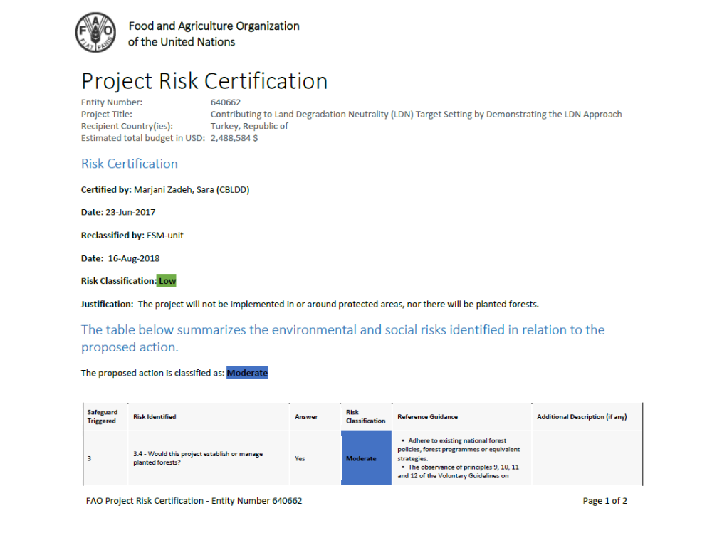

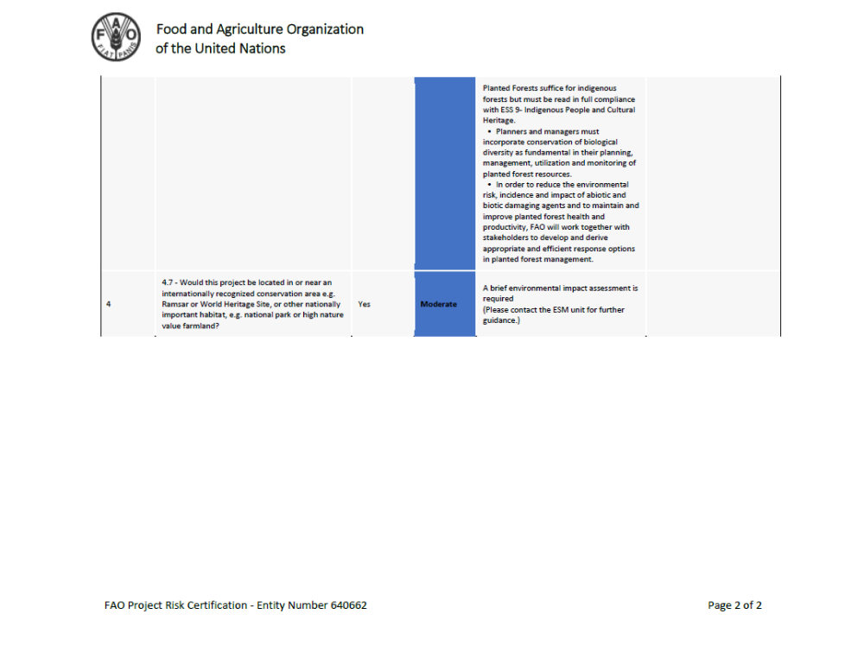

APPENDIX 6. TERMS OF REFERENCE
National Project Director
Timing/Duration | Full time for project duration
Background | The PD will be a senior officer seconded to the Project by the national lead agency.
Main tasks | - Assume overall responsibility for the successful execution and implementation of the project, accountability to the Government and FAO for the proper and effective use of project resources;  - Serve as a focal point for the coordination of projects with other Government agencies, FAO and outside implementing agencies;  - Ensure that all Government inputs committed to the project are made available;  - Supervise the work of the Project Coordinator and ensure that the Project Coordinator is empowered to effectively manage the project and other project staff to perform their duties effectively;  - Supervise the preparation of project work plans, updating, clearance and approval, in consultation with FAO and other stakeholders and ensure the timely request of inputs according to the project work plans;  - Represent the Government institution (national counterpart) at the tripartite review project meetings, and other stakeholder meetings;  - Build and strengthen synergies and collaboration with other stakeholders and contribute to knowledge exchange and benefits at national level.
Project Coordinator (PC)
Timing/Duration | Full time for project duration
Background | The PC will be a senior officer seconded to the Project by the national lead agency.
Main tasks | - Manage Project Coordination Unit (PCU)  - Prepare annual and quarterly workplans and prepare ToR for all inputs;  - Ensure all PCU staff and all consultants fully understand their role and their tasks, and support them in their work;  - Oversee day-to-day implementation of the project in line with the workplans;  - Assure quality of project activities and project outputs;  - Coordinate regular planning and communication events, starting with inception mission and inception workshop;  - Oversee preparation and implementation of M&E framework;  - Oversee preparation and implementation of Project communication and knowledge management frameworks;  - Oversee preparation of progress reports and all monitoring reports.  - Lead interactions with stakeholders  - Liaise with government agencies and regularly advocate on behalf of the Project;  - Coordinate project interventions with other ongoing activities, especially those of co-financers and other GEF projects;  - Facilitate and strengthen collaboration between national project’s stakeholders and regional/international partners to ensure smooth implementation and delivery of project’s activities;  - Support the establishment of the project as an umbrella for LDN in Turkey and encourage regional/international partners to support this initiative;  - Regularly promote the project and its outputs and findings on a national, and where appropriate, regional stage.

Project Implementation Unit (PIU) Staff
Title | Project Manager (PM)
Timing/Duration | Full time for project duration
Background | The PM is a GEF funded position reports to the PC. Under direct supervision of PC, PM will be responsible for the below mentioned tasks and responsibilities.
Main tasks | - Support PC in leading, managing, administering and overseeing the implementation of the project and ensure that organization procedures are adhered to;  - Represent the project at different forums and collaborate with the relevant institutions as required;  - Prepare detail project annual and quarterly work plans in line with the budget and in collaboration with implementation institutions and FAO, and make necessary arrangements of their successful implementation in a timely manner;  - Review progress made towards the work plan proposed as well as the stated objectives;  - Ensure the preparation of quality reports in line with the rules and regulations;  - Guide and assist in developing and strengthening the capacity of local institutions and organisations and communities, to be carried out in consultation with the project partners;  - Monitor the project budget and prepare yearly expenditure plans and reports and inform the PC in a timely fashion;  - Act as PC as required;  - Perform any other functions as directed.
Key competencies/qualifications | - Advanced degree in natural resources management or related fields  - At least ten years of experience in the natural resources management sector in Turkey;  - Demonstrated ability to adopt new ideas;  - Demonstrated commitment to participatory and bottom-up approaches;  - Demonstrated ability to communicate, including advocating to government agencies;  - Demonstrated ability to manage, including project management, office management;  - English language skills are preferential

Title | LDN Expert
Timing/Duration | Part time for project duration
Background | This GEF funded position reports to the PC. The LDN Expert will be based in the PIU office.
Main tasks | The Expert will provide technical support to the project team in LDN within the scope of the project. Specific tasks include;  - Technical support to the PIU in demonstration and scaling up of best practices on SLM and SFM to achieve project targets  - Support to the PIU in mainstreaming LDN into strategies, plans and policies.  - Contribute to the PIU in strengthening the capacity of Turkey to plan and manage natural resources successfully under an LDN approach.  - Support to the PIU in developing capacity development strategies and activities including strengthening existing institutional capacities within Turkey in land degradation neutrality.  - Contribute to preparation of land use / microcatchment planning in the scope of the project.  - Facilitate and ensure proper liaison with project partners and stakeholders involved in projects implementation;  - Contribute to the technical backstopping for the implementation, monitoring and reporting on the project  - Perform other related duties as required
Key competencies/qualifications | - University degree in natural resource management, agriculture or forestry (or related technical disciplines).  - Five years experience in the areas land degradation neutrality such as SLM/SFM/CSA practices included projects  - experience in monitoring and evaluation  - English skills are preferential

Title | Monitoring and Evaluation Expert
Timing/Duration | Full time for project duration
Background | Monitoring and Evaluation Expert will be an officer seconded to the Project by the national lead agency. He/she will work at PCU office. M&E Expert will be based in PIU office.
Main tasks | Monitoring and Evaliuation Expert will support the PIU on M&E.  Monitoring and Evaliuation Expert will contribute to all Outcomes of the project. Monitoring and Evaluation Expert will work with the RC. Specific tasks include:  - Support the PC in monitoring and evaluation of key project results and impacts;  - Design, oversee and co‐ordinate the Project’s participatory M&E system, and prepare a results‐based monitoring and evaluation action plan for the project.  - Collect project indicator data and consolidate and input them in relevant databases; and (iii) provide consolidated M&E information to PIU to feed into the project progress reports and to support decision mechanism.  - Provide training to regional and local project staff approach and methodology to participatory monitoring and reporting, including the collection of meaningful data at the field level.  - Perform other related duties as required by the PIU
Key competencies/  qualifications | - A university degree in natural resource management, agriculture or forestry (or related technical disciplines). The M&E Expert should be familiar with result‐based project implementation and monitoring approaches, possess strong communication, team building, computing (word processing, spread‐ sheets and data‐bases) and report writing skills, and be fluent in spoken and written English  - Higher degree in impact monitoring and communications  - Five years experience in monitoring and evaluation  - English skills are preferential
Title | Translator/Secretary
Timing/Duration | Full time for project duration
Background | These co-finance funded positions will report to the PC. Translator/Secretary will be work at PCU office
Main tasks | The Translator/Secretary will provide interpretational, secretarial, and other administrative support to PC, PIU and the project team, including short-term experts/consultants. Specific tasks include:  Interpretational Tasks;  - Interpretation from Turkish into English and vice-versa;  - Arrange meetings and provide interpretation during meetings, and other events;  - Translate all internal documents to the Project, such as Progress, Quarterly, Annual Reports, Contracts, and other documents, from Turkish into English and vice-versa;  - Assist PC, PIU and project team and including short-term experts/consultants with translation, logistical arrangements, and other demands;  - Take minutes of meetings, translate and distribute it to related stakeholders;  - Provide other interpretational service as necessary.  Secretarial Tasks;  - Maintain proper filing and documentation of Project documents;  - Retain regular communication with Project Consultants to check upon their work progress;  - Assist with administration and management of the project office supplies, equipment, photocopier, fax and general maintenance;  - Provide other secretarial support to the project team;  - Perform other tasks as assigned.
Key competencies/qualifications | - Fluent spoken and written English and Turkish  - Minimum 2 years of relevant experience. Prior work experience in similar projects will be an asset  - University degree  - Good planning and report/minutes/memo writing skills is required;  - Able to carry out his/her work in an organized manner;  - Able to work independently and in a team;  - Familiar with MS Office

Title | Procurement and Finance Expert
Timing/Duration | Full time for project duration
Background | The Procurement and Finance Expert will be an officer seconded to the Project by the national lead agency. He/she will work at PIU office.
Main tasks | The Procurement and Finance Expert will provide financial, procurement related services and training in the procurement of works, goods and services under the Project, in accordance with procurement procedures addressed in the project documents; Specific tasks include:  - Prepare and provide assistance to the PIU in the preparation/updating of the procurement plan in the required format prior to submission of it to approval;  - Provide procurement advice to the PIU to ensure that procurement of all works, goods and services are undertaken in accordance with the approved Procurement Plan.  - Assist the project staff in the preparation of all sorts of bidding documents for works, goods and services and consultancy services;  - Review not only the administrative/commercial parts of the procurement documents, but also support/review the preparation of the technical specifications, TORs, etc. of the bidding documents and ensure the consistency of these sections with the other sections of the bidding documents and make necessary recommendations for changes/or make the changes where required.  - Review procurement activities regularly and submit progress reports to PIU  - Conduct other activities in procurement entrusted by the PIU  - Prepare financial reports and fund request forms  - Maintain adequate records of budget and expenditures

Provincial Staff
Title | Provincial Project Manager(s) (PMs)
Timing/Duration | Full time for project duration
Background | The PMs will be government officers seconded to the Project by both provincial implementation agencies, Provincial Directorate of MAF and Regional Directorate of Forestry for each project provinces.
Main tasks | - Manage provincial project implementation unit  - Ensure all field staff fully understand their role and their tasks, and support them in their work;  - Oversee day-to-day implementation of the project in line with the workplans;  - Lead interactions with local stakeholders  - Coordinate project interventions with other ongoing activities in the field,

Title | Field Expert(s)
Timing/Duration | Three x Full time for project duration
Background | Field Expert(s) will be officers seconded to the Project by by both provincial implementation agencies, Provincial Directorate of MAF and Regional Directorate of Forestry for each project provinces.
Main tasks | The Field Expert(s) will provide support to provincial project implementation unit and provide and channel guidance to local communities at demonstration sites. Specific tasks include:  - Provide technical and operational support to provincial project implementation unit for preparation of microchatchement plans / project implementation plans, and their implementation at Project sites  - Lead field-based M&E, together with local communities, of project environmental and socio-economic impacts  - Liaise regularly with PIU;  - Provide regular feedback and advance warning on conflicts, and assist with conflict resolution.

Terms of reference for the project steering committee

Role of the PSC
The PSC will be the policy setting body for the project; as and when required, the PSC will be the ultimate decision making body with regard to policy and other issues affecting the achievement of the project’s objectives. The PSC will be responsible for providing general oversight of the execution of the Project and will ensure that all activities agreed upon under the GEF project document are adequately prepared and carried out. In particular, it will:
- Provide overall guidance to the Project Management Unit in the execution of the project.
- Ensure all project outputs are in accordance with the Project document.
- Review, amend if appropriate, and approve the draft Annual Work Plan and Budget of the project for submission to FAO.
- Provide inputs to the mid-term review and final evaluations, review findings and provide comments for the Management Response
- Ensure dissemination of project information and best practices
Meetings of the PSC
- The Project Steering Committee meetings will normally be held annually (on rotational bases), but the Chairperson will have the discretion to call additional meetings, if this is considered necessary. Meetings of the PSC would not necessarily require a physical meeting and could be undertaken electronically. No more than 13 months may elapse between PSC meetings.
2. Invitations to a regular PSC meeting shall be issued not less than 90 days in advance of the date fixed for the meeting. Invitations to special meetings shall be issued not less than forty days in advance of the meeting date.
Agenda
1. A provisional agenda will be drawn up by the Project Coordinator and sent to members and observers following the approval of the Chairperson. The provisional agenda will be sent not less than 30 days before the date of the meeting.
2. A revised agenda including comments received from members will be circulated 5 working days before the meeting date.
3. The Agenda of each regular meeting shall include:
a) The election of the Vice-Chairperson
b) Adoption of the agenda
c) A report of the Project Coordinator on Project activities during the inter-sessional period
d) A report and recommendations from the Project Coordinator on the proposed Annual Work Plan and the proposed budget for the ensuing period
e) Reports that need PSC intervention
f) Consideration of the time and place (if appropriate) of the next meeting;
g) Any other matters as approved by the Chairperson
4. The agenda of a special meeting shall consist only of items relating to the purpose for which the meeting was called.
The PCU
The PCU will act as Secretariat to the PSC and be responsible for providing PSC members with all required documents in advance of PSC meetings, including the draft Annual Work plan and Budget and independent scientific reviews of significant technical proposals or analyses. The PCU will prepare written report of all PSC meetings and be responsible for logistical arrangements relative to the holding of such meetings.
Functions of the Chairperson
1. The Chairperson shall exercise the functions conferred on him elsewhere in these Rules, and in particular shall:
a) Declare the opening and closing of each PSC meeting
b) Direct the discussions at such meetings and ensure observance of these Rules, accord the right to speak, put questions and announce decisions
c) Rule on points of order
d) Subject to these Rules, have complete control over the proceedings of meetings
e) Appoint such ad hoc committees of the meeting as the PSC may direct
f) Ensure circulation by the Secretariat to PSC members of all relevant documents
g) Sign approved Annual Work Plans and Budgets and any subsequent proposed amendments submitted to FAO
h) In liaison with the PSC Secretariat, the Chairperson shall be responsible for determining the date, site (if appropriate) and agenda of the PSC meeting(s) during his/her period of tenure, as well as the chairing of such meetings
Participation
The PSC will be chaired by the Ministry of Agriculture and Forests (MAF). Other PSC members with the right to vote include FAO BH, LTO and the Project Coordinator will also be represented on the PSC, in ex-officio capacity. The Project Coordinator will be the Secretary to the PSC. Other active institutions, including representatives of implementing partners, may be invited or requested to participate as observers.
Decision-making
1. All decisions of the PSC shall be taken by consensus.
Reports and recommendations
1. At each meeting, the PSC shall approve report text that embodies its views, recommendations, and decisions, including, when requested, a statement of minority views.
2. A draft Report shall be circulated to the Members as soon as possible after the meeting for comments. Comments shall be accepted over a period of 20 days. Following its approval by the Chairperson, the Final Report will be distributed and posted on the Workspace as soon as possible after this.
Official language
The official language of the PSC shall be Turkish/English.

APPENDIX 7: FAO’s Role in Internal Organization (OPIM)
FAO will be the GEF Implementing Agency of the project and, as such, FAO will supervise and provide technical guidance for the overall implementation of the project, including:
- Administrate the portion of project GEF funds that has been agreed with the OP to remain for FAO direct implementation. These funds will be managed in accordance with the rules and procedures of FAO;
- Monitor and oversee OP’s compliance with the OPA and project implementation in accordance with the project document, work plans, budgets, agreements with co-financiers and the rules and procedures of FAO;
- Commence and completing the responsibilities allocated to it in the Project Document in a timely manner, provided that all necessary reports and other documents are available;
- Making transfers of funds, supplies and equipment, as applicable, in accordance with the provisions of the OPA;
- Review, discuss with the OP, and approve the project progress and financial reports, as detailed in the OPA and its annexes. undertaking and completing monitoring, assessment, assurance activities, evaluation and oversight of the project;
- Liaising on an ongoing basis, as needed, with the Government (as applicable), other members of the United Nations Country Team, Resource Partner, and other stakeholders;
- Providing overall guidance, oversight, technical assistance and leadership, as appropriate, for the Project;
- Initiating joint review meetings with the OP to agree on the resolution of findings and to document the lessons learned;
- Report to the GEF Secretariat and Evaluation Office, through the annual Project Implementation Review, on project progress and provide consolidated financial reports to the GEF Trustee;
- Conduct at least one supervision mission per year
- Lead the Independent Mid-Term and Final Evaluation, through the FAO Evaluation Office;
- Monitor implementation of the plan for social and environmental safeguards, in accordance with the FAO Environmental and Social Safeguards.

In collaboration with the PCU and the PSC, FAO will participate in the planning of contracting and technical selection processes. FAO will process fund transfers to the OP as per provisions, terms and conditions of the signed OPA.
The FAO Representative in Turkey will be the Budget Holder (BH) and will be responsible for timely operational, administrative and financial management of GEF resources implemented by FAO directly (see Appendix 3). The budget holder will be also responsible for i) managing OPIM for results, including monitoring of risks and overall compliance with the OPA provisions; ii)review and clear financial and progress reports received from the OP and certify request for funds iii) review and clear budget revisions and annual work plan and budgets; iv) ensure implementation of the Risk Mitigation and Assurance Plan v) follow up and ensure that the OP implements all actions and recommendations agreed upon during Assurance Activities.
As a first step in the implementation of the project, the FAO Representation will establish an interdisciplinary Project Task Force (PTF) within FAO, to guide the implementation of the project. The PTF is a management and consultative body that integrate the necessary technical qualifications from the FAO relevant units to support the project. The PTF is composed of a Budget Holder, a Lead Technical Officer (LTO), the Funding Liaison Officer (FLO) and one or more technical officers based on FAO Headquarters (HQ Technical Officer).
The FAO Representative, in accordance with the PTF, will give its non-objection to the AWP/Bs submitted by the PCU as well as the Project Progress Reports (PPRs). PPRs may be commented by the PTF and should be approved by the LTO before being uploaded by the BH in FPMIS.
The Lead Technical Officer (LTO) for the project will be (insert officer and division). The role of the LTO is central to FAO’s comparative advantage for projects. The LTO will oversee and carry out technical backstopping to the project implementation. The LTO will support the BH in the implementation and monitoring of the AWP/Bs, including work plan and budget revisions. The LTO is responsible and accountable for providing or obtaining technical clearance of technical inputs and services procured by the Organization.
In addition, the LTO will provide technical backstopping to the PT to ensure the delivery of quality technical outputs. The LTO will coordinate the provision of appropriate technical support from PTF to respond to requests from the PSC. The LTO will be responsible for:
- Assess the technical expertise required for project implementation and identify the need for technical support and capacity development of the OP.
- Provide technical guidance to the OP on technical aspects and implementation.
- Review and give no-objection to TORs for consultancies and contracts to be performed under the project, and to CVs and technical proposals short-listed by the PCU for key project positions and services to be financed by GEF resources;
- Supported by the FAO Representation, review and clear final technical products delivered by consultants and contract holders financed by GEF resources;
- Assist with review and provision of technical comments to draft technical products/reports during project implementation;
- Review and approve project progress reports submitted by the NPD, in cooperation with the BH;
- Support the FAO Representative in examining, reviewing and giving no-objection to AWP/B submitted by the NPD, for their approval by the Project Steering Committee;
- Ensure the technical quality of the six-monthly Project Progress Reports (PPRs). The PPRs will be prepared by the NPD, with inputs from the PT. The BH will submit the PPR to the FAO/GEF Coordination Unit for comments, and the LTO for technical clearance. The PPRs will be submitted to the PSC for approval twice a year. The FLO will upload the approved PPR to FPMIS.
- Supervise the preparation and ensure the technical quality of the annual PIR. The PIR will be drafted by the NPD, with inputs from the PT. The PIR will be submitted to the BH and the FAO-GEF Coordination Unit for approval and finalization. The FAO/GEF Coordination Unit will submit the PIRs to the GEF Secretariat and the GEF Evaluation Office, as part of the Annual Monitoring Review report of the FAO-GEF portfolio. The LTO must ensure that the NPD and the PT have provided information on the co-financing provided during the year for inclusion in the PIR;
- Conduct annual supervision missions;
- Provide comments to the TORs for the mid-term and final evaluation; provide information and share all relevant background documentation with the evaluation team; participate in the mid-term workshop with all key project stakeholders, development of an eventual agreed adjustment plan in project execution approach, and supervise its implementation; participate in the final workshop with all key project stakeholders, as relevant. Contribute to the follow-up to recommendations on how to insure sustainability of project outputs and results after the end of the project.
- Monitor implementation of the Risk Mitigation Plan, in accordance with the FAO Environmental and Social Safeguards.
The HQ Technical Officer is a member of the PTF, as a mandatory requirement of the FAO Guide to the Project Cycle. The HQ Technical Officer has most relevant technical expertise - within FAO technical departments - related to the thematic of the project. The HQ Technical Officer will provide effective functional advice to the LTO to ensure adherence to FAO corporate technical standards during project implementation, in particular:
- Supports the LTO in monitoring and reporting on implementation of environmental and social commitment plans for moderate risk projects. In this project, the HQ officer will support the LTO in monitoring and reporting the identified risks and mitigation measures (Appendix 4) in close coordination with the OP.
- Provides technical backstopping for the project work plan.
- Clears technical reports, contributes to and oversees the quality of Project Progress Report(s) (PPRs – see Section 3.5).
- May be requested to support the LTO and PTF for implementation and monitoring.
- Contribute to the overall ToR of the Mid-term and Final Evaluation, review the composition of the evaluation team and support the evaluation function.
The FAO-GEF Coordination Unit will act as Funding Liaison Officer (FLO). This FAO/GEF Coordination Unit will review and provide a rating in the annual PIR(s) and will undertake supervision missions as necessary. The PIRs will be included in the FAO GEF Annual Monitoring Review submitted to GEF by the FAO GEF Coordination Unit. The FAO GEF Coordination Unit may also participate in the mid-term evaluation, and in the development of corrective actions in the project implementation strategy if needed to mitigate eventual risks affecting the timely and effective implementation of the project. The FAO GEF Coordination Unit will in collaboration with the FAO Finance Division to request transfer of project funds from the GEF Trustee based on six-monthly projections of funds needed.
The FAO Financial Division will provide annual Financial Reports to the GEF Trustee and, in collaboration with the FAO-GEF Coordination Unit, request project funds on a six-monthly basis to the GEF Trustee.

Cowie, A.L., Orr, B.J., Castillo Sanchez, V.M., Chasek, P., Crossman, N.D., Erlewein, A., Louwagie, G., Maron, M., Metternicht, G.I., Minelli, S., Tengberg, A.E., Walter, S., Welton, S. 2018. Land in balance: The scientific conceptual framework for Land Degradation Neutrality. Environmental Science & Policy. Vol.79: 25-35.
Orr, B.J., A.L. Cowie, V.M. Castillo Sanchez, P. Chasek, N.D. Crossman, A. Erlewein, G. Louwagie, M. Maron, G.I. Metternicht, S. Minelli, A.E. Tengberg, S. Walter, and S. Welton. 2017. Scientific Conceptual Framework for Land Degradation Neutrality. A Report of the Science-Policy Interface. United Nations Convention to Combat Desertification (UNCCD), Bonn, Germany. ISBN 978-92-95110-42-7 (hard copy), 978-92-95110-41-0 (electronic copy).
IPPC. 2006. IPCC Guidelines for National Greenhouse Gas Inventories. http://www.ipcc- nggip.iges.or.jp/public/2006gl/pdf/4_Volume4/V4_03_Ch3_Representation.pdf
Retiere, A., Sommer, S., Minelli, S., Byron-Cox, R., Candelori, M., 2015. Land degradation neutrality from concept to practice. Using the UNCCD indicator framework to set LDN national voluntary targets and monitor their achievement. Methodological note, Joint Research Center, Italy p 13.
UNCCD.2016. Arazi Tahribatının Dengelenmesine Yönelik Hedef Belirlenmesi-Teknik Klavuz. Arazi Tahribatının Dengelenmesi Hedef Belirleme Programı. http://unstats.un.org/unsd/envaccounting/ seeaRev/eea_final_en.pdf
http://www.fao.org/in-action/sharp/en/ date of access; May 30, 2018
GEF LD and CC-M Tracking Tools.
Prior to the preparation of the PIR report, the FAO-GEF Coordination Unit will provide the updated format as every year some new requirements may come from the GEF.
The NPC, the BH, the LTO and the FAO/GEF Coordination Unit should assign ratings to the PIR every year. The ratings can or cannot coincide among the project managers.
Please consult available corporate guidelines and training for information on how to complete the risk log on the ERM website.
H: High; MH: Moderately High; ML: Moderately Low; L: Low

